Free Community Shredding Event

Please come join the Rotary Club of Wayne for a free Community Shredding Day
- Dispose of confidential documents to prevent identity theft.
- Professionally destroyed on site.
- Open to the public.
- Maximum of 5 boxes.
- Email the Rotary Club of Wayne with questions.
- Rain or shine.

May 11, 2024 10 am – 1 pm
Hype Western Wayne Recreation Center, 4635 Howe, Wayne, MI 48184

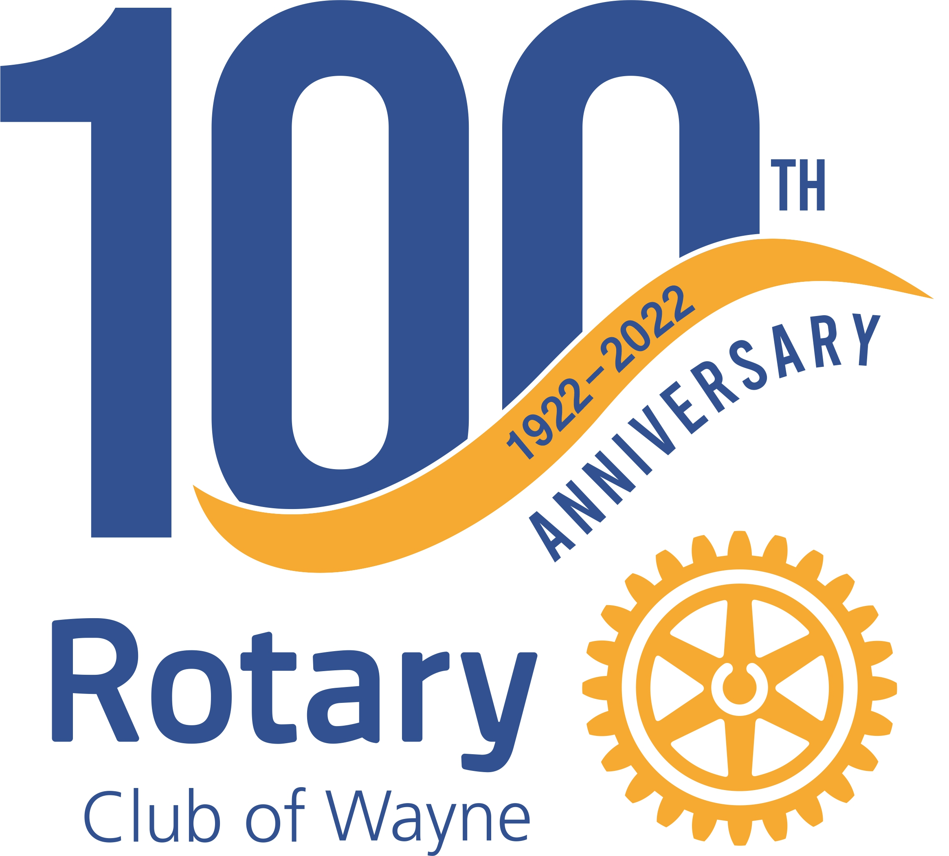

Email: waynerotary@gmail.com

