NorthStarMastFinal

March 14, 2013

Editors: Tammy Broderick and

Char Luttrell

Meeting Thursdays

at Noon at the

Holiday Inn

Near the University of Michigan

Service Above Self

RCAAN Board

of Directors

*President:*

Laura Van Steenis

*President Elect:*

Keith Krings

*Past President:*

Matt Copeland

*Secretary:*

Gail Scott

*Treasurer:*

Mary Gyorke

*Director,*

*Club Administration:*

John Arenz

*Director,*

*Rotary Foundation:*

Bob Overhiser

*Director,*

*Public Relations:*

Tamra Ward

*Director,*

*Service Projects:* Manish Mehta

*Director,*

*Membership:*

Bryan Schindel

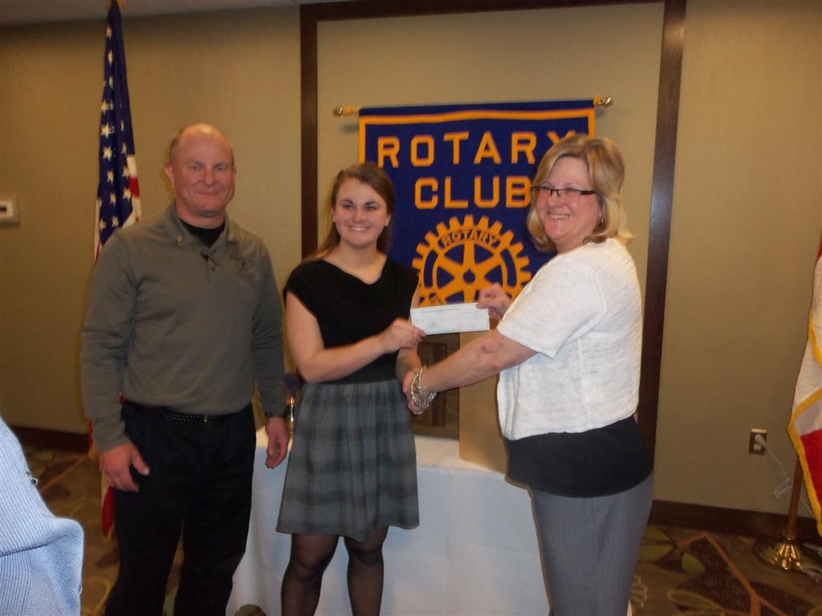

RCAAN Supports Girl Scout President Laura Van Steenis announced that our club will support Nicole Krings’ Girl Scout Gold Award Project with a $500 grant. Nicole’s dad is our President-Elect Keith Krings. Nicole, our speaker, was our only guest this week, welcomed by Gail Scott.

50/50 Winner

John Arenz sold the winner to Jeff Crause.

RCAAN is Back on Clubrunner

Thanks to Scott Nelson for restoring our website and to Eric Tindale for keeping our site up-to-date each week. Great Rotary North teamwork!

District Conference April 25-26

President Laura reminded us about the Rotary District 6380 Conference at the Royal Park Hotel in Rochester. The hotel is completely booked, but rooms are available at other hotels in Rochester. Our board of directors is subsidizing club members’ attendance at the conference with $150 grants.

Sympathy to Bob Greenough

Bob Greenough lost his older brother recently. He attended the funeral March 13. Bob read a tribute to his brother that he had shared at the service. We are sorry for your loss, Bob.

B.A.B.E.S.

We saluted Gail Scott’s birthday and Matt Copeland’s club anniversary.

Back to the 80s April 20

Our Back to the 80s fundraiser is set for April 20 at the Holiday Inn ballroom. Don’t forget to sell your little blue raffle tickets, or turn them in to Tammy and Don Broderick, so that other club members can get more tickets to sell. Please send in your dinner reservations as soon as you can.

Tamra Ward needs photos of us in the 80s by April 13. Give yours to her with a self-addressed envelope, so she can return them. For some of our newer members, nursery school photos or prenatal ultrasound prints may be the only photos available, but most of us can dig up some 80s gold!

UPCOMING PROGRAMS

Mar 21 Don Faber

Author

Michigan’s First Governor

Apr 18 Claire Zepeda

Sailing

Apr 25 Sean Reed

Clean Energy Coalition

PROGRAM RECAP

*Nicole Krings, daughter of President-Elect Keith Krings, spoke to us about her Girl Scout Gold Award. Nicole is a member of the National Honor Society at Northville High School*

The Gold Award is the highest award a girl can achieve in Girl Scouting, the equivalent of the Eagle Award in Boy Scouting. Nicole explained the process of identifying an issue or problem, investigating solutions, recruiting help from the community and raising funds to make the project a reality. The Gold Award requires 80 hours of community service.

Nicole chose to build simple musical instruments for the children at the Penrickton Center for the Blind. The Penrickton Center is a nonprofit day care and residential care facility for children who are blind and have other disabilities. The center was founded by three families to provide care for their own children in 1952.

Nicole raised funds for the instrument kits by conducting drives for scrap metal and deposit soda cans. She also donated her own babysitting money. With the help of her father, she learned how to work with wood to construct a Cajon drum and a Strumbly guitar. She plans to build and deliver four more instruments to the Penrickton Center, as funds become available.

Songs

Scott Nelson led us in singing “An Irish Lullaby” and “When Irish Eyes Are Smiling.” Bryan Schindel offered the invocation and Lisa Spaulding led us in reciting the Rotary Four-Way Test.

Happy Dollars

Lisa Spaulding Her first happy dollar –

After a health scare in her family all are doing well.

Jeff Crause Jeff’s daughter has been accepted into the dance program at the University of Michigan!

Brent Lofgren Brent wanted to know if all Irish songs are sung to the same tune. Kelly said it’s probably easier to sing them in the bar that way!

Manish Mehta Saline Rotary Club will support Project Dignity.

Char Luttrell Char brought greetings from Dexter Rotary Club, where Lori Sprague has just returned after treatment for cancer.

The Ms. Molly Foundation is at 96 percent of its June 30 fundraising goal.

Char’s daughter surprised her and joined her at the Molly Maid convention in Phoenix last week.

Kelly Mendenhall Kelly hopes to have a new job by next week.

Don Broderick Don chooses to be happy.

Laura Van Steenis We have a new pope!