PROPOSAL
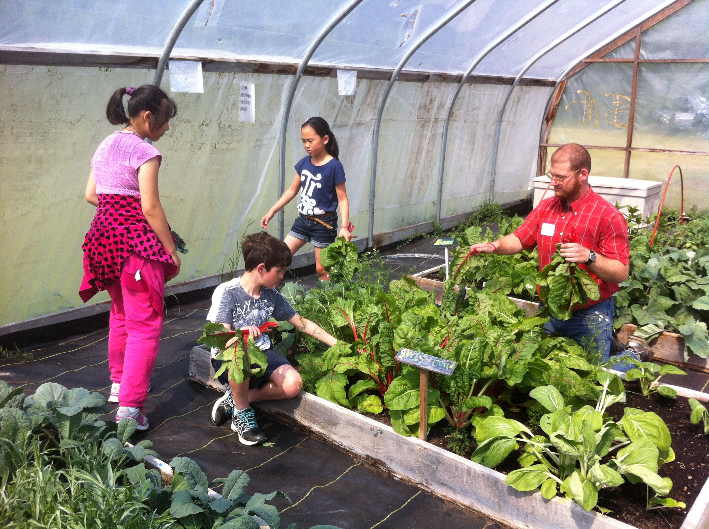
The Agrarian Adventure is the steward of a hoophouse erected in 2006 at Tappan Middle School, with generous support of community members, and the Ann Arbor Farm and Garden Association. This hoophouse has been utilized as a winter garden for students, a hub for seedling production and distribution, and as a growing site for students at Tappan (with particular leadership from those in the afterschool Food & Garden Club). Over the ten years since it was built, produce from the hoophouse has found its way to classroom and outdoor tastings, school cafeterias, student-prepared meals, the homes of Tappan families and garden volunteers, fundraiser events, local businesses, the Backdoor Food Pantry, and Food Gatherers.
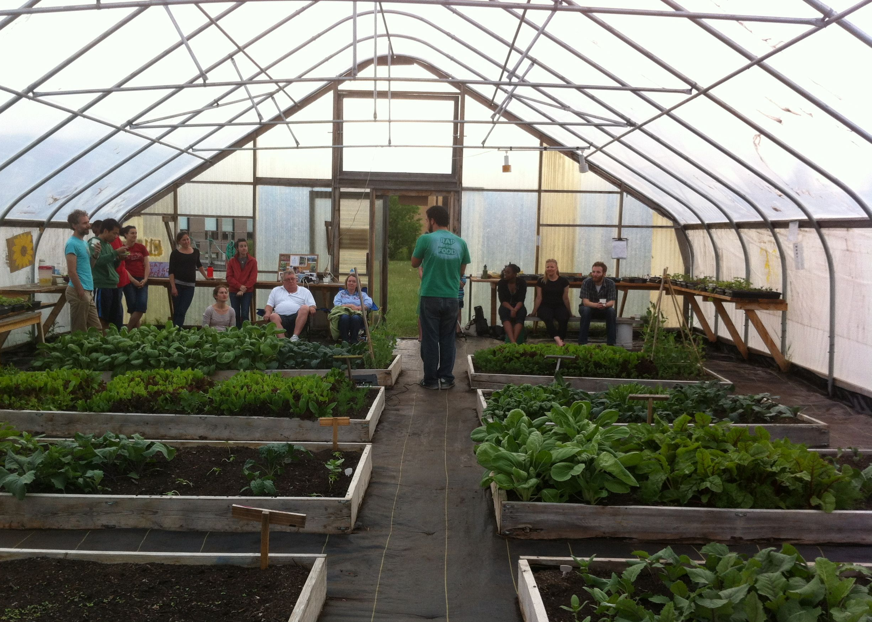
The hoophouse is a 30ftx48ft Ledgewood (semi gothic) with extended ground posts. Inside there are 10 wood framed planting boxes 8 inches deep (5 that are 4ftx8ft; 5 that are 4ftx12ft) for a total in ground planting area of 400ft². The remainder of the floor is covered in woven poly landscape fabric to suppress weeds. The Agrarian Adventure proposes to partner with The Rotary Club of Ann Arbor to restore this hoophouse as a resource for students starting in spring 2017. The restored hoophouse will be used for the Tappan Food & Garden Club, as well as a field trip site and resource for new garden clubs at three additional middle schools in the Ann Arbor Public School District. It will also serve as a site for the school garden seedling distribution program run by the Agrarian Adventure, which provides spring transplants free of charge to a dozen schools. Also included in this proposal budget are funds to support the Club Coordinator as well as materials to complete the partial deer fence around the adjacent Tappan Garden. We ask the Rotary Club to consider this proposal in full and to let us know what level of support is the best fit for them.

BUDGET
ITEM | DESCRIPTION | COST
Lumber for baseboards | Ten 2”x10”x10’ severe weather treated lumber | $147.70
Lumber for hipboards | Ten 2”x4”x10’ severe weather treated lumber | $60.20
Lumber for raised beds | Twenty 2”x12”x8’ severe weather treated lumber | $299.40
Lumber for raised beds | Ten 2”x12”x12’ severe weather treated lumber | $232.70
Lumber for raised beds | Eight 4”x4”x8’ | $79.70
Landscape fabric | Promat 6’x300’ landscape fabric | $238.57
Greenhouse plastic to recover sides and roof of hoophouse | 5.2 oz clear prefabricated panel, 35’x50’ | $559.00
Material for rear door | 36x72 clear acrylic sheet | $69.93
Screen for rear door | Magnetic mesh screen | $12.00
Material for rear vent | 6mm 4x8’ polycarbonate sheet | $54.95
Fence materials | Wood posts, wire, fenching, gates, hardware and post-hole digger rental | $600
 | TOTAL | $2354.15

