Rotary Club of Belleville – Service Above Self
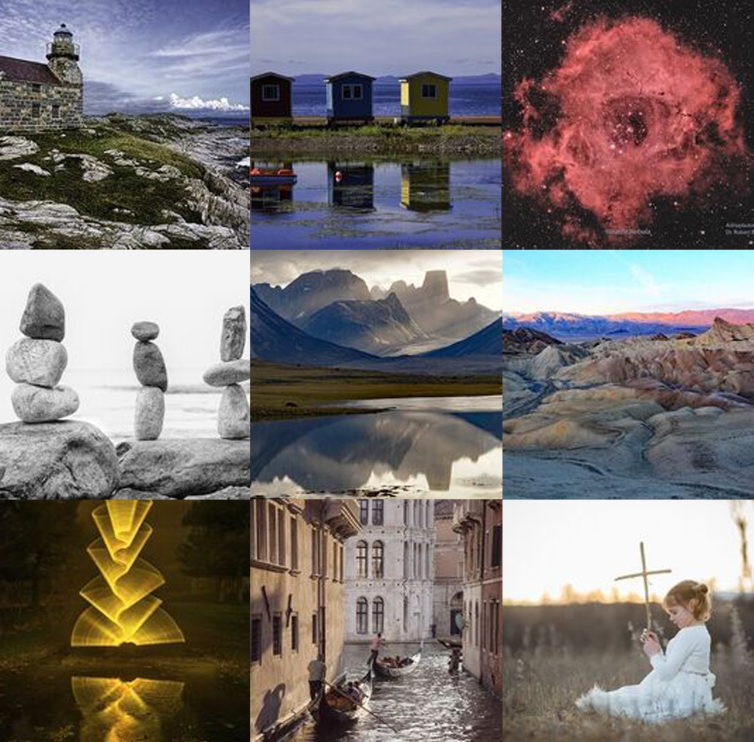
Thank you Rotarian Lola Reid Allin and all photographers for stepping up to make things better during the pandemic.
Photographers Stephanie Trattner and Lola Reid Allin have gathered a group of 29 Quinte area photographers to create a WIN:WIN fundraiser. Photographers donate an image, sell it online for $75 with all proceeds donated to BGH Foundation Front Line Workers. Purchasers get a beautiful photograph and BGH receives much needed funds.
Go to https://www.photosforbgh.com
This project has been extended to May 10th, 2020. A great gift suggestion for Mother’s Day as Mom will receive a beautiful photograph and know that much needed funds have been provided to BGH Foundation Front Line Workers.

