Rotary Club of Belleville
invites you to participate in a
KAIROS Blanket Exercise Workshop
April 14, 2018 – 10:00 a.m. to 12:00 p.m.

The KAIROS Blanket Exercise is a workshop that explores the nation-to-nation relationship between Indigenous and non-Indigenous peoples in Canada. It is an interactive learning experience that teaches Indigenous rights history. Developed in response to the 1996 Report of the Royal Commission on Aboriginal Peoples which recommended education on Canadian-Indigenous history as one of the key steps to reconciliation, the Blanket Exercise covers over 500 years of history in a one and a half hour participatory workshop.
Blanket Exercise participants take on the roles of Indigenous peoples in Canada. Standing on blankets that represent the land, you will walk through pre-contact, treaty-making, colonization and resistance. Nicole Patterson, a trained Blanket Exercise facilitator, will act as a narrator and the European colonizers. By engaging on an emotional and intellectual level, the Blanket Exercise effectively educates and increases empathy. The exercise is followed by a talking circle debriefing session.
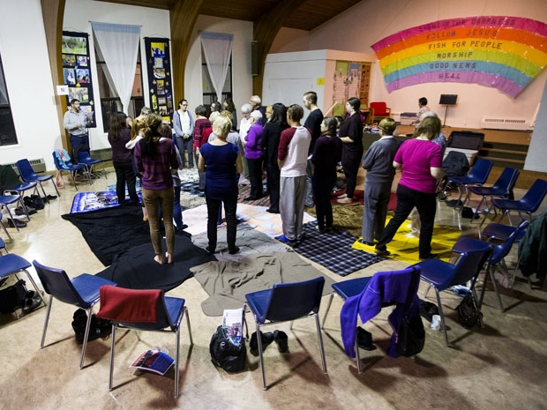

Date: April 14, 2018
Time: 10:00 a.m. – 12:00 p.m.
Location: Bridge St. United Church
60 Bridge St E
Belleville, ON K8N 1L7
Cost: $20 per person - all proceeds to the Red Cedars Shelter in Tyendinaga
Registration: in advance is required as spaces are limited
Contact: Birgit Wartenberg, b.w.wartenberg@gmail.com or 613-771-0075

