

The Lantz August in Review2026

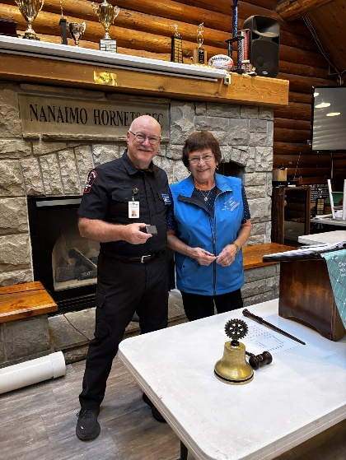
⭐ Celebrating Norm Smith’s Latest Paul Harris Milestone
Our club is delighted to recognize Norm Smith, who has once again reached a remarkable milestone in giving. Norm has received another Ruby Paul Harris Fellow, a distinction that reflects not only sustained generosity but a deep and unwavering commitment to the work of The Rotary Foundation.
Each additional ruby represents continued support for life-changing projects in education, health, peacebuilding, and community development around the world. Norm’s ongoing contributions strengthen Rotary’s impact and inspire all of us to keep striving toward a more hopeful, resilient future.
Please join us in congratulating Norm for his extraordinary dedication and for leading by example in Service Above Self.

Rotary Meeting- August 13th, 2026
The War in Ukraine
Our speaker, Robert (Bob) Aspen’s family emigrated to Canada in 1929. On a regular basis, he is in contact with family and friends and prepares carefully researched updates on the Ukraine conflict to interested observers.
In his presentation, Bob spoke about the 1932-1933 ‘Holodomor’ that left 2-4 million Ukraine farmers and families killed by starvation. Memory of that tragedy fuels the animosity of Ukrainians toward Russia and is the backbone behind the Ukrainians resilience to the Russian invasion.
Millions of people have left Ukraine for Poland, Hungary, Slovakia and other countries. Sirens happen 4-5 times a day. Electricity flows perhaps 4 hours a day. Personnel losses (killed, wounded & captured) are staggering – 1.5 million Russians, 760,000 Ukrainians - tragedies for both sides in a conflict that appears to be in a stalemate.
Bob concluded his presentation with a handout updating different facets of the war and encouraged us to reach out for more information and future fund-raising opportunities.

Rotary Meeting – August 20, 2026

Our speaker, Melissa Lavoie, who kindly stepped up at the last moment, initially grabbed our attention with details about the upcoming move for Loaves and Fishes into a much larger building on August 27th, 2026. Details and numbers like the following held our attention:
- Over 13,000 volunteers assisted during 2025;
- This branch is one of four in BC that receives a truck load of non-perishable food items from Food Bank Canada;
- There is a very wide distribution area, including Haida Gwaii, with an economic delivery system.

Then Melissa moved onto a new idea that is already in the works: the building of a (Rotary) kitchen in this brand new, spacious facility. In it –
- Food can be cooked so it will last longer/keep better;
- Volunteers and staff would have the use of the kitchen and could cook food that cannot be distributed as is;
- Space has already been allocated to house the necessary equipment whose placement a chef will oversee. Cost of the equipment is estimated to be $425,000 to $500,000

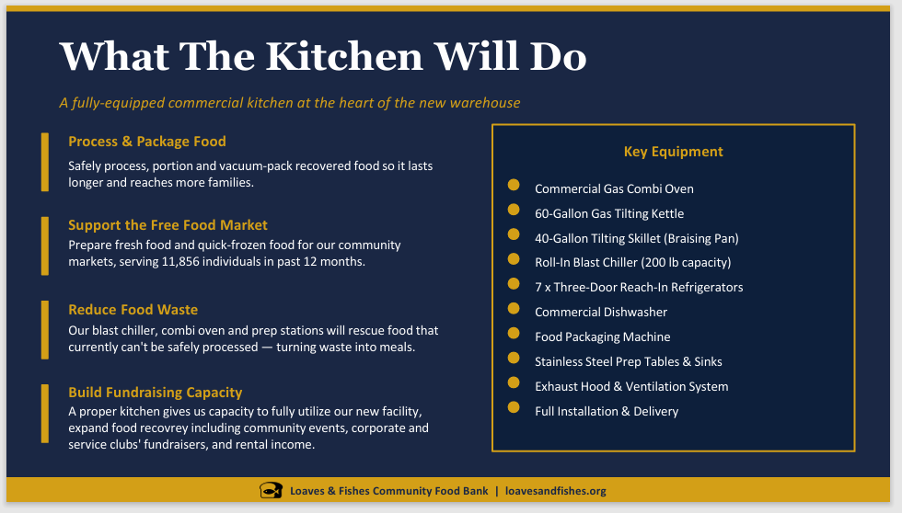Yep, all very exciting and our club will help in any way it can…

Rotary Meeting- August 27th
August 27th, saw new member Louise Bender deliver her classification talk to the Rotary Club of Lantzville. Louise shared a warm and engaging overview of her life’s journey, beginning with her roots in Kelowna, her upbringing in Merritt, and her decision to head out and explore the world.
Louise is happily married and the proud parent of two wonderful children. Her career path has been anything but ordinary—she has sold Cadbury chocolate out of an RV, worked in the unique world of ice sculptures, spent meaningful time in the non-profit sector, and most recently has found herself “finishing up—or sort of”—in Human Resources.
Her story highlighted creativity, adaptability, and a genuine commitment to people and community. Members appreciated the chance to learn more about Louise’s diverse experiences and the perspective she brings to Rotary.
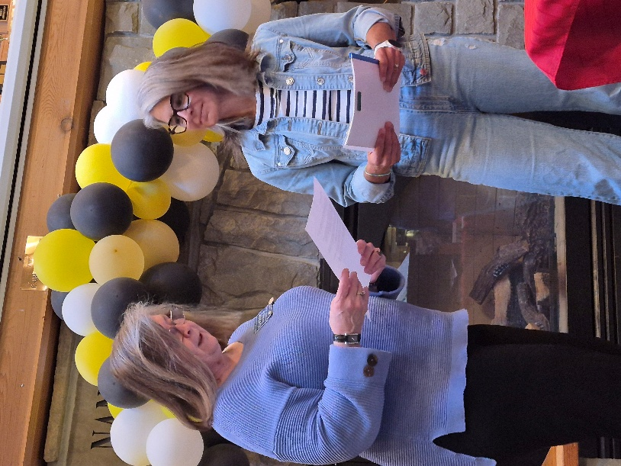

On Thursday, August 27th, the Nanaimo–Lantzville Rotary clubs came together for a joyful and energetic evening celebrating our Youth Exchange students—both current participants and returning alumni. The event, held as a BBQ fundraiser, brought members, families, and students together to share stories, reconnect, and support the life-changing Youth Exchange program.
The evening highlighted the confidence, growth, and global perspective these young leaders gain through Rotary’s international exchange opportunities. Alumni reflected on their experiences abroad, while current students shared their excitement for the year ahead. The sense of community, mentorship, and international goodwill was felt throughout the event.
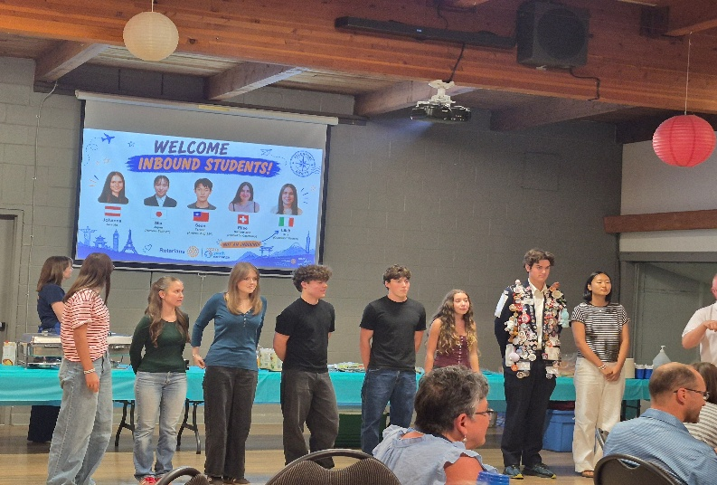
A heartfelt thank-you to everyone who attended, volunteered, and contributed. Your support ensures that future students will continue to experience the transformative impact of Youth Exchange.

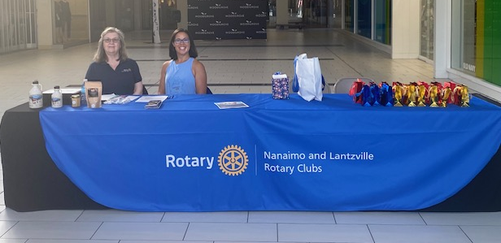
Fitness for a Purpose – August 29 & 30
On August 29th and 30th, Rachel Robertson is spearheading an exciting new fundraiser, Fitness for a Purpose, in collaboration with Woodgrove Centre. This two-day community event will raise funds in support of NeuroSplash, the Nanaimo White Rapids Swim Club’s specialized one-on-one swimming program designed for neurodivergent children.
NeuroSplash is entering its third year of programming and continues to provide a supportive, inclusive, and confidence-building environment where every child can learn essential water safety and swimming skills. Funds raised through Fitness for a Purpose will help ensure this valuable program continues to grow and serve families across Nanaimo.
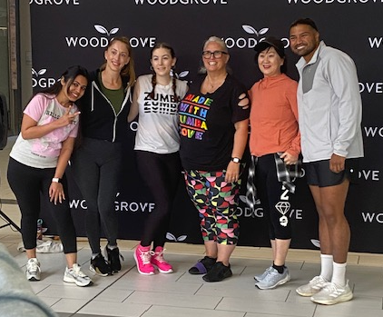

Fundraising for Wounded Warriors – August 29
On August 29th, the Rotary Club of Lantzville, in collaboration with the Lantzville Fire Department, supported the 4th Annual Vancouver Island Charity Firefighter Slo-Pitch Tournament by selling 50/50 tickets throughout the day.
This tournament, held in support of Wounded Warriors Canada, brings together firefighters, first responders, and community partners to raise funds and awareness for mental-health programs serving Veterans, active service members, and first responders.
Our club’s participation added meaningful support to the event’s fundraising efforts, and we were proud to stand alongside our local fire department in championing this important cause.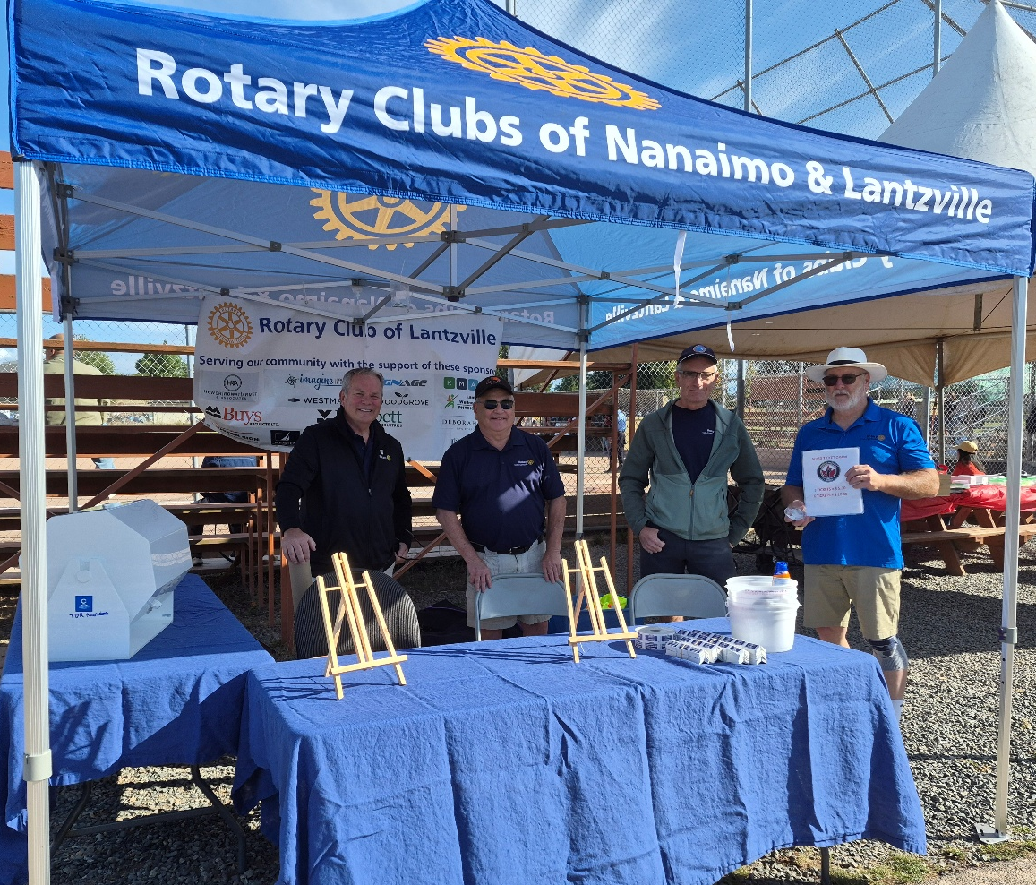
First team setting the 50/50.

Birthdays

Mark Taylor Sept 1st
Lee Rowley Sept 19th
Stephen Cochrane Sept 28th

Upcoming Speakers
September 4th Jacqualine Salvino Nanaimo Youth Services
September 10th Sarah Branley Habitat for Humanity
September 18th Joanne Swain Nananimo SAR
September 25th Scouts presentation

2026 ROTARY CLUB OF LANTZVILLE DUTY ROSTER
September 2026
If the date you are assigned does not work for you, please ask someone to take your task

DATE | Greeter | Cash | Sgt. Arms | INTROS | INSPIRATION | ROTARY  MINUTE
Sep 3 | Leanne | Jo-Anne | Doug S. | Dale | Rachael | Brian
Sep 10 | Alexis | Trevor | Doug V. | Lee | Michael | Dale
Sep 17 | Kay | Joy | Brian | Jodie | Sheila | Greg
Sep 24 | Jo-Anne | Mark | Greg | Rachel | Jan | Cor

For any additional news about The Rotary Club of Lantzville, please visit our Facebook Page:
https://www.facebook.com/RotaryClubofLantzville/

Labour Day (Monday September 7th)
This Photo by Unknown Author is licensed under CC BY
National Day of Truth & Reconciliation (Wed Sept 30th)
Happy Reading, Cheers

