

The Lantz December 2025
President’s Christmas Message

As we begin to celebrate the Christmas season, I want to extend my heartfelt thanks to each of you. This past year brought its share of hard work, trials and unexpected turns – yet every time, our club rose to the occasion. Your dedication, resilience and willingness to step in wherever needed have been nothing short of inspiring.

What truly sets our club apart is how well we work together. The camaraderie we share, the laughter, the encouragement, the helping hands is the spirit of Rotary at its finest. Whether we were tackling projects, navigating challenges or simply showing up at meetings, we proved time and again that we’re stronger together.

As we look ahead to a brand-new year, I feel optimistic. If the past year has shown us anything, it’s that we can meet whatever comes our way by pulling together with the same teamwork, heart and good humour that define our club.

Wishing you and your loved ones a joyful Christmas and a bright, hopeful New Year. Thank you for everything you do. Here’s to another year of service and friendship.

November 2025 Highlights
November 16th: Grey Cup Saskatchewan 25 – Montreal 17
Thank You Greg for organizing the pool and raising $300 for the club.
November 22nd: Rotary Lights at NRGH work party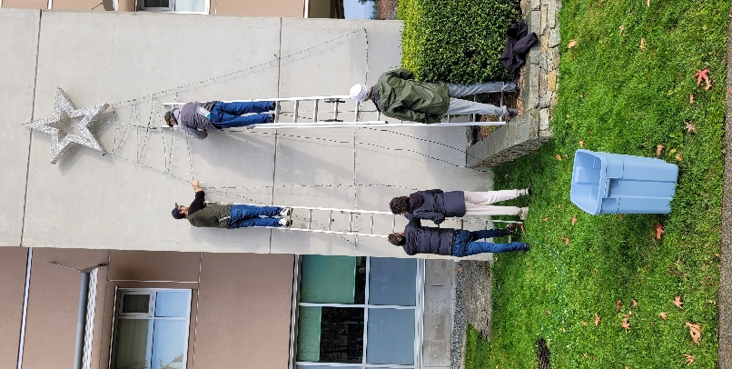 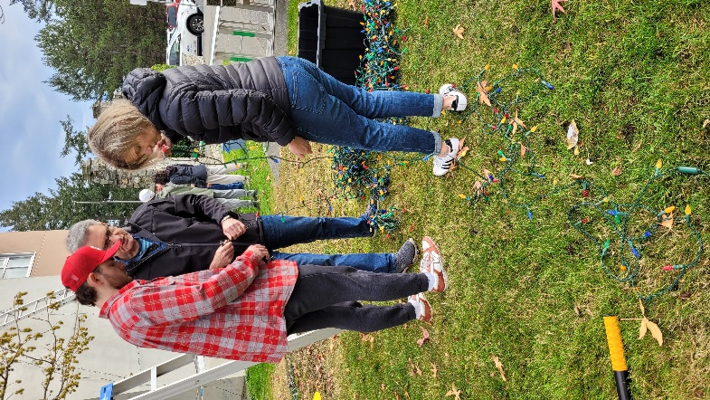
November 29th: Men’s Rugby Game 4PM (Shepherds Pie /Serving 60 People)
November 30^{th:} Lantzville Firefighters Annual Food Drive

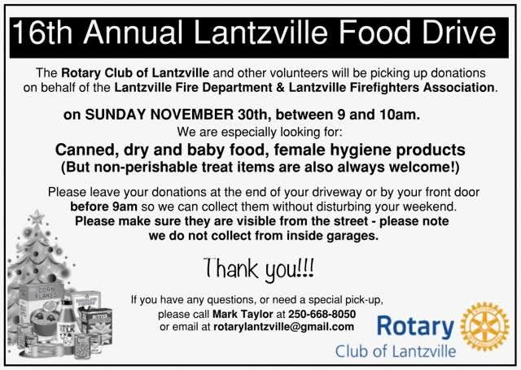
Upcoming Events for December

Dec 6th: We are again sponsoring a Salvation Army Kettle and will be working the Kettle from 9:00 am until 5:00 pm at Canadian Tire on December 6th.
Please contact Dale for any available timeslots!

Dec 9: Rotary Club of Lantzville Christmas Party
Inviting you, family & our Rotary friends to join us on Tuesday, December 9th, 5:30 - 8:00 pm at Simon Holt Restaurant for our Christmas social.

This has always been a fun casual evening and a great opportunity to connect and re-connect with our extended ‘Rotary’ family.

The venue is the private dining room at Simon Holt. Menu is an assortment of appetizers, dessert, pop, coffee, water & a no host bar.
accordingly.

Cost @ $ 20 per person is payable in advance or at the door. No charge for children.

If you decide to go, Please RSVP Joy


Dec 11th:
Our bi-monthly business meeting and the AGM where we will vote on the 2026 executive team. Please mark your calendars

Dec 18th Youth Exchange Students

Dec 25: Christmas

Birthdays and Anniversaries
Birthdays Anniversaries

Dec 5 Ralph Lemmon None
Congratulations Ralph.

2025 ROTARY CLUB OF LANTZVILLE DUTY ROSTER
December 2025
If the date you are assigned does not work for you, please arrange for
someone to take your task

DATE | Greeter | Cash | Sgt. Arms | INTROS | INSPIRATION | ROTARY  MINUTE
Nov 27 | Stephen | Trevor | Doug S | Jodie | Sheila | Mark
Dec 4 | Michael | Jo-Anne | Brian | Jan | Lee | Leanne
Dec 11 | Brian | Joy | Doug S. | Norm | Rachel | Dale
Dec 18 | Dale | Mark | Lance | Ralph | Alexis | Doug

For any additional news about The Rotary Club of Lantzville, please visit our Facebook Page:
https://www.facebook.com/RotaryClubofLantzville/

Chrismas Quote: “Love the giver more than the gift”-

Happy Reading. Cheers!

