

The Lantz February 2026

President’s Message

As we head into the second month of the year, there’s plenty to look forward to - socials, raffles and getting our steps in for charity. February may be short, but it’s already shaping up to be a busy and fun one for our club.

Dale has the Super Bowl raffle well in hand and ready for kickoff on February 8. Thanks Dale, for taking the lead and keeping the excitement (and ticket sales!) rolling along.

Michael and Joy have also been hard at work arranging an upcoming social – a Mix and Mingle (with pizza!) hosted by Joy and George on February 15. It’s a great opportunity to relax, connect and enjoy each other’s company outside our regular meetings, so be sure to mark you calendars.

Coldest Night of the Year is back! This year’s walk takes place on February 28. Last year, Nanaimo raised an incredible $114,000 and this year the goal is $125,000. So, sign up, strap on your walking boots and let’s help push that total even higher.

And last but not least, Lance, our President Elect, and Jodie as Assistant Governor will be heading to PELS at the end of February. We wish them well as they prepare for the year ahead and represent our club.

As always, thank you to everyone who continues to step up, lend a hand and bring such great energy to our club. Here’s to a positive, active and enjoyable February ahead.

January 2026 Highlights
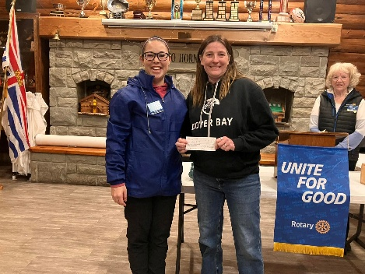
Funds for Bus passes were donated to Karen from Dover Bay Secondary School.
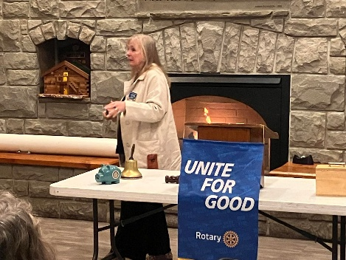
Our own Shawn Kilner from Imagine Cruise &Travel sharing the ins and outs of the travel industry with our club

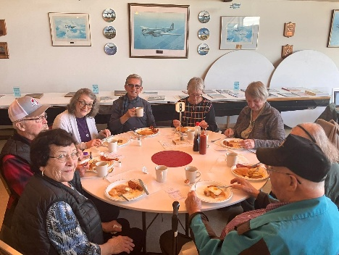 Members of our club having Breakfast at 808 (Thunderbird) Wing RCAFA

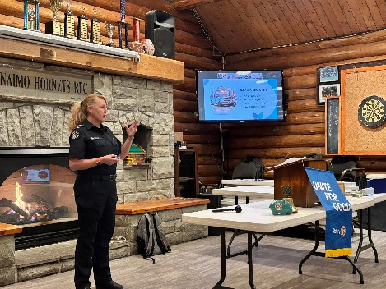
Cassie Stephenson from BC Emergency Health Services spoke about the fleet and the wonderful paramedics who are there for all BC residents 24/7.

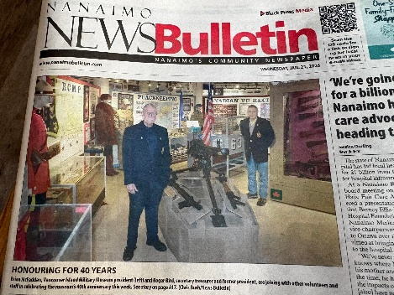
Our own Brian Mc Fadden Headlined the Nanaimo Bulletin Celebrating 40 years of the Vancouver Island Military Museum

Upcoming Events for February
Feb 8 Super Bowl: Seattle Seahawks – Los Angeles Rams (start 4:30 PM)

Feb 14 Valentines Day

Feb 15 Valentines Mix and Mingle at Joy and George’s home 1-3 PM. 113 Cheryl Place, Nanaimo. (Pizza provided – BYOB)


Birthdays and Anniversaries

February 2nd Michael Ribicic
February 5th Trevor Lee
February 15th Janice Stromar
Happy Birthday!

Upcoming Speakers

Feb. 5th Business Meeting
Feb 12th Maria Martens Island Kids First
Feb. 19th Mic McDaniel Rotary Club of Tacoma (Zoom )
Feb 26th Ralph Lemmon Collision/ repair Industry

2026 ROTARY CLUB OF LANTZVILLE DUTY ROSTER
January – March 2026
If the date you are assigned does not work for you, please ask someone to take your task
 | Greeter | Cash | Sgt. Arms | INTROS | INSPIRATION | ROTARY  MINUTE
JAN 8 | Stephen | Jo-Anne | Brian | Jodie | Lance | Leanne
JAN 15 | Ralph | Joy | David | Lee | Stephen | Rachel
JAN 22 | Leanne | Mark | Greg | Alexis | Janice | Douglas
JAN 29 | Don T. | Trevor | Douglas | James | Doug S. | Mark
FEB 5 | James | Jo-Anne | Lance | Stephen | Norm | Lee
FEB 12 | Michael | Mark | Doug S. | Leanne | David | Janice
FEB 19 | Trevor | Joy | Brian | Rachel | Michael | Alexis
FEB 26 | Greg | Trevor | David | Greg | Leanne | Lance
MAR 5 | Brian | Jo-Anne | Greg | Trevor | Jodie | Joy
MAR 12 | Dale | Mark | Douglas | Michael | Lee | Norm
MAR 19 | Jo-Anne | Joy | Lance | James | Rachel | Dale
MAR 26 | Norm | Trevor | Doug S. | Joy | Alexis | Doug

For any additional news about The Rotary Club of Lantzville, please visit our Facebook Page:
https://www.facebook.com/RotaryClubofLantzville/
Valentines Quote: “To love and be loved is to feel the sun from both sides”
Happy Reading. Cheers!

