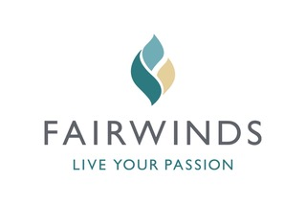
BE A PLAYER




REGISTRATION IS EASY

By Email: brsparkes@telus.net
By Mail: Complete form and send with payment to: Barry Sparkes, 3992 Gulfview Drive,
Nanaimo, BC, V9T 6B5 (250.756.2690)

Players
Name | Email
Click here | Click here
Click here | Click here
Click here | Click here
Click here | Click here

Team Captain
Name:Click here to enter text.
Phone:Click here to enter text.

Amount Enclosed: $Click here to enter text.

Cheque – Payable to “Rotary Club of Lantzville”
☐Visa
☐MasterCard

Credit Card # Expiry

Signature
Enter a Team or
$150 per Person

Four – Person Scramble Includes:
- 18 Holes of Golf
- Fantastic Barbecue Dinner
- Team Prizes (Men’s, Ladies and Mixed)
- Longest Drive – Men’s and Ladies’
- Hole-in-one Prizes
- Ken Barker Memorial Trophy for Low-Gross Team
- KP’S
- Golf Cart
- Rotary Two Bit Trophy for Low Gross Rotary Team

Fairwinds Golf Club
Friday, June 2, 2017
1:30 PM tee-off
Contact: Don Tamelin
250.618.5292
don.tamelin@cccu.ca

Early Bird Draw –

Deadline May 19, 2017
All registrations received and paid for prior to May 19, 2017 will have a chance to win two – 18 hole green fee passes to Fairwinds
Sponsors’ Team Check Here:
☐Gold Sponsor – 4 players
☐Silver Sponsor – 4 players
☐Bronze Sponsor – 2 players
HOSTED BY:
Rotary Club of Lantzville

VISIT us at
http://portal.clubrunner.ca/675

