


The Lantz June 2026

A word from your President
As May winds down, our little club continues to chug along in true Rotary fashion – staying busy, lending a hand and having a few laughs along the way.
Our volunteers have continued supporting Loaves and Fishes, setting up our new storage unit and helping in our community, proving once again that many hands really do make light work. Whether sorting, lifting, transporting or organizing, our members continue to show what community service is all about.
We are also very pleased to induct a new member this month, Louise Bender, into our Rotary family. Welcome, Louise. We are excited to have you join our energetic and dedicated group, and we look forward to working alongside you in the years ahead.
Preparations are now in full swing for Foam Fest on May 30. If all goes according to plan, the participants will have a great time – and a very wet one! Thank you in advance to everyone volunteering to help make this event another fun and successful day.
At the same time, we are preparing for another important event – the “passing of the torch” from myself to incoming 2026/27 President, Lance Stephenson. Our installation evening will be held at the Lantzville Legion on June 24, where the new president and executive will officially be welcomed. While there will be a few new faces stepping into roles, we are fortunate that several committee members have generously agreed to stay on for another year to provide continuity and support. The new executive will be ready to hit the ground running on July 1.
As I reflect on this past Rotary year, I want to extend my sincere thanks to my executive team. Your hard work, support, flexibility and willingness to pitch in whenever needed helped ensure the year ran smoothly. Most importantly, we worked together as a team, and that spirit of cooperation is what makes our club so special.


Thank you as well to every club member and spouse who volunteered their time, energy, ideas and enthusiasm throughout the year. Small clubs accomplish big things when everyone pulls together, and this club has certainly proven that time and time again.

May 2026 Highlights
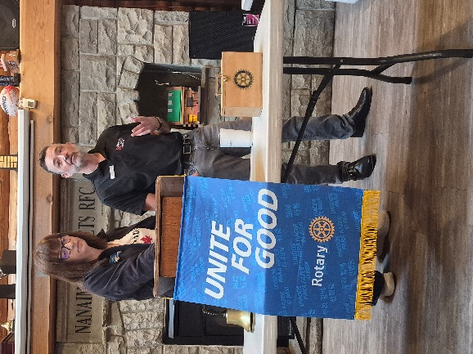
Presentation: Jan and Tom Stromar – DRIPA and Real Estate
Jan Stromar and her husband, Tom Stromar, provided an overview of the Declaration on the Rights of Indigenous Peoples Act (DRIPA) and its relevance to the Real Estate sector. They outlined the history of how DRIPA came into effect in British Columbia and discussed the resulting impacts on land use, consultation processes, and industry practices. Members appreciated the clear explanation of this evolving area of provincial policy.

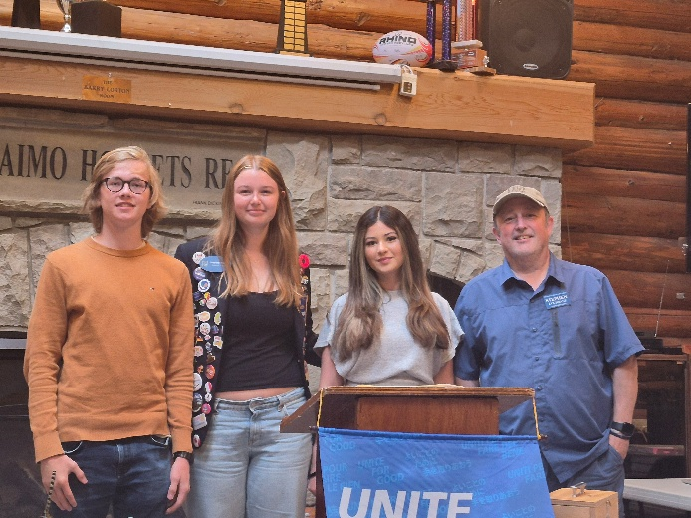

Rotary Youth Exchange Students Share Their Year in Canada
Our three Rotary Youth Exchange students joined us this week to share reflections on their exchange year. Each student introduced themselves, spoke about their home country and family, and highlighted the many experiences that shaped their time in Canada.
They described skiing, travelling to California and trying surfing, and taking part in a wide range of local activities throughout the year. Just as meaningful were the friendships they formed and the personal growth, they experienced along the way.
All three expressed deep gratitude for the opportunity and for the support they received from Rotary. Their stories were a wonderful reminder of the impact Youth Exchange has in building confidence, global understanding, and lifelong connections.

🌟 Supporting Our Community, One Organization at a Time
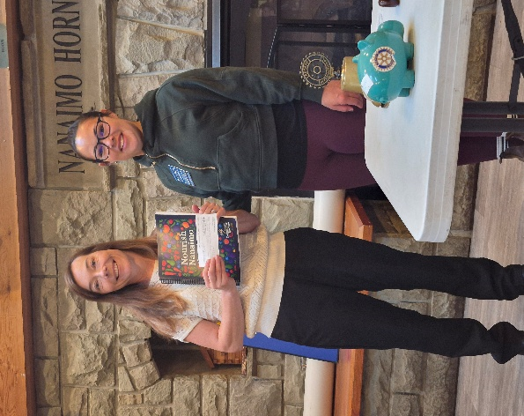
This month our club was exceptionally busy lending a hand to community organizations that make Nanaimo stronger. From Big Brothers Big Sisters to Nanaimo Community Kitchens, FoodShare, and Elder Dog — just to name a few — our members stepped up with enthusiasm and heart.
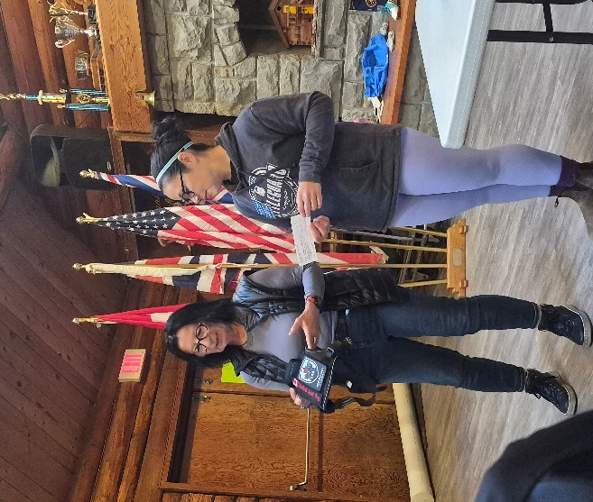
It is always a pleasure to support groups that are enhancing the lives of children, families, and seniors in our community. By working alongside these organizations, we help strengthen their
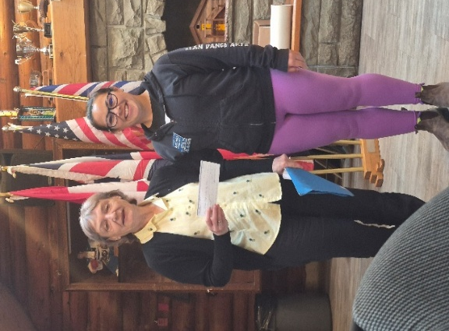
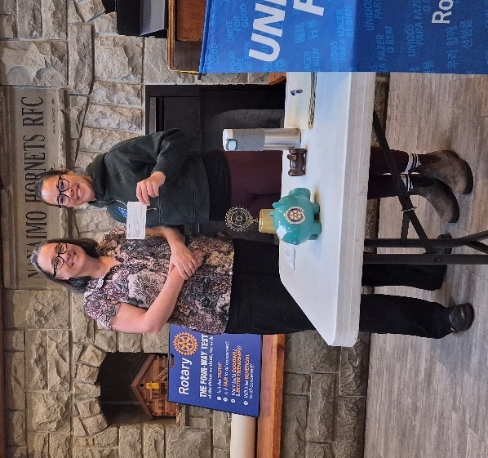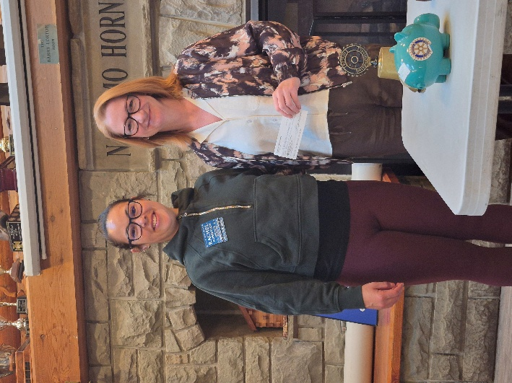
By working alongside these organizations, we help strengthen their programs and extend their impact, reflecting Rotary’s commitment to service above self.
And if all this wasn’t enough;
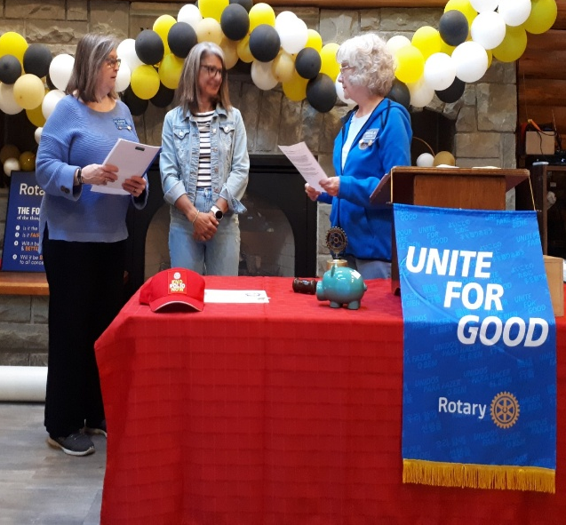 The Rotary Club of Lantzville is pleased to announce the induction of Louise Bender as our newest member. Louise’s commitment to community service and her enthusiasm for Rotary’s mission make her a wonderful addition to our club. We look forward to the contributions she will bring to our ongoing work locally and globally.

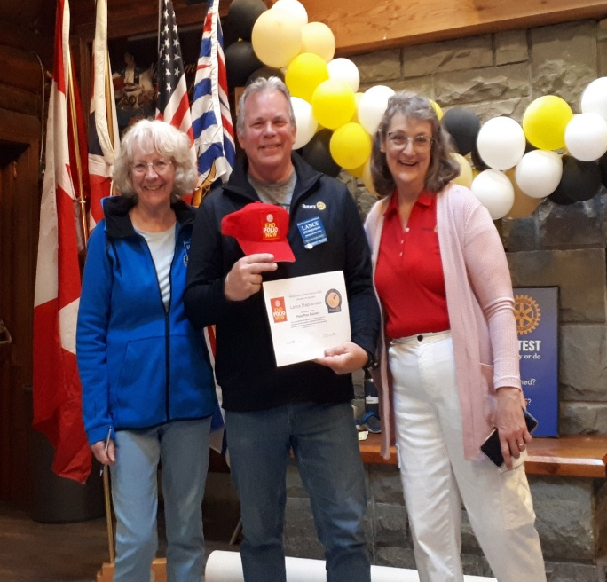
This month, we were also delighted to welcome two new members to the Polio Plus Society: Lance Stephenson and James Williams.
Their commitment strengthens Rotary’s global effort to end polio and reflects the spirit of service that defines our club.
Please join us in congratulating and thanking them for stepping forward to support this vital cause.

Our club was proudly represented at the 2026 Foam Fest in Lake Cowichan, where three of our dedicated members volunteered their time and enthusiasm. A great day of fun, foam, and community impact.


Upcoming Events for June
June 9th Loaves and Fishes (Contact Trevor if you would like to volunteer)
June 11th Departure Bay Sea Scouts are confirmed for bottle/recycle collection
June 24th Installation of President-Elect Lance Stephenson and the 26/27 Board of Directors
June 25th No Rotary Club Meeting

Birthdays

Jodie Williams- June 23rd
Lantzville Rotary- June 24th
Anniversaries
Lance and Cassie – June 15th

Upcoming Speakers
June 4th Business Meeting
June 11th Marina Martens Island Kids First
June 18th Kay Knox Classification Presentation

2026 ROTARY CLUB OF LANTZVILLE DUTY ROSTER

June 2026
If the date you are assigned does not work for you, please ask someone to take your task
DATE | Greeter | Cash | Sgt. Arms | INTROS | INSPIRATION | ROTARY  MINUTE
JUN 4 | Leanne | Joy | Doug | Jan | Lee | Jo-Anne
JUN 11 | Dale | Jo-Anne | David | Alexis | Joy | Michael
JUN 18 | Alexis | Mark | Lance | Michael | Jodie | Doug

For any additional news about The Rotary Club of Lantzville, please visit our Facebook Page:
https://www.facebook.com/RotaryClubofLantzville/

Happy Father’s Day (Sunday June 21st)

Happy Reading, Cheers

