

The Lantz April 2026

A word from your President
March may have come in like a lamb, but you certainly wouldn’t know it from our club’s perspective! We’ve been in a flurry of activity organizing and preparing for the shredding event on March 21. Thanks to everyone stepping up and following Joy’s lead, the day was a tremendous success – in fact, our best shredding event to date. Even the weather decided to cooperate, which felt like a win all on its own.
We were also pleased to welcome Sandy from the Nanoose Lions Club who joined us to observe the shredding operation and lend a helping hand. It was wonderful to connect, and she’s already looking ahead with enthusiasm to our joint shredding event coming up in June in Nanoose.
Of course, it’s not all work and no play – and we wouldn’t have it any other way. On March 14, about a dozen members gathered at the Lantzville Legion to celebrate St. Patrick’s Day in style. With hearty Irish stew, a tipple (or two) and an eclectic pipe band providing the soundtrack, it was a lively evening filled with laughter and camaraderie.
As the month winds down, it looks like March will go out as gently as it began, giving us a welcome bit of breathing space before our next big event. The Easter Egg Hunt is just around the corner, taking place on Easter Sunday at Seaview Elementary School. It’s always a highlight on our calendar and a wonderful opportunity to connect with our community.
Thank you all for your continued energy, teamwork and good spirit. Here’s to a fantastic finish to March and a fun-filled April ahead.

March 2026 Highlights
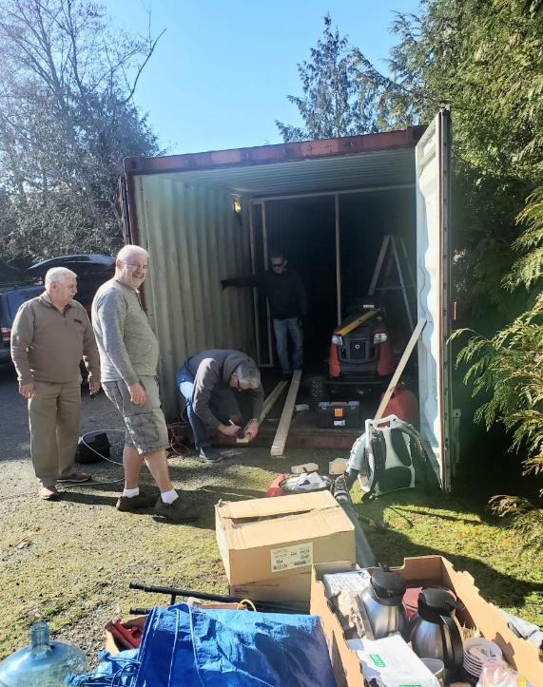
Club members were hard at work — some fixing up our new storage Sea can while others emptied and organized the Budget locker. It was a great example of teamwork in action and the kind of quiet effort that keeps our club moving forward. Thank you to everyone who pitched in.



James Williams is latest recipient of a Paul Harris Fellow. Congratulations James!

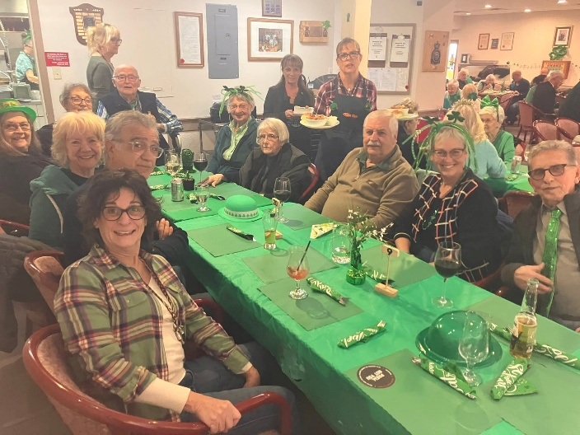

Several of our members met at the Lantzville Legion for St Patrick day get together. Cheers

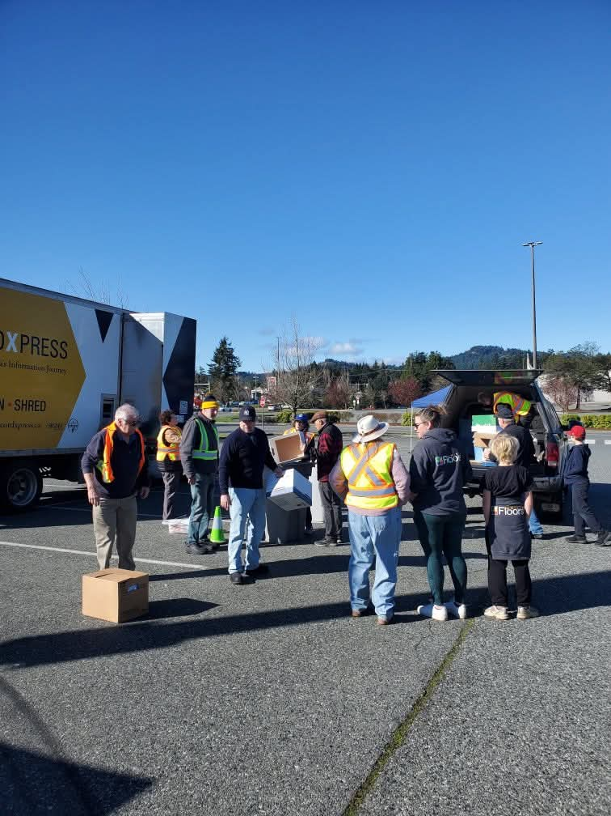
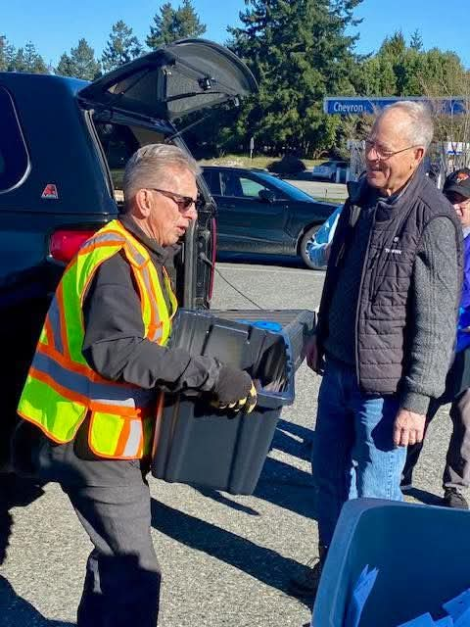
On March 21st the club had a very successful shredding fundraising event at the Woodgrove Mall parking lot. Thank you to all the members who donated their time!


Upcoming Events for April
Rotary Club of Lantzville Easter Egg Hunt April 5th, 1:00 PM at Seaview School


Birthdays and Anniversaries

Doug Slowski April 4th
Leanne Rose April 11th
Alexis Taylor-Vannatter April 16th
James and Jodie Williams celebrating their anniversary April 20th

Upcoming Speakers
April 2nd Business Meeting
April 9th Tamara Kronis MP
April 16th Jan and Tom Real Estate
April 23rd Sharon Speeval Elder Dog
April 30th Susan and David James Streamkeepers

2026 ROTARY CLUB OF LANTZVILLE DUTY ROSTER
April 2026
If the date you are assigned does not work for you, please ask someone to take your task
DATE | Greeter | Cash | Sgt. Arms | INTROS | INSPIRATION | ROTARY  MINUTE
APR 2 | Kay | Mark | Brian | Alexis | Douglas | Leanne
APR 9 | Stephen | Joy | David | Greg | Kay | Jodie
APR 16 | Michael | Trevor | Lance | James | Rachel | Mark
APR 23 | Norm | Jo-Anne | Greg | Jan | Cor | Dale
APR 30 | Leanne | Mark | Doug | Lee | Brian | Trevor

For any additional news about The Rotary Club of Lantzville, please visit our Facebook Page:
https://www.facebook.com/RotaryClubofLantzville/

Happy Easter (April 5-6)


Don’t miss out—be sure to register for a weekend that’s packed with fun, learning, and great connections!
 Happy Reading, Cheers

