


The Lance August 2025
A Word from Your President
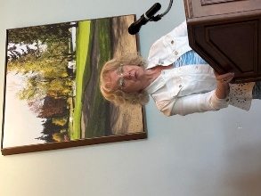

It is hard to believe we’re already a month into the new Rotary year—and what a month it’s been!
From the start, my goal has been to set a clear, energizing direction for the club: stay active, stay connected and make an impact together. We have a couple of new directors who bring fresh energy to the table, and with your support, we’re off to a strong start.
A special shout-out to David Lobay for surprising us with our new club mascot—the Rotary Pig.
It’s an old-school piggy bank with plenty of character. How are we going to fill it? What will the funds support? We haven’t decided yet. But if you know this club, you know we’ll find a way to turn it into something meaningful and fun.
One of the highlights so far was our annual BBQ—set against the stunning backdrop of Jim and Dianne’s property. Thank you both for your generosity in hosting us. Joy, Dale and Michael managed the logistics like pros, making sure the tents were up, the food was set, and the vibe was perfect. Jamal and Stephen staffed the grills like seasoned chefs, serving up a feast that matched the setting. It was one of those classic Rotary nights: good food, easy camaraderie and real connection.
We’ve also had a strong start to our speaker series. Thank you, Greg, for lining up such interesting voices. It’s been thought provoking, informative and it’s only getting better from here.
Looking ahead to Month #2, we’ve got work to do. Summer is packed with events that will need all hands-on deck—whether that means stepping up, pitching in or taking the lead. It’s what we do best.
We’ve always been a club that rallies, supports one another and gets the job done with a smile.
Let’s keep that energy going.
Here’s to a great month ahead. Go Lantzville!

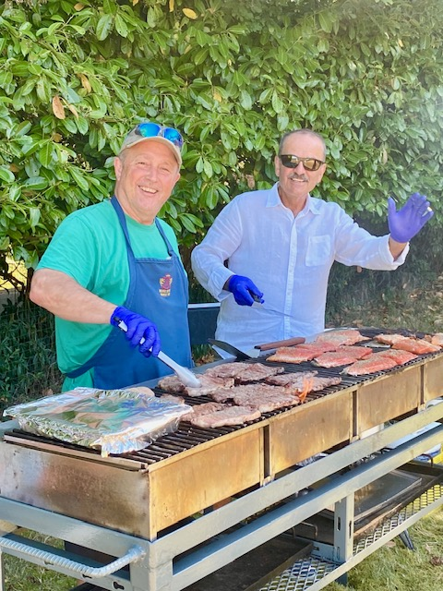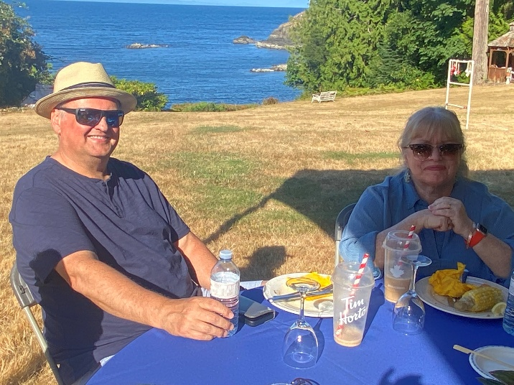
Summer Barbeque Pictures

Rotary international Convention 2025 in Calgary, Alberta

Rotary International Convention 2025: Calgary Welcomes the World
From June 21–25, Calgary played host to a truly global gathering as over 15,000 Rotarians from more than 120 countries descended on the city for the 2025 Rotary International Convention. Held at Stampede Park and the newly expanded BMO Centre, the event celebrated Rotary’s mission of service, peace, and international fellowship.
Themed “Magic All Around,” the convention featured inspiring keynote speakers including Academy Award-winner Geena Davis, Nobel laureate Tawakkol Karman, and WHO Director-General Dr. Tedros Adhanom Ghebreyesus. Attendees engaged in breakout sessions on topics ranging from climate action to AI in service work, while the House of Friendship buzzed with global project displays and cultural exchange.
The Areas of Focus Hubs in the House of Friendship were educational as well as inspiring. This is where you really begin to understand how large and far-reaching Rotary is.
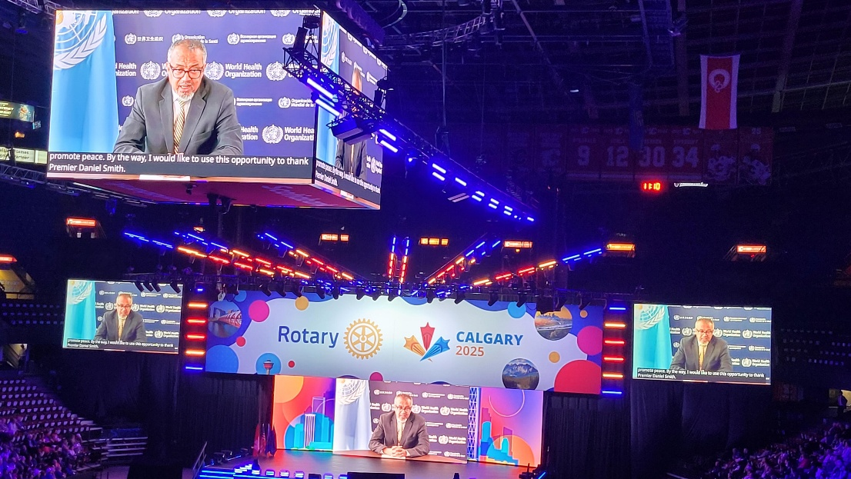

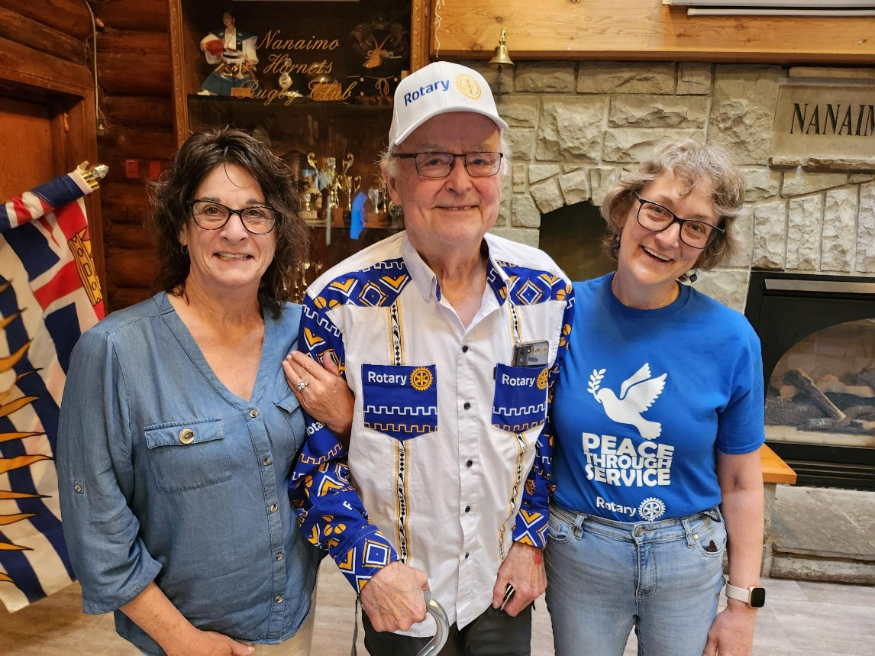
Leanne, James and Jodie back from Calgary

Calendar
On August 16, the Tour de Rock - Cops for Cancer will be holding the ‘Mock Tour’ for the 2025 Tour de Rock team. This years Mock Tour will kick off from Aspen Grove School, 7660 Clark Drive, Lantzville.

The Mock Tour is an opportunity for this year’s team to ride all together with a full police and medical escort. They will ride from Nanaimo to Duncan and return. They will leave Aspen Grove School at 9 am, make several stops on their way to Duncan and then ride back to Aspen Grove arriving around 5pm.

This year again, Lantzville Rotary will be volunteering to prepare and serve the dinner to the riders, support crew, family members and Rotarian's. We are looking for 10 volunteers to help set up and serve 16:00 to 19:00. Your commitment to this event in very much appreciated.

For more information, please contact Lance at 250-667-2912

Loaves & Fishes work Party is the second Tuesday each Month (Aug 12 5:00 – 7:00 PM)
Next Sea Scouts Bottle Drive is scheduled for August 21 and 28, 2025.
August 28, Welcome barbeque and Fundraiser for our Rotary Exchange Students.
Silent Auction Donations are much appreciated.
Location: Nanaimo Curling Club 6-8 PM. Cost $30.00

Speakers
Aug 7- Laura Shannon – SPOCA
Aug 14 - Kimberly Kelly
Aug 21 - Sully Macys – Kettle Bell Club
Aug 28 - Christine Douglas - Janico

Birthdays and Anniversaries this Month.
No Birthdays this Month.
Anniversaries:

Aug 5- Alexis and Douglas Aug 20 – Joy and George
Aug 7 – Norm and Kim Aug 21 – Mark and Helen
Aug 8 – Stephen and Shawna Aug 29 Cor and Carol

Aug15 – Brian and June
Aug 21 – Mark and Helen
Congratulations to all of you.

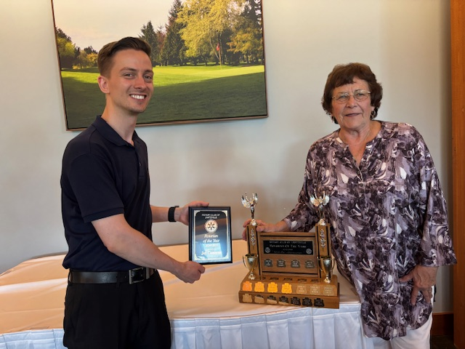
Rotary of the year award precented by our previous President Michael Ribicic to Joy Cameron

2025 ROTARY CLUB OF LANTZVILLE DUTY ROSTER
July – September 2025
If the date you are assigned does not work for you, please arrange for
someone to take your task.
DATE | Greeter | Cash | Sgt. Arms | INTROS | INSPIRATION | ROTARY  MINUTE
July 3 | Ralph | Trevor | Douglas | Mike | Dale | Jo-Anne
July 10 | Dale | Jo-Anne | Troy | Leanne | Stephen | Rachel
July 17 | Leanne | Joy | Brian | Jodie | Janice | Cor
July 24 | Jo-Anne | Mark | Doug S. | Greg | Cor | Troy
July 31 | Douglas | Trevor | Lance | Stephen | Norm | Lee
Aug 7 | Norm | Jo-Anne | Greg | Cor | David | Mark
Aug 14 | Jo-Anne | Joy | David | Troy | Michael | Alexis
Aug 21 | Ralph | Mark | Douglas | James | Janice | Lance
Aug 28 | Stephen | Trevor | Troy | Jodie | Mike | Don
Sept 4 | Michael | Jo-Anne | Brian | Jan | James | Norm
Sept 11 | Brian | Joy | Doug S. | Mike | Rachel | Dale
Sept 18 | Mike | Mark | Lance | Ralph | Alexis | James
Sept 25 | Doug S. | Trevor | Greg | Lee | Don | David

