

The Lantz July 2026

A word from your President
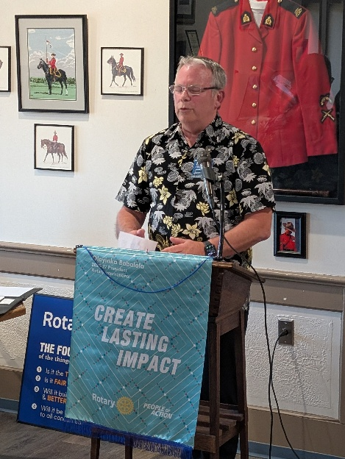Where to start?? What a humbling opportunity you have provided me. I want to thank you for believing in me, for placing your trust and confidence in me, and for this opportunity to be your President. I am proud to serve in this role and to continue the incredible work that has been built by the dedicated leaders who came before me.
Rotary has always been about service above self. It is about seeing a need and stepping forward to make a difference. Whether we are supporting local families, assisting youth, raising funds for important community initiatives, or contributing to international projects, our collective efforts demonstrate what can be accomplished when people come together with a shared purpose.
The Rotary Club of Lantzville has a proud history of service, friendship, and community leadership. As we look ahead to the coming year, I am excited about the opportunities before us. Together, we will continue to strengthen our club, expand our impact, and build meaningful connections throughout our community.
This year, I encourage all of us to continue embracing Rotary's ideals. Let us look for new ways to serve our community, especially that of Lantzville. Look at building new partnerships, find new sponsorships, and creating new opportunities to make a positive difference. Rotary is family, let us support one another, celebrate our successes, and face challenges with optimism and determination together.
My goal as President is simple: to encourage participation, foster fellowship, and ensure every member feels valued and engaged, and HAVE FUN!! Each of us brings unique talents, experiences, and perspectives, and it is through that diversity that the Rotary Club of Lantzville thrives.
As I begin this humbling journey, I do so with enthusiasm, gratitude, and confidence in what we can accomplish together. I am proud to be a member of the Rotary Club of Lantzville, proud to serve as your President, and excited for the year ahead. Please feel free to reach out, I am only a phone call or text away.
Lance Stephenson
President – Rotary Club of Lantzville
250-667-2912

June 2026 Highlights

On June 9th some of our members went out to volunteer at Loaves and Fishes, without their fearless leader Trevor. There was something fishy going on.

On June 20th we held a shredding fundraiser, partnering with the Nanoose Bay Lions Club.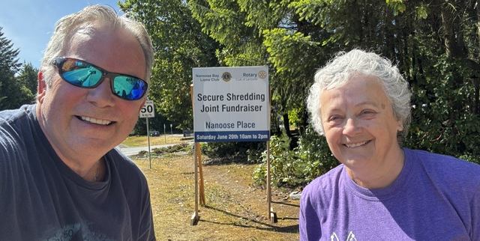
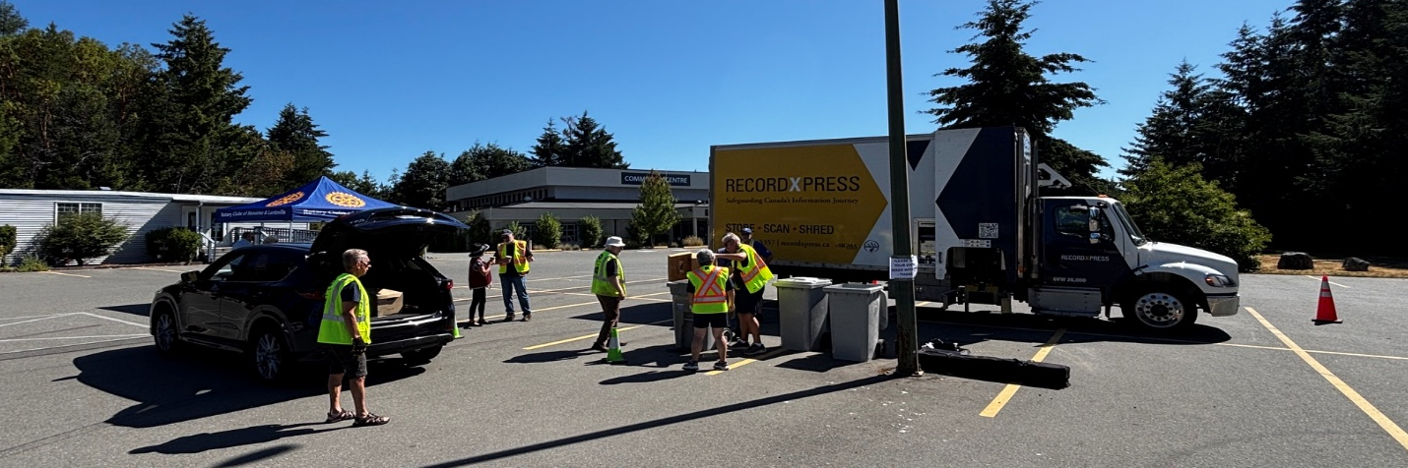

The weather was cooperating to the fullest as you can see in the pictures.
A big thank you to all of you who came out to help with this event.
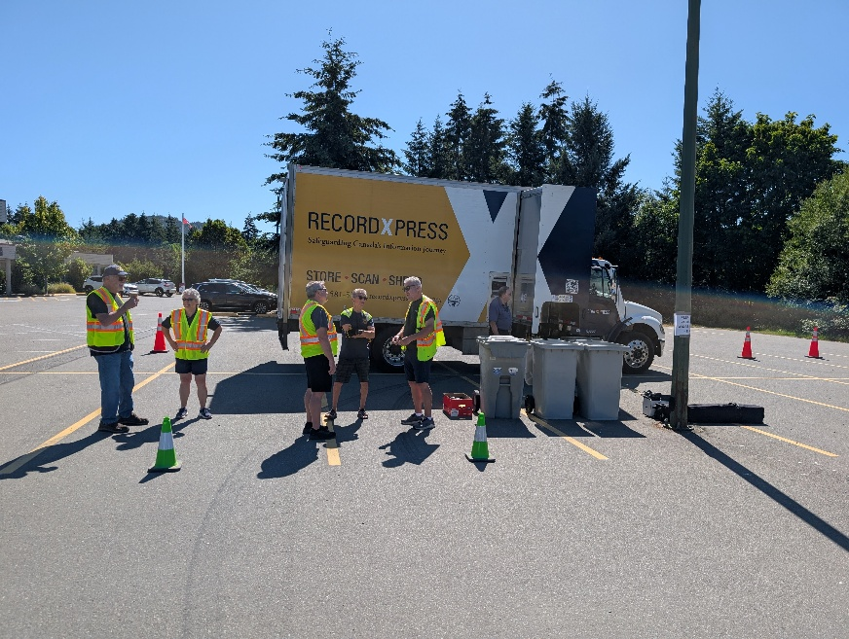

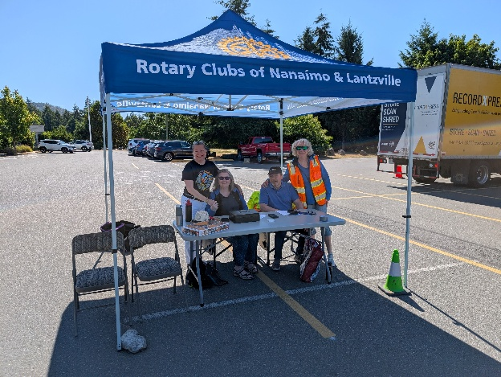

On June 20th our Rotary Club met at the Legion in Lantzville to install the new executive board for the upcoming year.
First of all, the Legion out did themselves by serving us a fabulous meal consisting of chicken and salmon followed by a yummy desert. After dinner we continued with the program which consisted of the existing officers stepping down and the new board being installed.

A big thank you to all of you who served on the board the previous year dedicating your time and energy to your community. This also includes all the volunteers who helped behind the scenes to make this past year successful.
This Photo by Unknown Author is licensed under CC BY-NC-ND
Our new board are the following people:
Club Officers & Directors for 2026-2027
President Lance Stephenson Community Services Louise Bender
President Elect Rachel Robertson Foundation / Polio+ Joy Cameron
Vice President Trevor Lee Membership Jo-Anne Tremblay
Secretary Jodie Williams Administration Dale Werezak
Treasurer Mark Taylor Public Image Norm Smith
Immediate Past President Sheila Bergin & Greg Devenish International Service Leanne Rose
Youth Services Alexis Taylor-Vannatter


Thank You, Dale Werezak, for organising this year’s installation ceremony.
Thank You, Jodie Williams, for doing the Installation of the new Executive and Directors
Thank You, Stephen Cochrane, for doing an outstanding job MCing the ceremony and keeping things on time and schedule.
Thank You everyone else who I forgot to mention in helping make this a very successful event.

Club Officers for 2026-2027

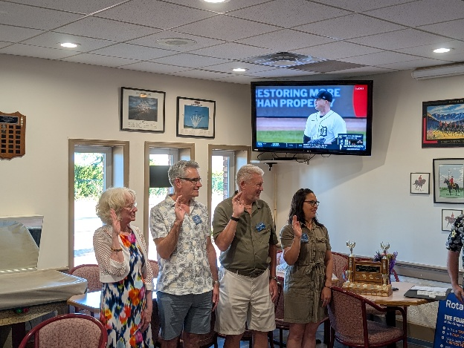

A few of our Directors for 2026-2027

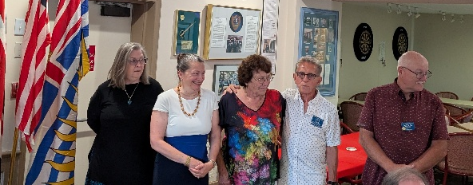

Stephen Cochrane receiving the Rotarian of the year award from President Sheila Bergin


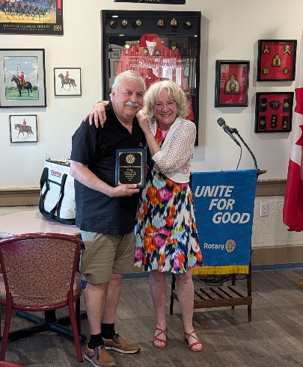
Douglas Slowski receiving the 25-year Rotary service award from President Sheila Bergin

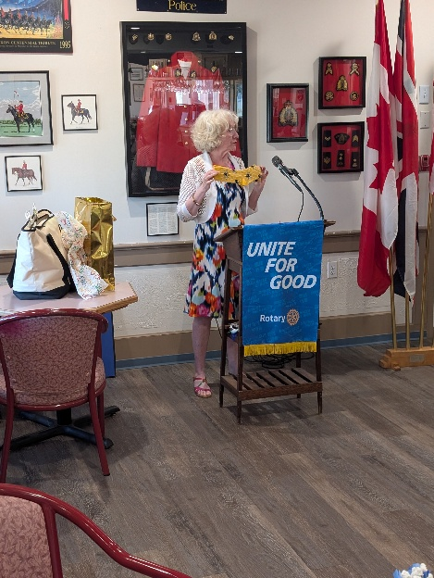
25-26 President Sheila Bergin unpacking useful gifts for our 26-27 President Lance Stephenson.

Congratulations are in order for Douglas Slowski for Receiving a Branch 257 Legion service medal!
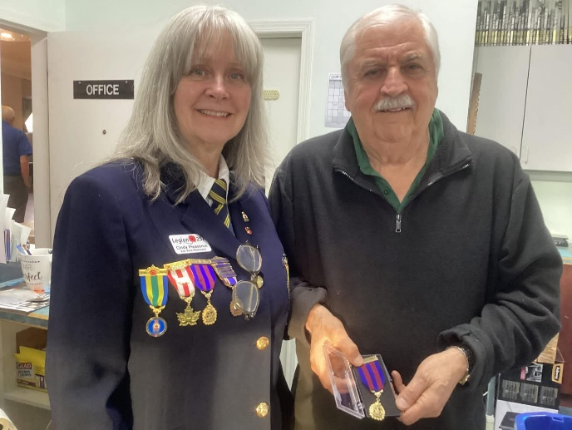

Happy July Celebrations
Birthdays Anniversaries
17 Norm Smith 29 Janice & Tom
21 Don Tamelin
21 Douglas Vannatter


Health of the Club
James Williams is out of the Hospital and slowly recovering at home.
Wishing you speedy recovery from all your friends at Rotary

Upcoming Speakers
July 2 Zoom Presentation Anshu Chandra Eye Care Haiti
July 9th Tricia Print Three Printing
July 16th Adrienne Nolan Operation Freedom Paws
July 23rd Verena Munnion Altrusa Baby Bundles Project

2026 ROTARY CLUB OF LANTZVILLE DUTY ROSTER

DATE | Greeter | Cash | Sgt. Arms | INTROS | INSPIRATION | ROTARY  MINUTE
Jul 2 | Stephen | Mark | Brian | Jodie | Alexis | Norm
Jul 9 | Dale | Jo-Anne | David | Jan | Lee | Stephen
Jul 16 | Kay | Trevor | Greg | Dale | Norm | David
Jul 23 | Alexis | Joy | Doug S. | Kay | Louise | Michael
Jul 30 | Louise | Mark | Doug V. | Stephen | Cor | Jodie

If the date you are assigned does not work for you, please ask someone to take your task

Up Coming

Club BBQ is to be hosted by Lance and Cassie Stephenson at 8383 Bayview Park Dr, Lantzville July 26th. Dale will have details coming soon.

For any additional news about The Rotary Club of Lantzville, please visit our Facebook Page:
https://www.facebook.com/RotaryClubofLantzville/


Happy Canada Day

Happy Reading, Cheers

