April 2025 | The Rotary Club of Lantzville
Quote of the month: | “Ability is what you are capable of doing  Motivation determines what you do  Attitude determines how well you do it.”  March Speakers in Review  Katimavik marketing manager, Tom Ahern was in Nanaimo to recruit volunteer participants and business employer sponsors for the Nanaimo ‘FuturePerfect’ employment skills program. This 12-week program provides young adults with a place to stay and employment skills training. It is funded by the Government of Canada.  Take a Hike Foundation works in the school year with vulnerable grade 8 – 12 students to enhance their well-being and future. The Nanaimo program opened in 2019 at Woodlands school. The program model works to engage students in academic programs, counselling sessions and land-based learning activities. In 2023-2024 227 youth participated in 13 programmes offered in 3 regions in BC. The Foundation’s motto – Empowering Youth, Changing Lives – is working.  George Anderson, MLA for Nanaimo-Lantzville, gave a review of his and the governments many activities since the election. George is the Parliamentary Secretary for Transit and he also serves as Deputy Chair of the Committee of the Whole. The NRGH Tower, the Lantzville long term care facility and addiction issues were some of the topics covered in a very lively Q&A.  Mike Squire, City of Nanaimo water technician, gave a very informative overview of our water supply. He showed slides of the South Nanaimo River rain dominant watershed, the dams and the 2015 water treatment plant. 1.03 billion dollars is the estimated replacement value of these assets. The City of Nanaimo provides water to our 110,700 residents, 1st nations, Lantzville, North Cedar, Harmac and fisheries. Interesting to note, despite increasing population, thanks to continuing education and metering our water usage is declining.
Fact of the month: | Rotary International, a founding partner of the Global Polio Eradication Initiative (GPEI), has played a crucial role in the fight against polio, contributing over $2 billion and countless volunteer hours to protect children in 122 countries, reducing polio cases by 99.9% since their first project in 1979.  April Birthdays and Anniversaries:  Doug Slowski – April 4th  Leanne Rose – April 11th  Alexis Taylor-Vannater – April 26th  James & Jodie Wiliams – April 20th  If you think we are missing information, please let us know!  Upcoming Meetings:  April 3rd - Rob Hutchins, Principal – Dover Bay International School  April 10th - Club Bi/Monthly business meeting  April 17th - TBA speaker presentation  April 24th - TBA speaker presentation  For more images and updates through the month, visit our Facebook page:  https://www.facebook.com/RotaryClubofLantzville/  Volunteering:  Loaves and Fishes, March 11th, 5:30-7:00. Register online ASAP
  Duty Roster | Greeter | Cash | Sgt. Arms | Introductions | Inspiration | Rotary Minute
  April 3 | Dale | Trevor | Douglas | Don | Sheila | Norm
  April 10 | Stephen | Jo-Anne | Troy | Jodie | Janice | Joy
  April 17 | Norm | Joy | Brian | Mike | Rachel | Mark
  April 24 | Leanne | Mark | Doug S. | Alexis | Troy | Dale

Our Fundraiser…

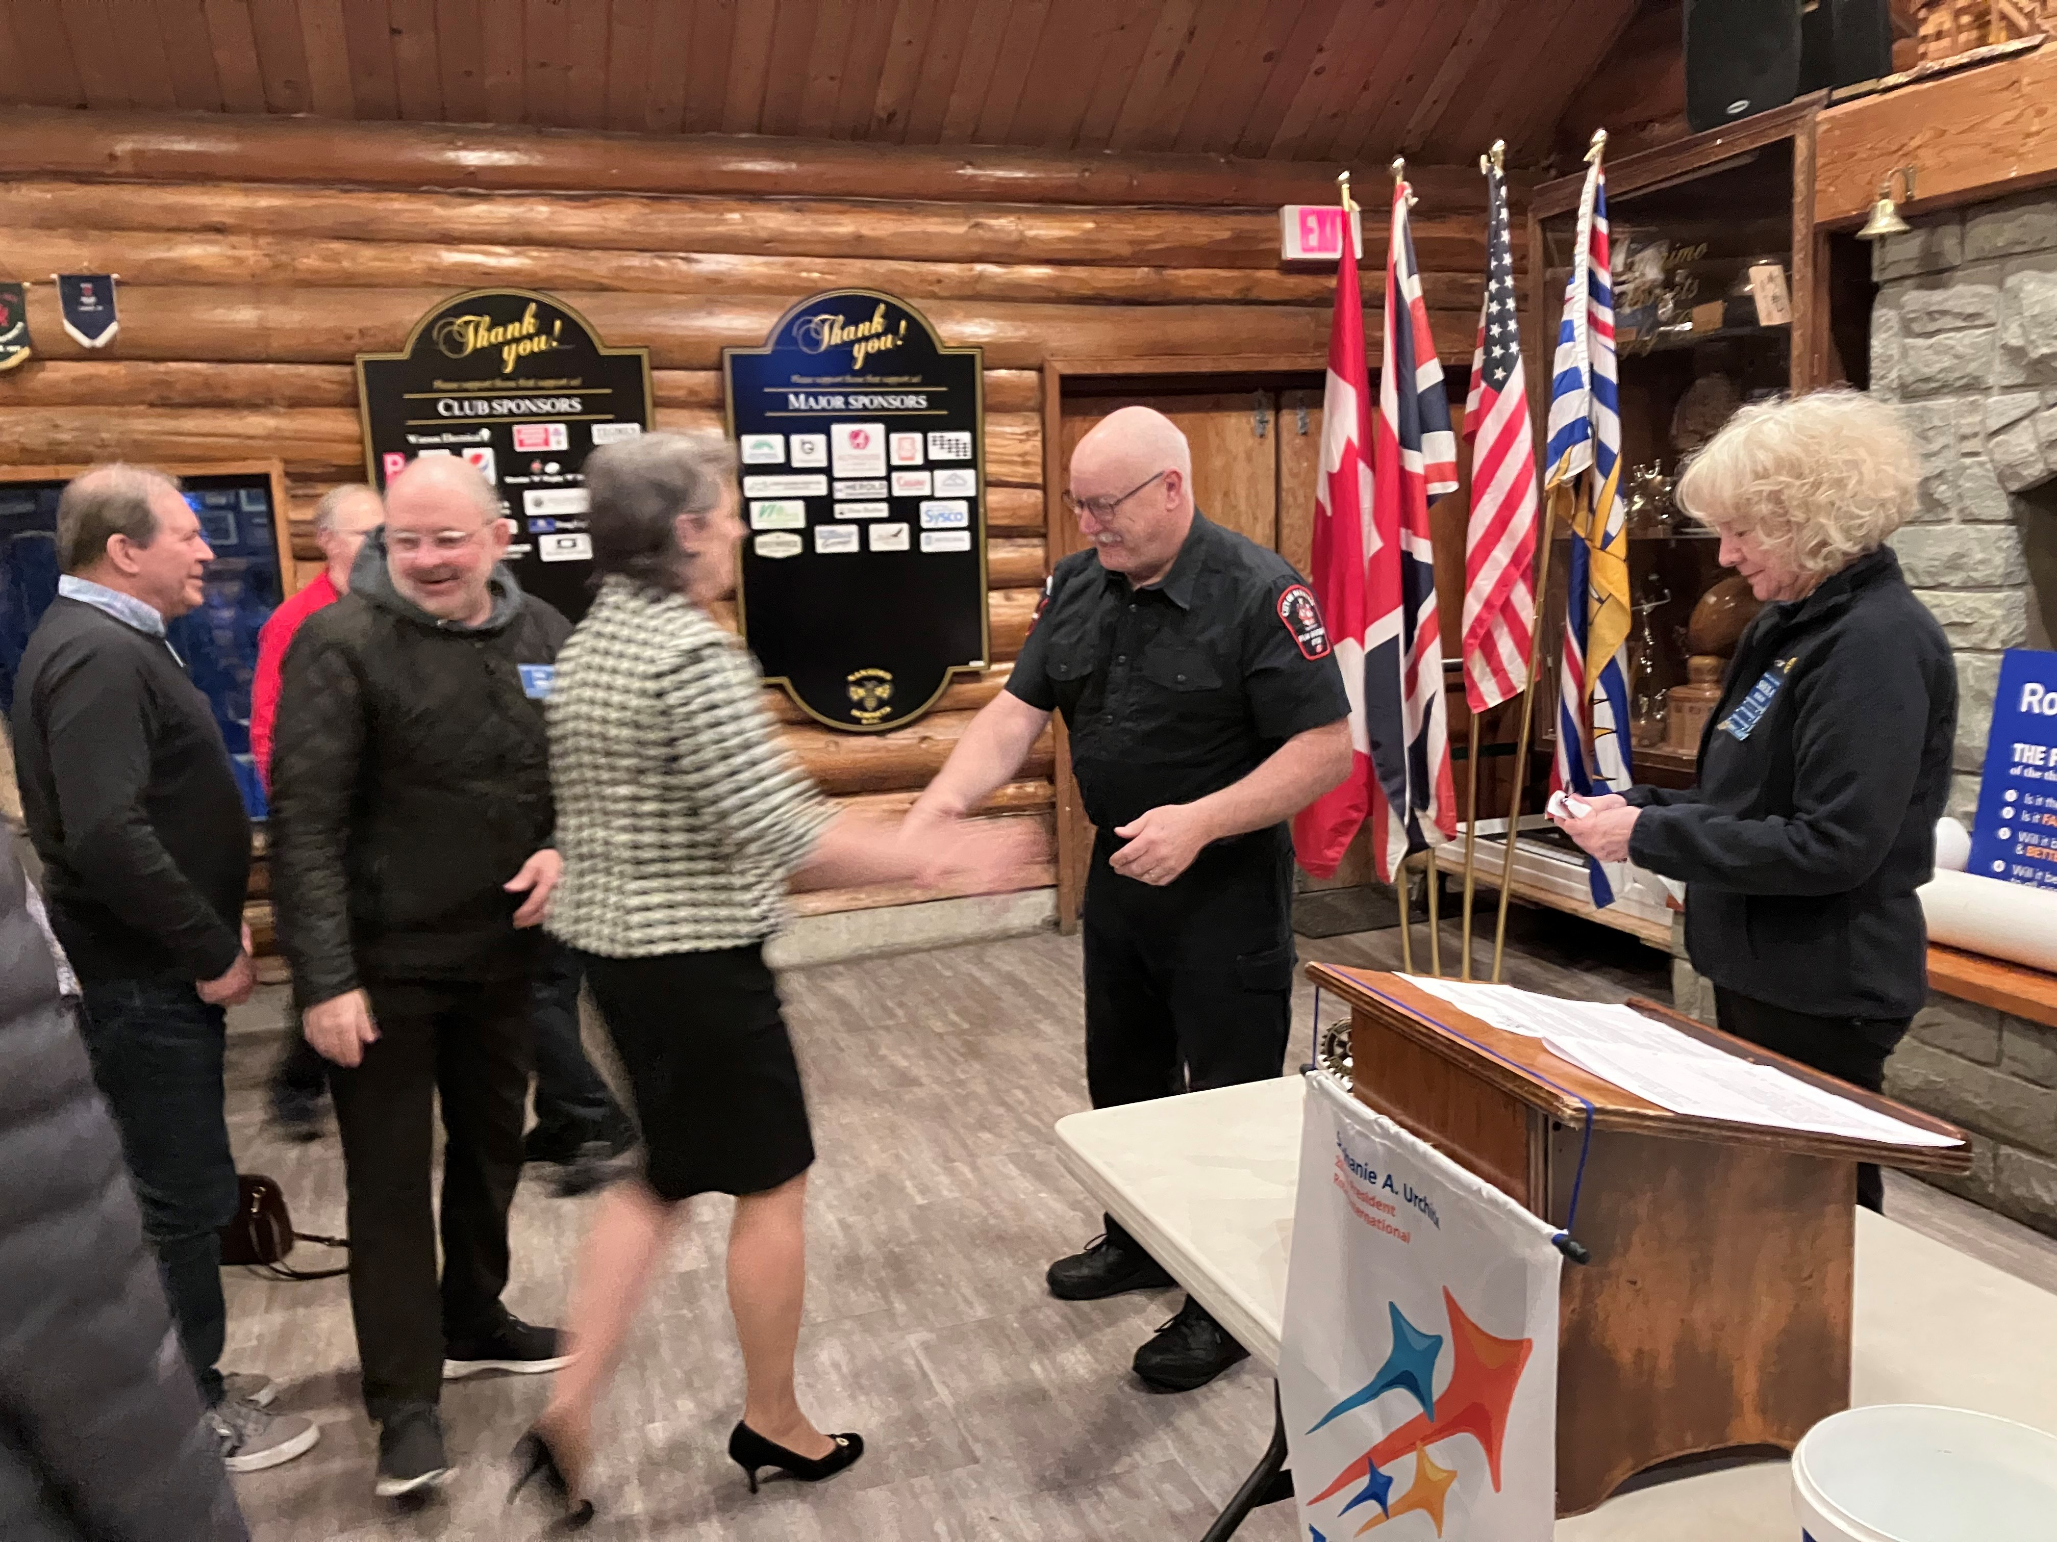

A warm Rotary Club Lantzville welcome
To our newest member, Norm Smith.

Rotary Theme for April is Environment

Upcoming schedule of events:

April 2nd -Directors Meeting

April 5th -Club Shredding Event@ Woodgrove Centre

April 8th -Loaves & Fishes 5:30 – 7:00 P.M.

April 10th -Club Bi/Monthly Business Meeting – Potential Special Guest Speaker, TBA.
Departure Bay Sea Scouts Bottle Drive

April 13th -City of Nanaimo Earth Day Community Celebration

April 15th -Club social, 5:30 p.m. Wine Works – spouses and guests welcome. RSVP to Greg

April 20th -RCL Easter Egg Hunt

Congratulations to…
Everyone for their maple syrup sales support. Bottom line = $ 9,500 in sales. Special thanks to Mark for his incredible, thoughtful organization.

Cheques…
Our club proudly presented a cheque to Loaves & Fishes,

March Social…
Thank you to Michael for organizing our ‘Happy Hour’ St. Patrick’s Day gathering at the Longwood Pub.

Thank you to everyone that helped the club this month. Whether that be at the Rugby Club, Loaves and Fishes, attending club event planning meetings, sharing our message at the Chamber Business after Business event, or by just being awesome!

Best wishes for a happy, eventful April!

