

The Lantz March 2026

A word from the Membership Chair
This article aims to clarify a question on the Membership Satisfaction Survey which was about membership orientation, education and training. Rotary International through their website provides comprehensive membership training to help new members understand, connect and thrive in their clubs. Key resources include the Rotary Basics online course via the Learning Center and the New Member’s Welcome Kit. Effective orientation focuses on educating members on club structure, the Rotary Foundation, and local service opportunities while training focuses on leadership and engagement. Members are encouraged to consult both the Rotary Club of Lantzville website on https://portal.clubrunner.ca/675 and the Learning Center often to understand Rotary’s mission and improve the membership experience through engagement and participation. New members are also encouraged to ask questions of the Membership Chair, their mentor and other Club Executive whenever an issue arises. Our Club’s Foundation Chair provides the members with regular updates on how well our contributions progress towards reaching our goals. We are proud of the generosity of our members in reaching those goals whether Polio Plus, Annual Fund and Paul Harris Fellows. We may be a small club, but we are nevertheless mighty in so many ways!

February 2026 Highlights
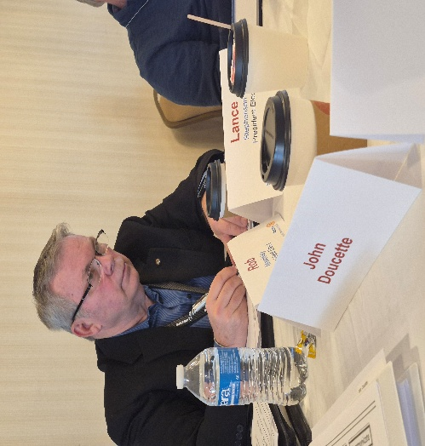
President‑Elect Lance Stephenson dedicated time this past weekend to deepening his understanding of Rotary and the responsibilities of an effective club President at the President-Elect Learning Seminar in Sea-Tac

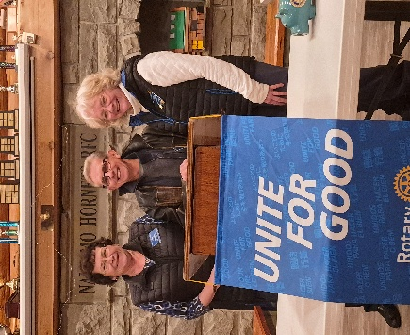
Recently, our club has had the immense pleasure of celebrating several members whose outstanding commitment to The Rotary Foundation has been formally recognized. Their generosity and service exemplify the spirit of Rotary and strengthen the impact we make—locally and around the world.
The latest recipient of a Paul Harris Fellow is Dale Werezak

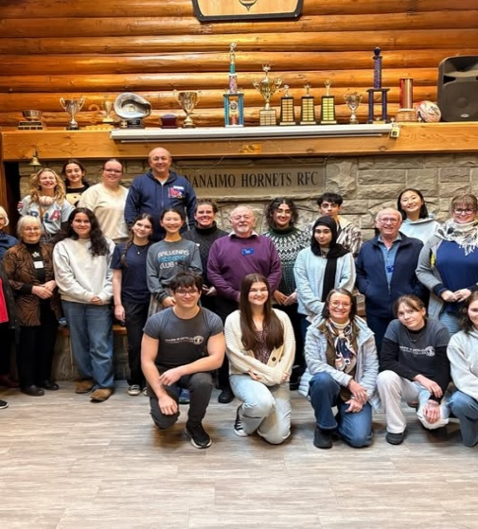
Our very own Stephen Cochrane, District Youth Services Chair, spent time with our Interact and RYLA members this past weekend—and what an impact he made. His thoughtful guidance, genuine curiosity, and deep commitment to youth leadership sparked meaningful conversation and left our youth leaders feeling energized and supported. We’re grateful for his dedication to helping the next generation of Rotary changemakers thrive.
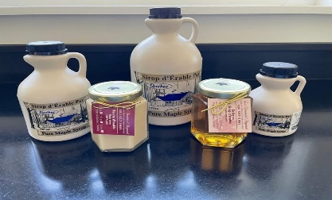
Upcoming Events for March
March 5th Bring your bottles & cans to our meeting for the Departure Bay Sea Scouts
March 10th is the deadline for Maple syrup orders
March 14th St. Paddy’s Day Dinner 5:00pm at the Seaview Legion Lantzville Music by Oceanside Pipe Band. Meal; Beef Stew/Roll/ Dessert-$20
March 21st Secure Document Shredding 10 am – 2pm Woodgrove Centre by the White Spot Restaurant
March 21st Women Rugby Match Vegetable Dhal & Rice + Naan Serving 50 people Serving at 1:00

Birthdays and Anniversaries

Sheila Bergin March 7th
Joy Cameron March 12th
Rachel Robertson March 13th
Ralph and Valery Lemmon celebrating their 46th anniversary March 1st

Upcoming Speakers
March 5th Graham Calder District 5020 Rotary Friendship Exchange
March 12th Helen Lingman Nanaimo Foodshare
March 19th Alexis Taylor-Vannatter Island Crisis Care Society
March 26th Deborah Cooper COCO Cafe Cedar

2026 ROTARY CLUB OF LANTZVILLE DUTY ROSTER
March 2026
If the date you are assigned does not work for you, please ask someone to take your task
 | Greeter | Cash | Sgt. Arms | Intros | Inspiration | Rotary  Minute
MAR 5 | Brian | Jo-Anne | Greg | Trevor | Jodie | Joy
MAR 12 | Dale | Mark | Douglas | Michael | Lee | Norm
MAR 19 | Jo-Anne | Joy | Lance | James | Rachel | Dale
MAR 26 | Norm | Trevor | Doug S. | Joy | Alexis | Doug

For any additional news about The Rotary Club of Lantzville, please visit our Facebook Page:
https://www.facebook.com/RotaryClubofLantzville/

REMEMBER: Never iron a four-leaf clover, because you don’t want to press your luck
Happy Reading. Cheers!

This Photo by Unknown Author is licensed under CC BY-NC-ND

