

The Lantz May 2026

A word from your President
April certainly kept us hopping – and not just because of Easter
Our Easter Egg Hunt on 5 April was a wonderful mix of organized chaos, laughter and chocolate-fueled excitement. Children were everywhere at once – running, searching, squealing with delight and somehow managing to consume their body weight in chocolate. It was great to see so many families enjoying the fun together.
A special highlight was the appearance of the Pink Easter Bunny, who bore a remarkable resemblance to Cassey Stephenson. Adults got into the spirit just as much as the kids, proving once again that you are never too old for chocolate or a photo with your home-made Easter bonnet.
Behind the scenes our members rolled up their sleeves for a couple of productive work parties. The old lockup was cleared out, sorted through and our equipment successfully relocated to our new and improved storage unit at St. Phillip by-the-Sea. It was a fine display of teamwork, determination and the mysterious Rotary ability to make heavy lifting look like a social event.
And as it that wasn’t enough, we also paid our clubhouse rent the Rotary way – by preparing and serving lunch at two Hornets rugby games. Once again, volunteers stepped up whenever needed, the work got done, and the fun was always close at hand.

That’s what makes this club so special. No matter the task – hiding eggs, hauling gear, or feeding hungry rugby players – our members show up with energy, humour and a willingness to pitch in.
Thank you all for another month of service and fellowship. 

April 2026 Highlights
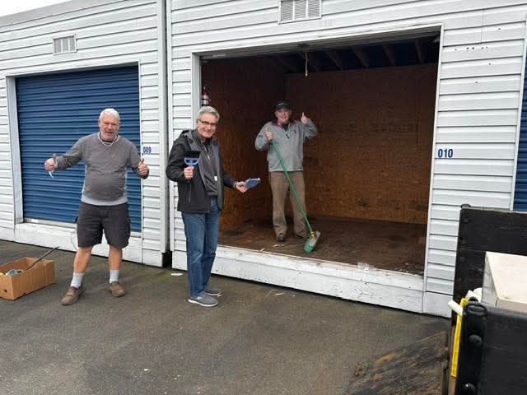

Clean out of the rented storage locker. Job well done.

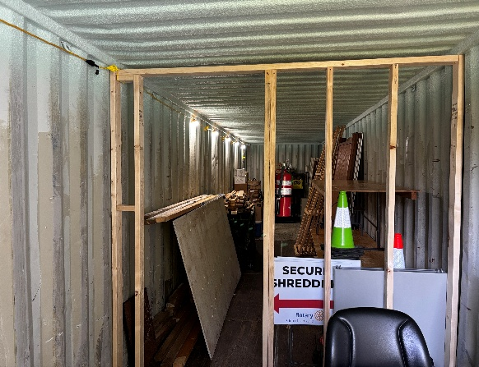
Moving in to the new
storage with lights!!

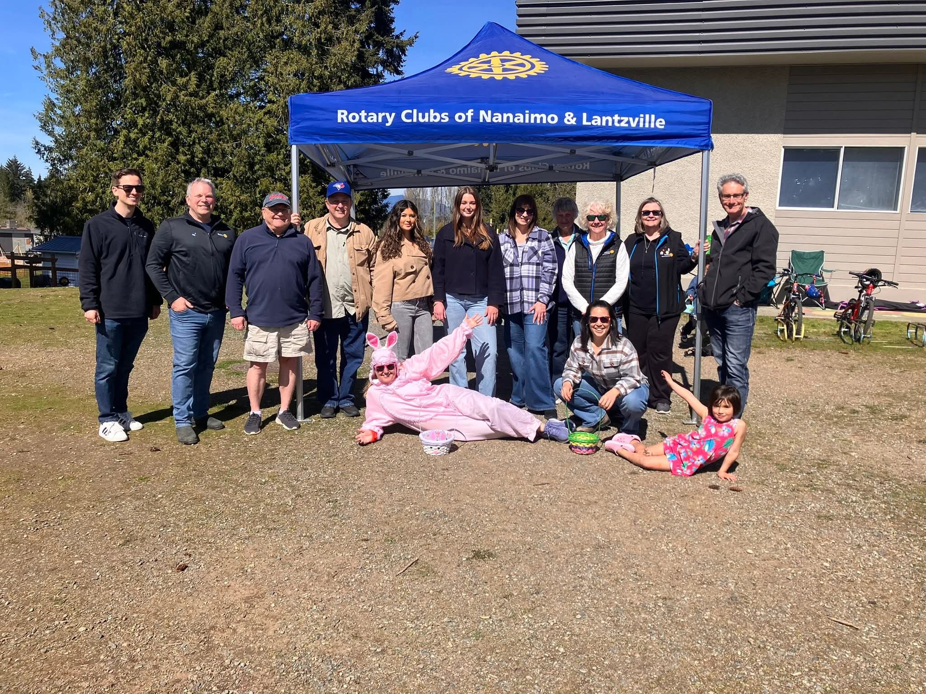

The crew from our Rotary Club who gave up their Easter Sunday Afternoon to hide hundreds of eggs around the school property for the annual Easter Egg hunt. This event brought a lot of smiles on the children’s faces. I wonder how many eggs were not found and left for the person who is cutting the grass.
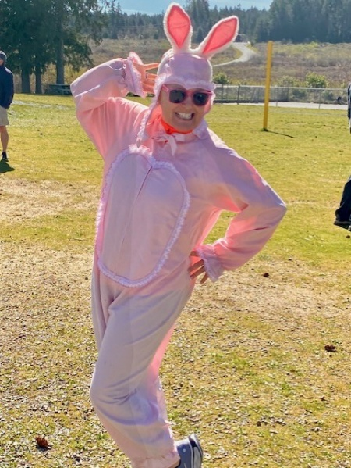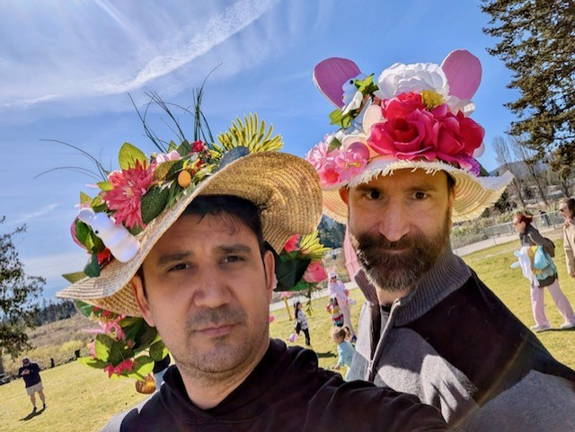
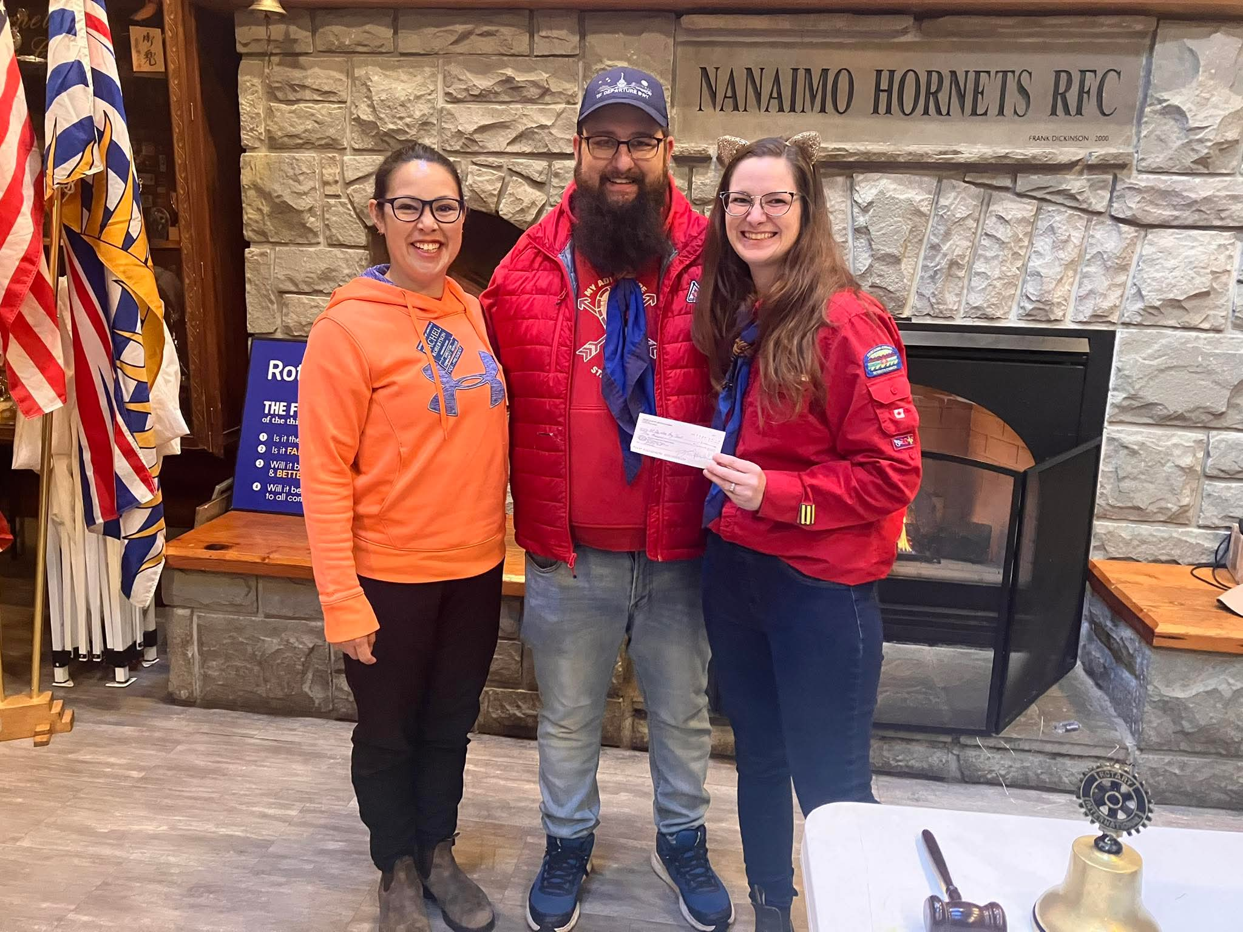

Our own Rachel Robertson handing out a cheque to the Sea Scouts for their up coming educational trip to Nootka Sound. Of the $14,000 required for the trip, they already had raised over $11,000. Very impressive.

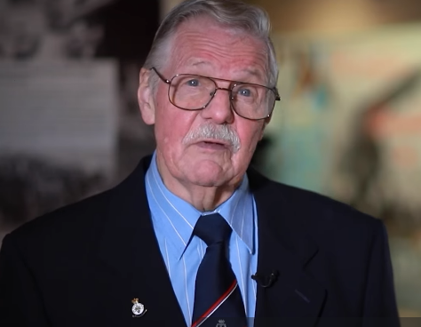
On April 15 our long time Rotary member Brian McFadden received the Heritage Culture Award from the City of Nanaimo for all the volunteer hours he had provided to the Nanaimo Military Museum for the past 30 years. Congratulations Brian
On April 18 the Rotary Club of Lantzville join the Nanaimo Rotary Clubs for their annual trash pick up on City streets in recognition of Earth Day.
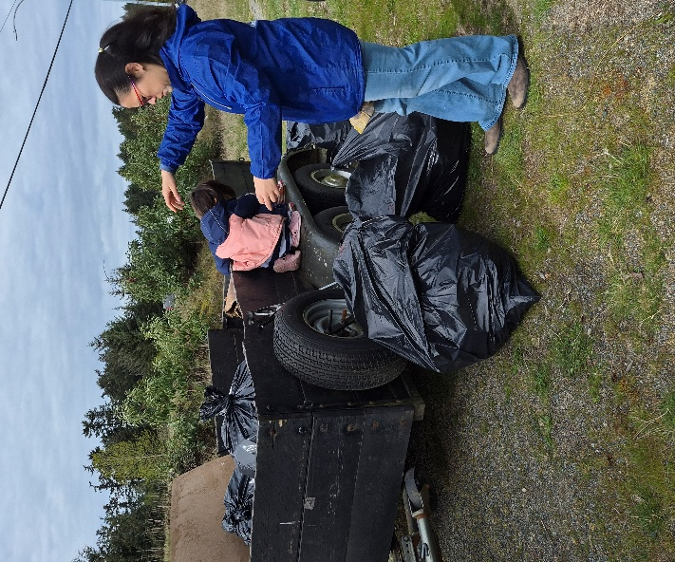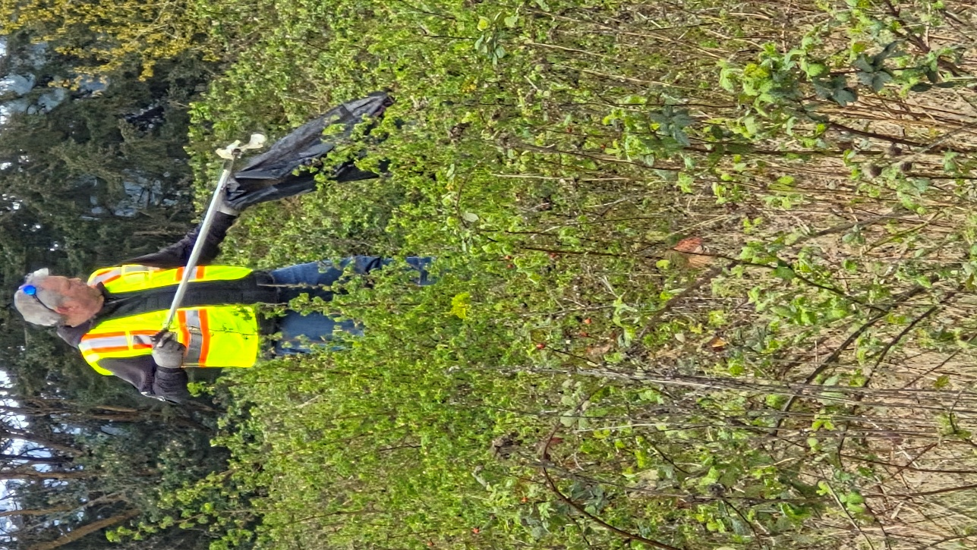

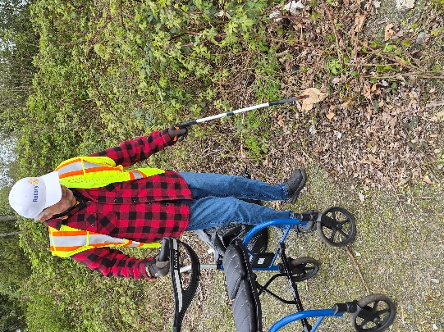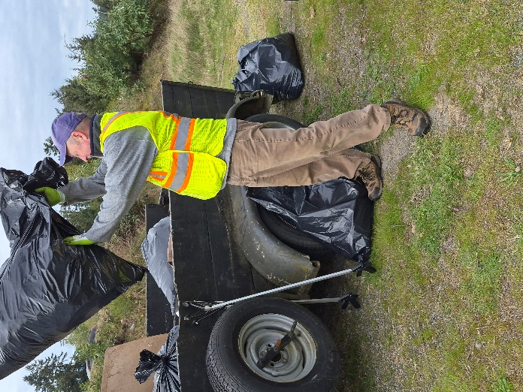

Upcoming Events for May
May 8-9 Rotary District 5020 District Conference in Victoria BC.
May 12 Loaves and Fishes (Contact Trevor if you would like to volunteer)

Birthdays

Cor Buys – May 11
Brian McFadden – May 20
Lance Stephenson – May 21
Anniversaries
Doug & Heather - May 9
David & Gayle - May 26

Upcoming Speakers
May 7th Jan Stromar Real Estate Market
May 14th Presentations from Rotary Student Exchange
May 21st Joan Ryan Youth Protection presentation
May 28th Lance Stephenson President-elect strategic planning
2026 ROTARY CLUB OF LANTZVILLE DUTY ROSTER
May 2026
If the date you are assigned does not work for you, please ask someone to take your task

DATE | Greeter | Cash | Sgt. Arms | INTROS | INSPIRATION | ROTARY  MINUTE
MAY 7 | Trevor | Joy | Brian | Norm | Dale | Jodie
MAY 14 | James | Trevor | David | Jodie | Norm | Lance
MAY 21 | Joy | Jo-Anne | Lance | Dale | Greg | Rachel
MAY 28 | Michael | Mark | Greg | Cor | Janice | Brian

For any additional news about The Rotary Club of Lantzville, please visit our Facebook Page:
https://www.facebook.com/RotaryClubofLantzville/
May Long Weekend (Monday May 18th)
Happy Mother’s Day (Monday May 10th)
 Happy Reading, Cheers

