

The Lantz October 2025

September 2025 Highlights
On September 9, several of our members put in another shift at the Loaves & Fishes Warehouse. (Thank You!)
September 13 was the 50th anniversary of the Lantzville Minetown Day. A large contingent of our club members were involved in the judging and supervising of the events being held. A few of the events monitored by our members were, Nail Hammering, Watermelon Eating Contest and the Bike Parade.
Here is a little bit of the history of Mine Town Day: Lantzville's first Minetown Day was in 1975, celebrated to commemorate the 50th anniversary of the Lantzville Hotel. The event, initiated as a community celebration with a family-focused and affordable design, has evolved into an annual tradition honoring the town's mining history and fostering community spirit through activities like a pancake breakfast and a kids' bike parade.

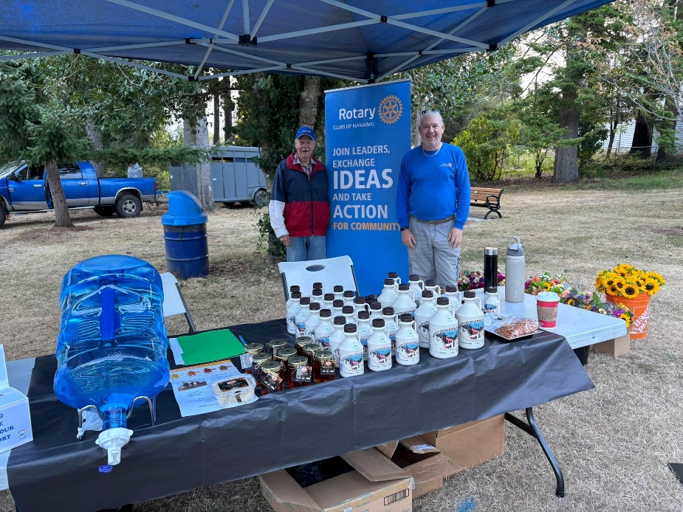

Brian and Trevor manning the Rotary Booth at Minetown Day.
On September 20th there was an Area 40 5 Club gathering at 808 Wing. A fabulous barbeque was enjoyed by all, followed by enjoying some of the games available. It was also a great opportunity to visit with members of the other clubs. Everyone had a great time.

As I am writing this, the Tour de Rock is ongoing as we speak. Below is a picture of the riders going by Cameron Lake on their way to Port Alberni.


Upcoming Events for October
October 4: Secure Document Shredding in the White Spot Parking Lot (10am – 2pm)
October 14: Loaves & Fishes (5:30pm – 7:00 pm)
October 18: Hornets Rugby meal

Speakers for October
Oct 2 Dave Marshall – Ham Radio Emergency
Oct 9 Linda Stephenson – The Men’s Center
Oct 16 Bern Muller – Salvation Army
Oct 23 Tina Moreira – Nanaimo Hospital Foundation
Oct 30 Ray-Lynn Varga – Re Fine Home Inc.

Birthdays & Anniversaries

Oct 2 David Lobay
Oct 10 Shawn Kilner
Happy Birthday to both of you.

2025 ROTARY CLUB OF LANTZVILLE DUTY ROSTER
October – December 2025

If the date you are assigned does not work for you, please arrange for
someone to take your task
DATE | Greeter | Cash | Sgt. Arms | INTROS | INSPIRATION | ROTARY  MINUTE
OCT 2 | Ralph | Trevor | Douglas | James | Dale | Jo-Anne
OCT 9 | Dale | Jo-Anne | Troy | Leanne | Stephen | Rachel
OCT 16 | Leanne | Joy | Brian | Jodie | Janice | Cor
OCT 23 | Jo-Anne | Mark | Doug S. | Greg | Cor | Troy
OCT 30 | Douglas | Trevor | Lance | Stephen | Norm | Lee
Nov 6 | Norm | Jo-Anne | Greg | Cor | David | Mark
Nov 13 | Jo-Anne | Joy | David | Troy | Michael | Alexis
Nov 20 | Ralph | Mark | Douglas | James | Janice | Lance
Nov 27 | Stephen | Trevor | Troy | Jodie | Don | Don
Dec 4 | Michael | Jo-Anne | Brian | Jan | Lee | Norm
Dec 11 | Brian | Joy | Doug S. | Norm | Rachel | Dale
Dec 18 | Dale | Mark | Lance | Ralph | Alexis | Doug

To follow through on last month’s joke
Why can’t a bicycle stand up by itself? Because it’s Two Tired

For any additional news about The Rotary Club of Lantzville, Please visit our Facebook Page:
https://www.facebook.com/RotaryClubofLantzville/

Happy Reading. Cheers!



