
The Rotary Club of Lantzville

The Lantz
August 2025 Highlights

August was hot – and not just the weather! Our members packed the month with service, fellowship and fun. Here’s a look back at everything we accomplished together:

Service in Action

Loaves & Fishes Warehouse -- Members rolled up their sleeves to sort food donations. It was hot, messy work, and let’s be honest – a little odiferous. But with good teamwork and good spirits the job got done.

Tour de Rock Mock Run Dinner – We prepped and served a lasagna dinner for the riders at the end of their trial run. The meal was a success – even if the evening ended with an unexpected sprinkler shower! Luckily, everyone laughed it off.

Rotary Connections

Nanaimo Rotary Club President’s BBQ – AG Jodie and President Sheila joined the Nanaimo Club’s summer gathering. They enjoyed delicious food, met new and old acquaintances, and managed to not fall into the koi pond.

Sunday Social in the Garden – Joy and George generously opened their beautiful garden for a Sunday afternoon get-together. Shade from the trees and soft breeze kept it perfectly pleasant – a relaxing summer afternoon well spent.

Fundraising Spotlight

RYE BBQ – August 28th – The finale of the month! Held at the Curling Club, this event ran smoothly with a strong turnout, engaging student presentations and a buzzing silent auction.
The one hitch? The BBQ itself refused to light. But in true Rotary spirit the organizers and cooks problem solved on the fly, with help from the local fire station. The firefighters agreed to let us use their BBQ, so Stephen and Trevor loaded up the food, dashed to the fire hall to grill it then hauled it back just in time. Dinner was a little late but worth the wait. Huge thanks to them for perseverance and creativity under pressure. Club volunteers were Stephen and Trevor as chefs, Troy as organizer and Greg, Douglas and Alexis helping where needed.

Caring for Our Own

August also brought some challenges for a few of our members:

- Jan is working her way around with a boot cast and knee scooter after breaking her foot.
- James is recovering from a broken pelvis and getting about with a walker and wheelchair.

- Cor underwent back surgery just last week and is on the mend.

We’re keeping them in our thoughts and sending wishes for smooth and speedy recoveried.

Rotary Club of Lantzville Shines at Tour de Rock Mock Tour!

A huge shout-out to our amazing Lantzville Rotary members who rolled up their sleeves on August 16 to serve dinner to the Tour de Rock riders, support crew and volunteers after the 2025 Mock Tour. Their warm hospitality and energy made every rider and guest feel welcome, valued and celebrated.

The Mock Tour is the big “practice run” for the official Cops for Cancer – Tour de Rock (20 Sep – 3 Oct), giving riders the full team experience with a police escort. This year’s ride saw the team leave Nanaimo at 9:30 a.m., cycle to Duncan and push back to Nanaimo – with the communities of Nanaimo, Ladysmith, Chemainus and Duncan cheering them on. It was the perfect chance to introduce this year’s dedicated team before they set off on the epic ride from the northern tip of Vancouver Island all the way to the south, including a leg out to Tofino.

Tour de Rock is so much more than a ride – it’s about hope, courage and community. We’re proud that the Rotary Club of Lantzville could play a part in lifting up the riders and crew who carry that spirit forward.

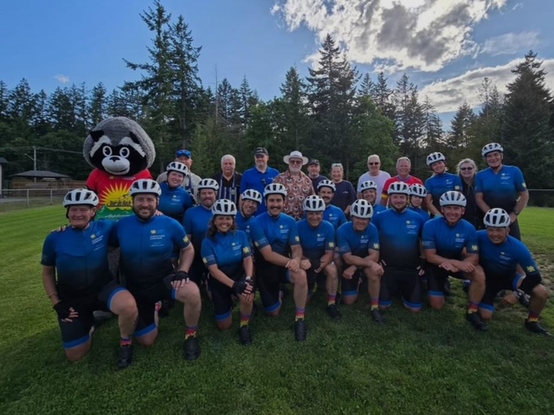

Caring for Our Own

August also brought some challenges for a few of our members:

- Jan is working her way around with a boot cast and knee scooter after breaking her foot.
- James is recovering from a broken pelvis and getting about with a walker and wheelchair.
- Cor underwent back surgery just last week and is on the mend.

We’re keeping them in our thoughts and sending wishes for smooth and speedy recovery.

A reminder the club’s September 11th meeting is cancelled as we are invited to the Rotary Club Nanaimo Daybreak meeting Wednesday September 10th for the District Governor Tony Camaroda’s visit.

Happy Birthday to:

Mark Taylor September 1
Troy DeJong September 16
Lee Rowley September 19
Stephen Cochrane September 28

Please review the duties for September. Names have been changed, to protect the injured.

Duty Roster | Greeter | Cash | Sgt. Arms | Introductions | Inspiration | Rotary Minute
Sept 4 | Michael | Jo-Anne | Brian | Stephen | James | Norm
Sept 11 | NO MEETING
Sept 18 | Doug V. | Mark | Lance | Ralph | Alexis | James
Sept 25 | Doug S. | Trevor | Greg | Lee | Micheal | David
For more images and updates through the month, visit our Facebook page:

https://www.facebook.com/RotaryClubofLantzville/

Looking forward

Sept.13th Minetown Days

Sept. 20th All Rotary clubs get together at 808 Wing on Nanaimo Lakes Rd.

Volunteering:
Loaves and Fishes, Sept. 9th, 5:30-7:00. Register online ASAP
Minetown Day, Sept.13th

Speakers for September

Sept 4th Alexis Taylor-Vannatter Island Crisis Center
Sept 11th No meeting
Sept 18th Evelyn Boegh District Partnership Committee
Sept 25th Cora Leschert Nanaimo Family Life Association

Gratuitous Chuckle:

For those missing Michael’s Dad Jokes, here’s one for you:

What do you call a chicken who crosses the road, rolls in the mud and crosses back again?
A dirty double crosser.
… you’re welcome.

