


The Lantz November 2025

President’s Message
In the blink of an eye, October came and went –and what a month it was! The Lantzville Rotary Club was busy as ever, and once again our members stepped up to ensure our events ran smoothly. It was a happening month, filled with both planned and unexpected moments. Even with a few absences due to health, travel and work commitments, we kept the momentum going and made it all happen. Below is a quick snapshot of where our time and energy were spent.
As November rushes in, we turn out attention to the festive season and the exciting events ahead. I have every confidence our Leads will continue to enjoy the full support and cooperation of our club – because helping out and pitching in is what we do best!
Let’s keep the spirit strong and the Rotary wheels turning.

October 2025 Highlights
Oct 3 The Tour de Rock concluded in Victoria BC. Raising a total of $828,028 for the Canadian Cancer Society.
Oct 4 The team of Rotarians from our club were out in full force to help at the document shredding event at the Woodgrove parking lot. Over 2k was raised for your community. Thank you to all of you who came out to help and to Joy for organizing the event.
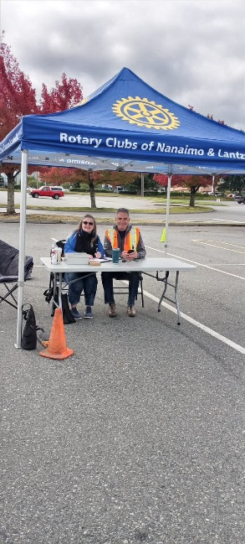

Mark and Jo-Anne taking in the money at the shredding event.

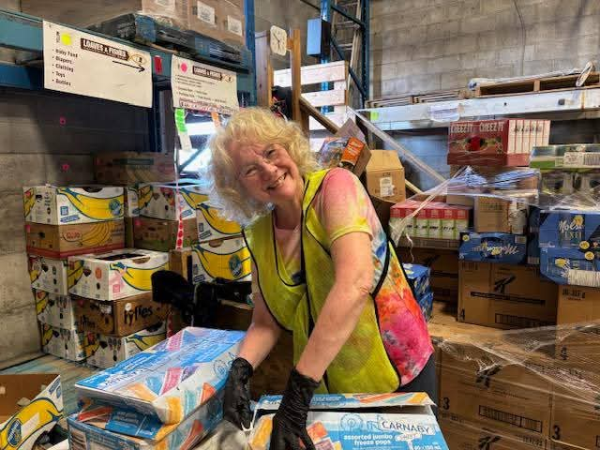
Oct 14 The crew went out to sort food at the Loaves and Fishes Warehouse.

Our Rotary President sorting food at Loaves and Fishes with a smile

Oct 18 Food was prepared for the Nanaimo Hornets Rugby home game.
Thanks to the cooking skills of David, Joy, Doug and Dale.

Oct 18
Our own Rotarian Rachel Robertson opened her new Pilates studio 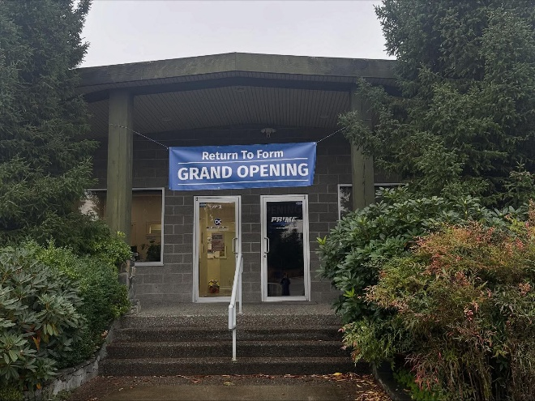 
Rachel’s new Pilates studio Sheila and Jo-Anne presented Rachel with
a congratulatory bouquet from the club.

Oct 27 Club Social hosted by Cassie and Lance Stephenson
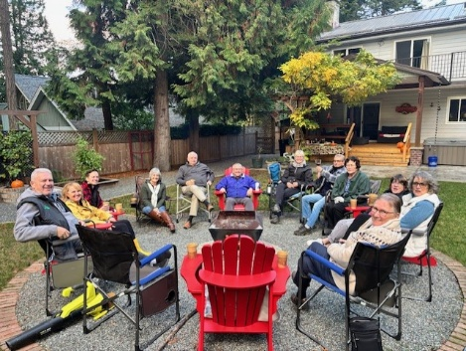
A good time us had by all
.

October 23 Tina Moreira from the Nanaimo District Hospital Foundation visited us at our morning meeting and gave us a presentation on the current affairs at the hospital. As we are all eagerly waiting for the new hospital tower, we were told it was not in the immediate budget.

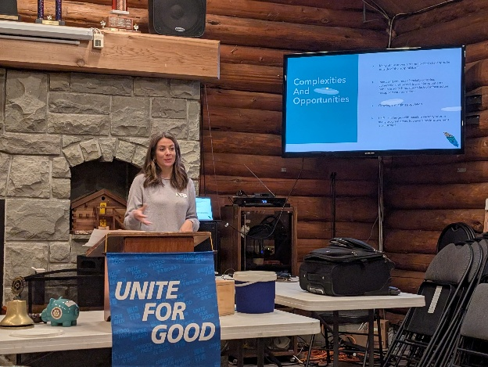

Upcoming Events for November
Nov 4 Loaves & Fishes (5:30-7:00 PM)
Nov 13 Visit by the YE students
Nov 15 Hornets Rugby Games
Nov 22 Christmas Decorating at NRGH 11-3
Nov 29 Hornets Rugby Games
Nov 30 Lantzville Food Drive

Speakers for November
Nov 6 Brian MacFadden - Remembrance Day
Nov 13 Helen Lingham – Nanaimo Food Share
Nov 20 Neil Rukus – Lantzville Fire Chief
Nov 27 Judy Stephen – Nanaimo Magazine

Birthdays and Anniversaries
Birthdays Anniversaries
Nov 29 James Williams Nov 4 Lee & Caroline Rowley
Nov 13 Greg &Sue Devenish
Happy Birthday Congratulations

Health
James Williams is currently residing in the Nanaimo Hospital. We wish you a speedy recovery James.
Norm Smith healing at home. Hope to see him at the meetings soon.

2025 ROTARY CLUB OF LANTZVILLE DUTY ROSTER
November 2025
If the date you are assigned does not work for you, please arrange for someone to take your task

DATE | Greeter | Cash | Sgt. Arms | INTROS | INSPIRATION | ROTARY  MINUTE
Nov 6 | Trevor | Jo-Anne | Greg | Doug | David | Mark
Nov 13 | Jo-Anne | Joy | David | Brian | Michael | Alexis
Nov 20 | Ralph | Mark | Douglas | Greg | Janice | Lance
Nov 27 | Stephen | Trevor | Doug | Jodie | Sheila | Greg

For any additional news about The Rotary Club of Lantzville, Please visit our Facebook Page:
https://www.facebook.com/RotaryClubofLantzville/

Quote: “Just one small positive thought in the morning can change your whole day”-

Happy Reading. Cheers!

