

The Lantz September in Review2026
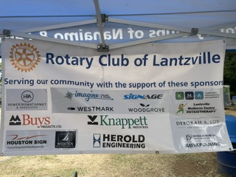

“Lantzville Rotary is more than grateful to all the above sponsors for their support. Their annual donations of $300 help us help others in our community.”

🌟 Another Paul Harris Recognition for Greg Devenish
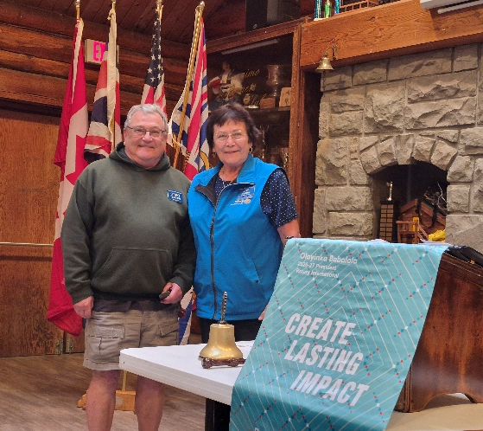
This month our club is proud to recognize Greg Devenish for achieving another Paul Harris level, reflecting his continued commitment to The Rotary Foundation and its life-changing work. Greg’s steady support strengthens Rotary’s impact locally and globally, and we are grateful for his ongoing dedication to service.

September 3rd
Nanaimo Youth Services Association (NYSA)
To start the month off we had a very informative speaker, Jacqualine Salvino.
She told us that Nanaimo Youth Services Association (NYSA) continues to provide essential supports that help young people build stability and independence.
Housing & Life Skills NYSA offers 22 transitional housing units for youth ages 16–19 in its Youth Housing building, along with 14 affordable units for young adults ages 19–25 at Rowe House. Youth participate in SmartRenter workshops and life-skills programming such as budgeting, menu planning, and personal development.
Employment & Training: BladeRunners program prepares youth for full-time employment, offering training stipends and funding for tools, work wear, and other job-related costs. NYSA also operates L2N Driver Training, providing supervised driving hours to help young people qualify for their road test.
Personal Support Through its Supportive Living program, NYSA provides outreach to approximately 50 youth connected to the Ministry of Children and Family Development. Additional supports include life-skills workshops, job coaching, résumé assistance, and employment-search strategies. This is where we as members of the community can help. Jacqualine would like us to tell our work story to youth in their programs.



September 10th
Habitat for Humanity
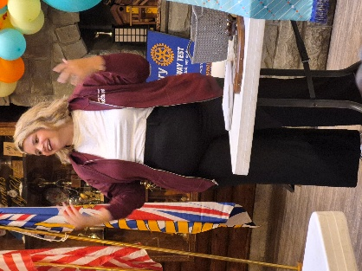
Habitat for Humanity, guest speaker Abigail Shakespeare, informed us, steps in to help the “missing middle” group of people find suitable and stable housing. They presumably have work, so aren’t homeless but can they afford today’s high rents, let alone be able to buy their own place. “Housing,” she said, “takes 30% or more of our income and 33% of Canadians spend more than that every month.”
Stress relieved, the benefits of living in stable housing are major: earnings increase and multi-generational opportunities are possible. So, finding or providing a place that this section of humanity can call home is the focus of the nine such agencies in BC. In fact, 28 homes have been built in our area, and another is about to open on 2nd Street - providing stable accommodation for one of the 200 families who have submitted applications. Those residents: parents, children, grandparents, will pay no interest on the mortgage and have the remarkable opportunity to pay off the down payment by volunteering with the society for 500 hours. Seventeen builders do the construction with the help of these volunteers and others from all walks of life.
Restore shops are part of Habitat for Humanity, circulating useful, donated items into new and needy residences. Some critical repairs for seniors still in their own homes can be provided as well.
“Volunteers are always needed, always welcome,” Abigail stressed. “Would Lantzville Rotary like to put in a team?”
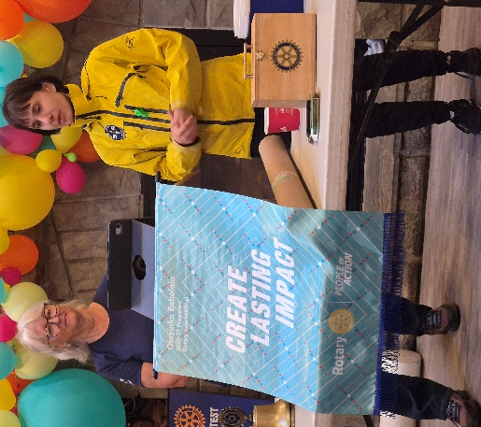
September 17th Search & Rescue
At this regular Thursday morning meeting, Jodie introduced two speakers – volunteers from Nanaimo Search and Rescue. Natalia Filip is one of the hardy rescuers who goes out to help and bring back outdoor adventurers who get themselves into an untenable situation. Joanne Swain wasn’t up to those physical challenges but helps in a different way. “When rescuers come back,” she told us, “The last thing they feel like doing is sitting down at a computer and typing up a report. I can do that for them along with other paperwork.”
Rescuers fall into three categories: air, marine, and ground. Training, representing possible scenarios, are many, varied and essential - to the tune of 20 per year. “Before that,” explained Natalia,” we had to complete 100 hours of training, including an overnighter where we were put in a challenging situation such as our unprepared rescuees might experience,” she continued. “That was quite an experience, and all had to be done so we could qualify! We do more trainings than rescues.”
Some more numbers: there are 78 teams with approximately 3000 members in BC. 38 must be on call 24/7. There is no charge, ever, for assistance given. Money to cover cost of equipment comes from donations and grants. The current swift-water rescue truck is inadequate and needs to be upgraded. Helicopter training is especially expensive, as are most rescues. And now a drone team is in training which also eats up $$. Search dogs are invaluable members which require intense training which must be completed before they are 2 years old.
As well as their emergency calls, Search & Rescue members are on stand-by at some events, both supporting other agencies like BC Wildfire and talking to the public. They hand out mini kits containing a survival blanket and a whistle. These were put to their intended use by some teenagers who needed help – a “textbook” rescue case for the girls had listened well at a presentation by Search and Rescue at their school.

September 24th, 2026
Louise introduced William Litchfield, Sea Scout Leader of Departure Bay Scouts, and his 3 children, who are Sea Scouts. All were still excited about a 3-day Scouting Camp being held at Nootka Marine Centre. So, he with the teenagers adding info from time to time, talked about that first – an example of a wondrous outdoor adventure. “You helped us fund this amazing weekend,” he began. “You bring bottles and cans regularly and made a financial donation as well. That money, plus from others, brought the price down to a manageable $100 per person. The venue produced amazing food, including pre-wrapped lunches to go to sea with them.
“It was all about fishing,” he explained, “partly in the pouring rain! They learned the differences between rock fish, halibut, sole, ling cod (electric blue!), salmon and how to catch each kind. There were regulations to learn and decisions to be made about which size to throw back. Getting their hands dirty was part of each day, including how to fillet fish. They cooked their own salmon one night: seasoned, glazed, and carefully placed on the ring of rocks around the campfire.” They gave some fish names; we were told but ate them anyway! Some days they were far out on the ocean, depending on the kind of fish they sought. Stabilizers on the boat reduced rocking and seasickness. Once an eagle grabbed the bait off a line being flung out to the water! At their graduation, each scout was gifted with a fishing rod and some frozen fish to take home.
After telling us about this with great enthusiasm, William went on to give more general details about their program. “That was this year’s big camping event,” he continued. “Next year’s will be something equally special – but different! At regular meetings they learn many varied skills like sharpening knives, safe use of matches and axes, even cooking skills where sometimes they must earn the ingredients. They must then eat what they have prepared!” Even riding the buses was a learning experience.
“Today’s kids miss out on many challenging experiences like failing a grade at school or playing rough in the playgrounds. Scouting takes away the cotton wool, and best of all, they have fun indoors, and especially out of doors, that doesn’t include cell phones and social media.” No wonder that troupe has a waiting list of more kids wanting to join.
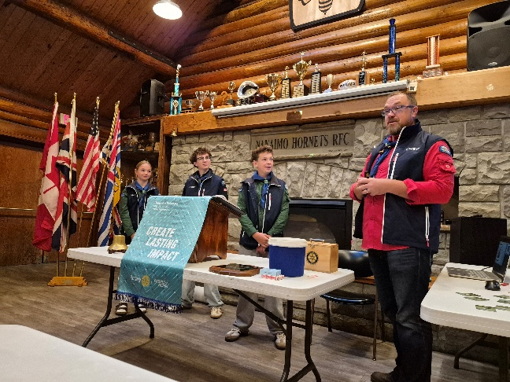

Tour de Rock Gala, Nanaimo, September 27th, 2026

Some of My Impressions

- That remarkable bike ride from Port Alice via Tofino to Victoria is one of the ambitious fundraiser under the Cops for Cancer banner; their focus is on children with cancer.
- The room at Coast Bastion Hotel was decorated and welcoming, each table with floral centerpieces donated by Thrifty Foods and some printed information. Seating was set aside at each table for 1 or 2 cyclists, randomly chosen by them. Our table netted two ladies who aren’t “cops” but had their own personal reasons for joining the ride and representing their communities.
- I couldn’t help noticing how many attendees were clad mainly in black and white. The multi-coloured jackets of the riders stood out beautifully in contrast.
- The food was delicious and plentiful.
- Silent Auction items drew plenty of generous offers.
- A live auction was run by Norm with speed, finesse, humour and more liberal donations.
- Presentations were made stating heart-felt thanks to the many people who are essential in preparing and running a huge event like this.
- Lots of laughter sounded around the room, often brought on by remarks made by those at the microphone; plenty of enthusiastic clapping and cheering resounded often too.
- What an ambitious way to raise money for cancer research focusing on children.
- An amazing story of how a family dealt with their child’s cancer diagnoses and how the child wanted to give back by having a lemonade sale. The child presented a cheque to the Tour for over $1000.00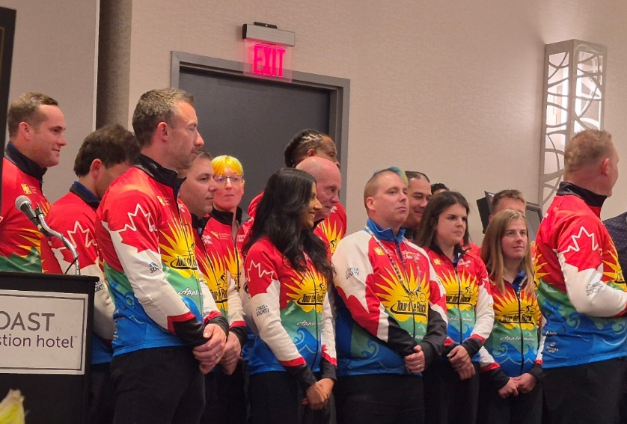
- WOW!!


Birthdays
^{David Lobay Oct 2nd}
^{Shawn Kilner Oct 10th}
^{Kay Knox Oct 13th}

Up Coming Events
Oct 3rd Fall Shredding Event at Woodgrove Centre
October 16th from 13:00 to 17:00 hrs at St. Philip-By the-Sea
Oct 24th & 25th Puzzle Sale at Woodgrove Centre. Centre Hours

Upcoming Speakers
Oct 1st Rotary Business Meeting
Oct 8th George Anderson MLA
Oct. 15th District Governor Linda Kaye Briggs
Oct 22nd Keighley Becker "Partnerships ears to you "
Oct. 29th Cherie Alyward Classification

2026 ROTARY CLUB OF LANTZVILLE DUTY ROSTER
Oct 2026
If the date you are assigned does not work for you, please ask someone to take your task
DATE | Greeter | Cash | Sgt. Arms | INTROS | INSPIRATION | ROTARY  MINUTE
Oct 1 | Stephen | Trevor | Doug V. | Joy | Lee | Jodie
Oct 8 | Kay | Joy | David | Michael R. | Alexis | Stephen
Oct 15 | Norm | Mark | Brian | Jodie | Trevor | David
Oct 22 | Cassie | Jo-Anne | Jodie | Lee | Brian | Doug S.
Oct 29 | Dale | Trevor | Doug S. | Cherie | Cassie | Sheila

For any additional news about The Rotary Club of Lantzville, please visit our Facebook Page:
https://www.facebook.com/RotaryClubofLantzville/

Thanksgiving Oct 12th
Halloween Oct 31st

Happy Reading, Cheers

