i

April 15th, 2021
Maternal & Child Health
Service Month

IN THE LANCE THIS WEEK

Meeting Notes
Inspiration
Bits and Pieces

FUTURE EVENTS

April 22nd - Dr. Deb Saucier
President,
Vancouver Island
University

VISITORS AND GUESTS
Past president Barry Sparkes; Kimberley Barrett, Nanaimo Rotaract

CELEBRATIONS
Congratulations to James and Jodie on their 14th wedding anniversary.

HEALTH OF THE CLUB
Our condolences to Don White with the loss of his beloved wife Iline.

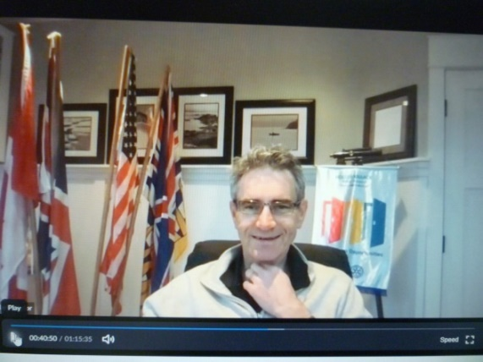

MEETING NOTES

Looking to what the new normal might look like, President Mark was very appreciative of our survey responses. The venue committee (Mark, Jodie, Joy & Michael) recommendationsare to meet in person July/August at Huddlestone Park every second week following public health officer regulations. Alternate weekly meetings would be via zoom. In September, we hope we are able to have weekly in person meetings at the Nanaimo Rugby Club.Details as to food and beverages need further discussion. On the fourth Thursday each month the club would meet via zoom.

Looking to broaden membership and enhance community service, Kimberley tells us Nanaimo Rotaract is transitioning to a community based club. A current polio plus fund raising project, they are selling vaccination bracelet. RCL donations can be directed to Greg.

INSPIRATION

Commenting on the amazing current events in the science world, Lee shared favourite quotes…

“Science without religion is lame. Religion without science is blind. ”

“Nothing in life is to be feared, it is only to be understood. Now is the time to understand more.”

FOR ROTARY – JANUARY 2005
~Author Unknown~

Things I learned from being a Rotary Exchange student:
1. Service before self.
2. Independent investigation of truth.
3. Is it fair to all concerned?
4. The oneness of humanity.
5. If it is to be; it’s up to me.
6. I am only one, but I am one. I can make a difference if I choose to.
7. Do what you can, with what you have, where you are.
8. The world changes bit by bit, one person at a time. Be one of the people who help it change.
9. Strength comes from the inside, not out.
10. Change happens because of hard work, not hard wishes.

BITS AND PIECES

Update from Tessa, a small project we funded, ‘Help Lesotho’ is putting together workbooks for children unable to attend school.

It’s official, Team Lantzville has 8 RCL members joining President Mark in a virtual cross Canada journey. This event is being done in honour of Jennifer Jones who will become the first woman RI president on July 1st, 2022.

April 24th – 30th is World Immunization Week. Thanks to the Bill & Melinda Gates Foundation, donations to Rotary’s Polio Plus Fund will be tripled.

As a surprise to him, William L’s wife & children orchestrated a ‘Just Because’ celebration party with signs, music & burgers. What a great idea!

Many of us and our friends have or are scheduled for the COVID vaccination. How fortunate we are to have the science we have today!

Today’s duties – TY Troy, Lee, Jodie, Joy

