Luci

April 1st, 2021
Maternal & Child Health
Service Month

IN THE LANCE THIS WEEK

SPEAKER PRESENTATION
INSPIRATION
SARGENT @ ARMS
ROTARY MINUTE

FUTURE EVENTS

April 8th– Dr. Ruth Mathieson
International Service - Kenya

VISITORS AND GUESTS

RCL honorary member, Barry Sparkes; Lucy Morel, RYLA 2021 participant

CELEBRATIONS

Birthday wishes to Doug Slowski and Jamal Youssef.
~~~

‘If we have the attitude that it is going to be a great day it usually is.’ Catherine Pulsifer
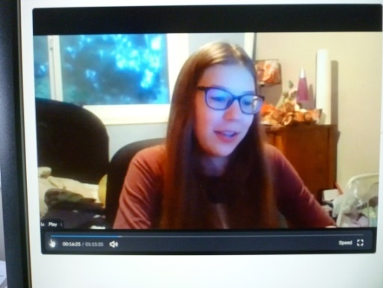
SPEAKER PRESENTATION

Lucy Morel is an exceptionally ‘with-it’ grade 11 student at Wellington. She recently participated in District 5020 – 5030, 10 day virtual Rotary Youth Leadership Award conference along with several hundred students from 5 countries.

Lucy gave an amazing presentation about the conference.Some of her take away key messages...
-why relationships matter,
-individual personalities differ, important to recognize and learn how to work with this,
-practice letting go,
-how our brains process information,
-4 steps for an apology; how to say TY,
-okay to be the dumbest person in the room.
-tell everyone your goals.

A follow-up to the conference, Lucy’s action group is working on a VI Restoration project. Kudo’s to Lucy for her amazingly inspiring presentation.

INSPIRATION – TY DAVID LOBAY

SARGAENT AT ARMS – MIKE WALKER

Being April 1st& a first time SaA, Mike gave us several chuckles. With no rehearsal, the meeting agenda began with the Four Way Test followed by a toast to Rotary. Introductions happened after Lucy’s presentation and the meeting ended with a robust version of ‘Canada’. Yes, we survived!

Happy bucks, sad bucks…member updates…

Troy delighted with his Calgary visitor, the opportunity to catch-up & going for bike rides.

Dale, looking forward to Easter egg hunt for his neighbours children.

Greg & Susan, thrilled to view the Orcas in H.Bay.

Happily vaccinated - Brian & Sandy, Joy & George, Lee’s parents.

From Don T., it’s a great time for sports fans.

Cor happy to be building a house on Sprout Lake, not so happy as to lumber costs.

ROTARY MINUTE - CHERYL

From the minute you take your 1st breathe until we take our last – most of us live @ about 40% of our true capacity. We are all free to find our own greatness, but first we must master our own minds.

TY’s to everyone from PRESIDENT MARK!
