i

April 22nd, 2021
Maternal & Child Health
Service Month

IN THE LANCE THIS WEEK

Meeting Notes

Inspiration

Dr. Saucier

FUTURE EVENTS

April 29th-RCL Information meeting

VISITORS AND GUESTS
Past president Barry Sparkes; Dr. Deb Saucier, VIU President

CELEBRATIONS

Congratulations to Brian & Sandy Rodgers on their 58thwedding anniversary.

“It’s amazing what you can achieve if you do not care who takes the credit for it.”
~~~Roosevelt.
“President Mark”

Meeting Notes

Pres. Mark welcomes everyone to sign-on on our Team Lantzville virtual cross Canada journey.

From Troy, the 7-10 Club needs a new home.

INSPIRATION

“I came to believe that health services out not to have a price tag on them, and that people should be able to get whatever health services they required irrespective of their individual capacity to pay.”
~ Tommy Douglas

ROTARYMINUTE – JAMES WILLIAMS
James took the opportunity to talk about Rotary Friendship Exchanges. This is an international exchange program for Rotary members and friends that allows participants to take turns hosting one another in their homes and clubs.

In 2017, James and Jodie were one of 6 couples from VI and the Puget Sound participating in a 2 week Rotary Friendship exchange in New Zealand.

As part of the exchange, they visited 5 different clubs – each providing unique cultural activities.
For James & Jodie, it was a highly recommended, wonderful experience that left them with many good/long lasting friendships.

DR. DEBORAH SAUCIER
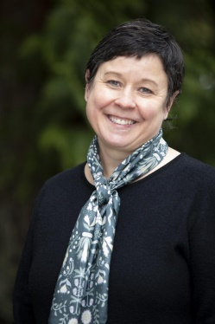

Appointed in November 2019, Dr. Deborah Saucier is the President & Vice-Chancellor of VIU.
She is an experienced administrator, accomplished neuroscientist and devoted educator. Originally from Saskatoon, Dr. Saucier is a member of the Metis Nation of Alberta. She has strong Vancouver Island family roots and very much welcomed the opportunity to return home.

Dr. Saucier spoke about how VIU has weathered the COVID storm. In 1 week, VIU moved 2,000 faculty and 13,000 students to on line learning. With partnership funding from a national non-profit, VIU MBA students were placed in local businesses to provide guidance with COVID recovery plans. In a matter of 6 weeks, VIU provided ½ million $$$’s for emergency bursaries. The need to provide safe, affordable access to education has become more challenging. Education does not just happen in a vacuum – it is informed & shaped by partnerships & participants.

VIU is built by & for the community with a unique mandate. Dr. Saucier spoke about the development of a bold new vision for the future. Work began in 2020 with conversations, workshops, surveys, meetings, emails, phone callswith employees, learners and community members. Following revisions and approval by VIU’s governance bodies, the final document will be launched in the Fall. The Plan is all about welcoming People, honoring Place, building Potential.

Dr. Saucier’ sincere, interesting presentationwas amazingly, inspirational. VIU is in good hands.

