i

April 29th, 2021
Maternal & Child Health
Service Month

IN THE LANCE THIS WEEK

Meeting Notes
Rotary Minute
Member Updates

FUTURE EVENTS

May 6th, 2021 Scout CampCaillet
Chris Stephens

13th Real Estate 2021
Jan Stromar

VISITORS AND GUESTS

ADG, Wayne Anderson

HEALTH OF THE CLUB

Great to hear that Jamal is mostly recovered, looking healthy, keeping very busy. Late May, golf is a go for Dale.

MEETING NOTES

In opening remarks, President Mark acknowledged that our RCL weekly meeting is held in the traditional territory of the Snaw-naw-as First Nation.

A delightful treat, as an alternative to O’Canada, we listened to ‘Up Here, In Canada’ by BC country singer Clarke W. Thank you Barry!

In your incoming email from Mark, are details about the May 14-16th, Presidential Conference USA. Registration for this event closes May 7th.

This week, Greg will deliver our ‘vaccinated’bracelets. Thank-you from Rotaract for RCL support.

Update from Stephen, the VI Eco Challenge collected 250 lbs of garbage. Prize donations to participants will be distributed this week.

The 2020 Kettle campaign was a huge success. SA envoy, Dawne Anderson sent a thank-you to RCL and our volunteers. FYI…volunteers are currently needed at the SA Thrift Stores.

Mark is looking for registrations for our Team Lantzville April- May 31st, cross Canada journey.

CONGRATULATIONS

To Stephen with his new job @ VI Construction Association. Added bonus, Stephen will be our 2021-2022 Youth Service Director.

To Lee – Our newest Paul Harris Fellow!
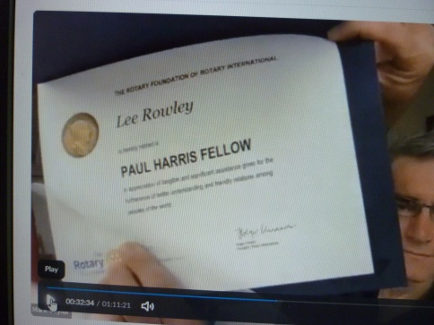

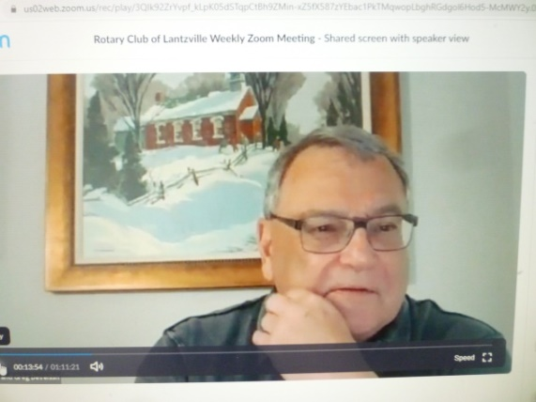
ROTARY MINUTE – GREG DEVENISH
A condensed version of Greg’s touching Mother’s Day story.

A little boy came up to his mother in the kitchen and handed her a piece of paper. In part, this is what it said: For cutting the grass: $ 5.00, for cleaning up my room this week: $1.00, for going to the store for you: .50, taking out the garbage: $1.00 for getting a good report card: $5.00,
…total owed: $ 14.75.

Well, his mother looked at him and the boy could see the memories flashing through her mind. She picked up the pen, turned over the paper he’d written on, and in part, this is what she wrote: “For the nine months I carried you: No Charge, For all the nights I sat up with you, doctored and prayed for you: No Charge, For the toys, food, clothes, and even wiping your nose: No Charge. When you add it up, Son the cost of my love is: No Charge.”

When the boy finished reading, there were big tears in his eyes, and he looked straight up at his mother and said, “Mom, I sure do love you.” And then he took the pen and in great big letters he wrote: “PAID IN FULL.”

“What happens is of little significance compared with the stories we tell ourselves about what happens. Events matter little, only stories of events affect us.” ~~~RabihAlameddine

MEMBER UPDATES

Upcoming for Jodie, zoom learning with two conferences – Diversity&Equality&Disaster Aid

With limited supply and suppliers, James says looking for car restoration parts is depressing.

Joy & George looking forward to watching the Kentucky Derby.Ongoing busy in the garden.

Mark is busy with online teaching. Happy $$$’s, daughter Sara tested negative for COVID; helped son Cameron purchase his first car.

The ‘Up Here, In Canada’ video reminded Randy how much they miss road trips to see their family.

From Doug, Air Cadets are busy with 80th anniversary celebrations and planning for a 2022 UK- Canada exchange.

Dale reminisced about fond memories during his 4 years in Air Cadets. It was a truly great experience!

Mike is pleased the World Badminton Umpire Assessors are meeting, albeit at @ 5:00 am PST.

Greg is looking forward to a zoom VIMM tour with a Vancouver Boy Scout troup.

TY to this week’s 7-10 Crew
Greg, James Dave, Mark, Troy & Jodie

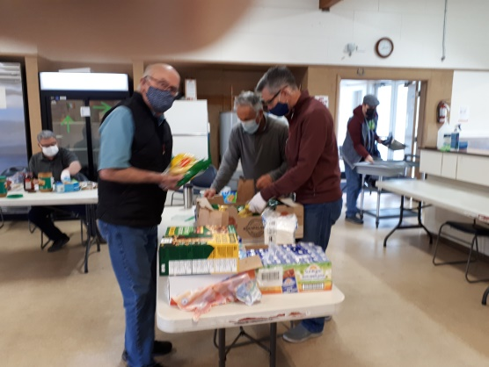
EXCITING NEWS FROM SAEKO

SaekoYabe was our RCL Youth Exchange student in 2015-2016.An extremely happy, outgoing lady, she willingly participated in club activities and eagerly shared her culture and her many Canadian adventures. This Spring,Saekograduated from Akita International University.

“I’ve spent 4 &½ years at AIU and graduated last weekend! I’m grateful to all the people who supported me in my life. I fully realize that ‘everything is a miracle’ is an important belief and is a true story that happened to me many times.”

EVERY ROTARIAN A ROLE MODEL

In 1949 RI adopted a special slogan relating to service to young people – “Every Rotarian an Example to Youth” as an expression of commitment to children and youth.

Over many years, our TCL has followed through on this commitment with family events; school breakfasts; scholarship & bursaries; support & participation of youth exchange, RYLA, Interact, Rotaract& Adventures activities; building community gardens & family housing; hosting community BBQ’s and providing financial support for children’s programs.

The slogan accepted over 70 years ago is just as vital today. It is a very thoughtful and ongoing challenge. “Every Rotarian an Example to Youth.”

CHILD & MATERNAL MORTALITY

The startling statistics on maternal and infant mortality offer perhaps the most disheartening evidence of human poverty. These statistics exceed the worst tragedies that we read about in Japan, Haiti, Africa, Thailand, etc. Worse – these human tragedies occur daily, year in and year out.

A German Red Cross worker holds a one month-old baby as he takes his last breath and dies. His mother died giving birth to him one month ago. The boy’s relatives kept him barely alive on sugar and water. But without mother’s milk, he couldn’t survive.

Each day over 25,000 children age five and below die from starvation – that’s 9 million children every year. (Starvation due to internal wars accounts for less than 10%)

350,000 mothers die every year, or one mother every minute from Reproductive Health causes of:

- Abortion
- Childbirth
- Complications from surgery

We know that nearly all these maternal deaths could be prevented.

Rotary International is moving to address these human tragedies through its programs of Humanitarian Service.

