i

April 8th, 2021
Maternal & Child Health
Service Month

IN THE LANCE THIS WEEK

SPEAKER PRESENTATION
INSPIRATION
ROTARY MINUTE

VISITING ROTARIAN – BELLEVIEW, ONT.
Dr. Ruth Mathieson

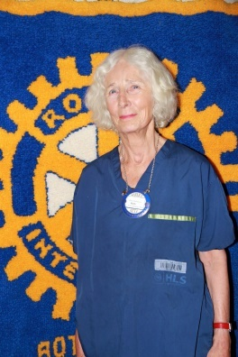

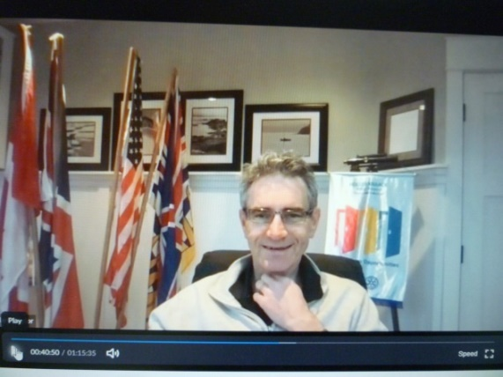
CLUB MEETING NOTES

For the next 2 weeks, five RYLA participants including our Lucy Morel are hosting a ‘Vancouver Island ECO Restoration’ contest. Contestants are charged with picking up a pound of garbage, tagging the location&posting to Instagram @ vi.eco.restoration. Check President Mark’s April 8th email for further information.

Ending on June 30th, as a fun fellowship event, Nanaimo Rotary is doing a virtual cross-Canada journey. President Mark is looking for RCL members to join him in this journey.

We had 60 people very happy at the 7-10 breakfast.

ROTARY MINUTE

Cor reflected on their February 2020 trip to Brazil and the subsequent COVID events that have and are still happening. Partly due to non-adherence to social distancing, Brazil currently has the 2nd highest # of deaths in the world. In Manaus, a city of 2 million people, 76 % of the population was infected in the first wave and 3,500 people died. The January 2ndwave defied ‘herd immunity assumptions’ with 3,200 deaths. Troubling times!

INSPIRATION

Not the strongest of our species survive, nor the most intelligent, but the one most adaptable to change. ~ Charles Darwin

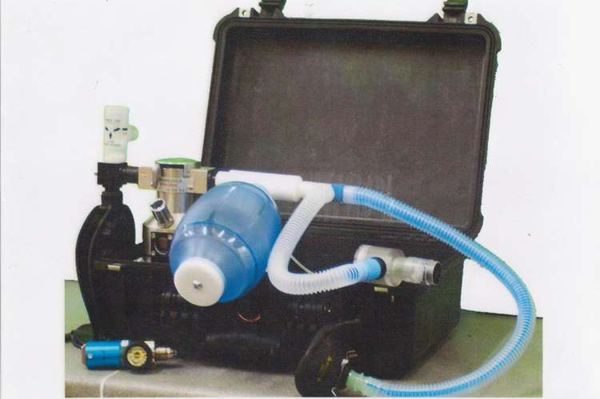

GLOSTAVENT
(A portable anesthesia machine)

In 2018, RCL supported the Belleview Ontario Rotary with their$ 25,000 district grant project to providean anesthesia kit to three rural hospitals in the Kagera region in NW Tanzania.

Dr. Mathieson, an anesthesiologist, works with a charity, Safe AnesthesiaWorldwide (SAWW). Their goal is to deliver medical equipment suitable for use in remote or poor locations that is effective, reliable and economical. In addition to equipment, SAWW provides skills training and support.

Glostavent is the brainchild of Dr. Roger Litringham. He saw the need for anesthesia when power or oxygen fails in the operating theatre. The machine is compact, relatively inexpensive and easy to use. It is manufactured in a small factory in the UK and used in more than 70 countries.

To Dr. Mathieson, a big thank-you for a very interesting presentation.

Happy Dollars – Sad Dollars

-Sad $ from Ralph, the company truck got smashed.
-Happy $ from Dale, on the mend, looking forward to golfing in May.
-James will soon be finished the car restoration.

Today’s duties TY Neil, Stephen, Michael, Cor

