“Rotary Opens Opportunities”

August 13th, 2020 – month theme is
Membership and Club Extension

IN THE LANCE THIS WEEK

RCAC CADETS
Lt. David Ruel

DARBY WALKER
‘Mind over Matter’

ROTARY MINUTE

VISITORS AND GUESTS

Barry Sparkes, Cor Buys & Cheryl Prince joined our ‘virtual’ meeting.

BIRTHDAYS & ANNIVERSARIES

Congratulations to Brian & June McFadden celebrating their 56th anniversary on August 15th.

ROTARY CLUB OF LANTZVILLE
MISSION STATEMENT
Joining in fellowship to support growth and development in education and health for those less fortunate in our local and international communities.

MEETING NOTES

Our meeting began with a warm welcome from president Mark followed by a recorded presentation of O’Canada. President Mark had big thank-you’s to our presentators.

Rachel is well prepared for ‘Fitness in the Park’ on Saturday. Thank-you to Lee for arranging the grounds & help with the tents, Stephen as MC, Harry as treasurer, club ambassadors Greg and Mark.

ROTARY MINUTE – LEE ROWLEY

History repeated – Lee spoke about Rotary’s response to the 1918 flu pandemic and gave examples of what Rotary clubs are doing in the 2020 pandemic.

In 1918, an estimated 500 million people worldwide became infected. Many cities closed theatres and placed restrictions on public gatherings. Rotary clubs, largely US based, were inspired to adapt and act. Following local guidelines they adjusted how they met and took action to help give local governments and health providers’ necessary services and support.

Today Rotarians response to the coronavirus is global. Everywhere there are examples of new pandemic inspired Rotary projects undertaken that are truly making a difference.

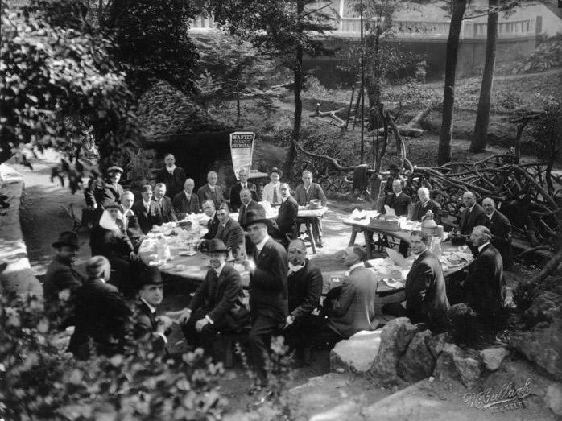

1918, Rotary Club of Berkeley
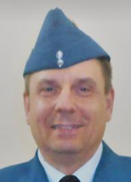

LT. DAVID RUEL
Collishaw Royal Canadian Air Cadet Squadron team member, Lt. David Ruel began by thanking us for our financial support. This has enabled them to purchase a pop-up tent that will be used to promote the squadron at public events. Across the country, there are over 450 air cadet squadrons with 23,000 cadets. Membership is open to youth aged 12-18.

In normal times, Collishaw squadron has 60-70 cadets meeting weekly to experience valuable life and work skills such as teamwork, leadership and global citizenship. Training nights cover a broad range of skills – drill, survival, principals of flight, navigation, etc. Successful completion of an air cadet proficiency level allows cadets to apply for summer courses to further develop areas of interest. Other activities include sports nights & field training exercises.

These past few months, the cadets worked on home activities. Going forward, squadron leaders across the country are currently working on the content and delivery of training in this new environment.

Passing thoughts…

The nice thing about living in a small town is that when you don’t know what you are doing, someone else usually does.

Before we work on artificial intelligence, why don’t we do something about natural stupidity?

‘MIND OVER MATTER’ DARBY WALKER

Darby began her presentation on a very rainy morning in Huddlestone Park by playing “The Grind”, a popular motivational speech used by the TCU baseball team. She spoke about the new and quickly growing field of Sport Psychology (SP). SP is like physiotherapy, but for the brain. Top athletes use SP to enhance their mental performance. SP is often used in business settings to assist professionals in team building and conflict resolution.

Always Darby has had a keen interest in sports. She has excelled and competed in gymnastics, speed swimming, volleyball and badminton. Following her 2018 graduation from VIU, in 2020 she attended the University of Stirling graduating with a Master’s of Science in Applied Sport Psychology. As a mental performance consultant, Darby works with athletes, sports teams and businesses.

Thank-you Darby for your presentation. We look forward to hearing more about your consulting practice.

“If you actions inspire others to dream more, learn more, do more, you are a leader.”

…John Quincy Adams



