“ROTARY CONNECTS THE WORLD”

August 15th^{h}, 2019
Membership Development Month

IN THE LANCE THIS WEEK

Dr. Glen Reed

Rebuilding Nanaimo BMX

FUTURE EVENTS

August 22nd - Dr. David Coupland
Nanaimo Regional Hospital
5 year transition plan

August 24th - 7-10 Community Breakfast
August 26th - Youth Exchange BBQ

August 29th - Chris Beaton
Nanaimo Aboriginal Centre

DUTY ROSTER – August 22nd
Greeters : Rodgers/Lemmon Cash: McFadden
Sgt-Arms: Tamelin Invocation: Cochrane
Introductions: Slowski Foundation: Elgie
Rotary Minute: Bergin

ROTARY CLUB OF LANTZVILLE
MISSION STATEMENT
Joining in fellowship to support growth and development in education and health for those less fortunate in our local and international
Communities.
VISITORS AND GUESTS

Guests for breakfast were Troy deJong – Price’s Alarms and Dr. Glen Reed – Reed Family Wellness Centre.

BIRTHDAYS AND ANNIVERSARIES

Today, Brian & June McFadden celebrate their 55th wedding anniversary. Next week, Mark & Hellen Taylor are 26 years married; Joy and George Robbins are 5 years.
HEALTH OF THE CLUB

Don Cohn and wife Shirley are into their new home at Bear Mountain. Don is anxious to get his ankle surgery behind him.

CLUB PRESIDENT – BARRY SPARKES

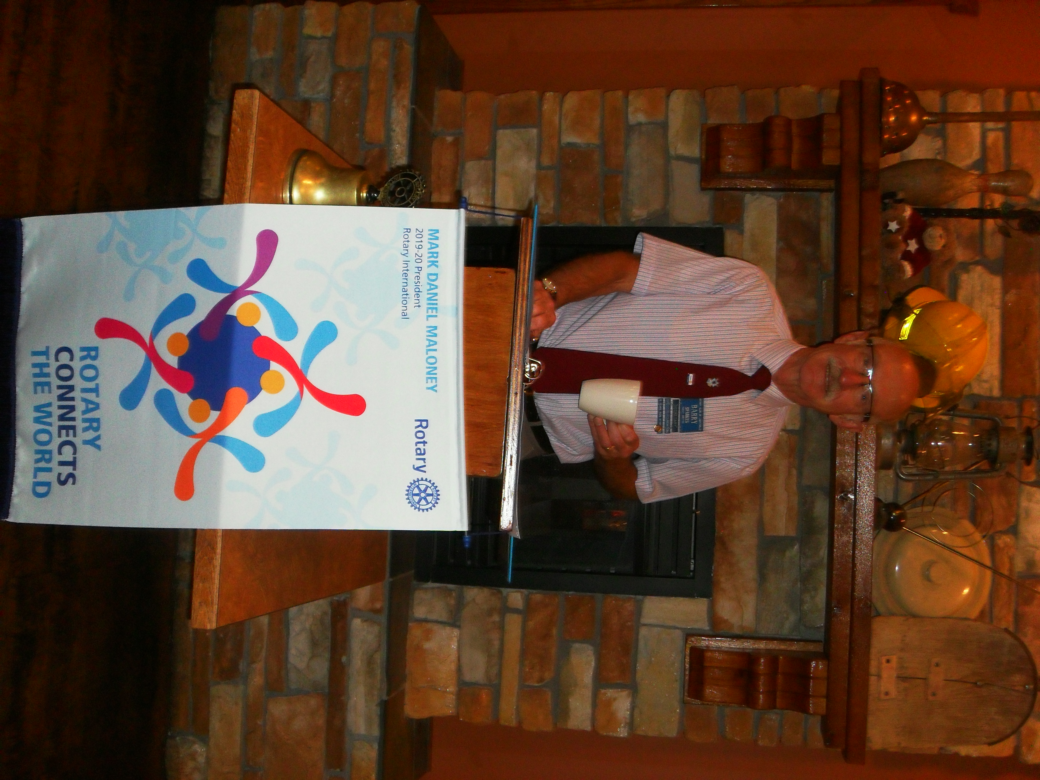

Barry extended a warm Rotary welcome to a rather noisy happy crowd.

Barry knew – August 15th marked the 50 anniversary of Woodstock – a 3 day festival of peace and music attended by ½ million people.

FOUNDATION
$ 90 contributed to the Rotary Foundation. Many thanks! David Elgie was the lucky holder of the draw for $ 14.
Please note, all contributions will go the Annual Fund unless you direct Barry otherwise.

SERGEANT AT ARMS – DAVE ELGIE

Happy $ from Harry – what a great place we live in. Last evening, on the beach, he and Maggie enjoyed a beautiful ‘red’ full moon. Silly happy $ from Tessa – puppy has mastered the stairs. Coming soon, Neil’s son is part of a Net Flix production in Kelowna. Not be to be outdone, Greg’s son was part of ‘Reefer Madness’. Happy $ from Doug S. 77 Air Cadets returned, safe & sound from their international home stay adventure. From Sheila, TY George for dinner last evening. Movie recommendations – from Ralph Lemmon ‘The Art of Racing in the Rain’, from Dave Elgie ‘Rocket Man’. Sad $ from Mike W. Truly missing, Janice and Darby who are still in Europe. He’s looking forward to rejoining them in Switzerland. Advertising $ from Don T. Please do consider attending the September 11th, TEDx talk at the Port Theatre. Dave E. looking for volunteers for the August 24th 7-10 Breakfast. As founding member of the Elite Calgary Flames fan club, Dave welcomes new members.
Lucky ticket winner was Joy. Not so lucky, she did not draw the joker. Next week, the pot is $ 340.

ROTARY MINUTE – HARRY HELFRICH

Harry talked about the strength and impact of our monthly magazine, “The Rotarian”.

Each edition is filled with stories of wonderful projects supporting humanity all across the globe. While reading you soon realize every good deed, every successful project was started by ONE person who had a passion for an idea. They brought that one idea to their club which enabled the passion to spread, and the idea then became a project. Sometimes, the idea spreads from Club to Club and becomes much bigger than even the original passionate person could have imagined. That is the power of passion and the power of Rotary.

Whatever your good idea, please do take the time to share it with club members. We need some ‘new’ good ideas and just maybe we too will end up in ‘The Rotarian’.
DR. GLEN REED
PRESIDENT NANAIMO BMX

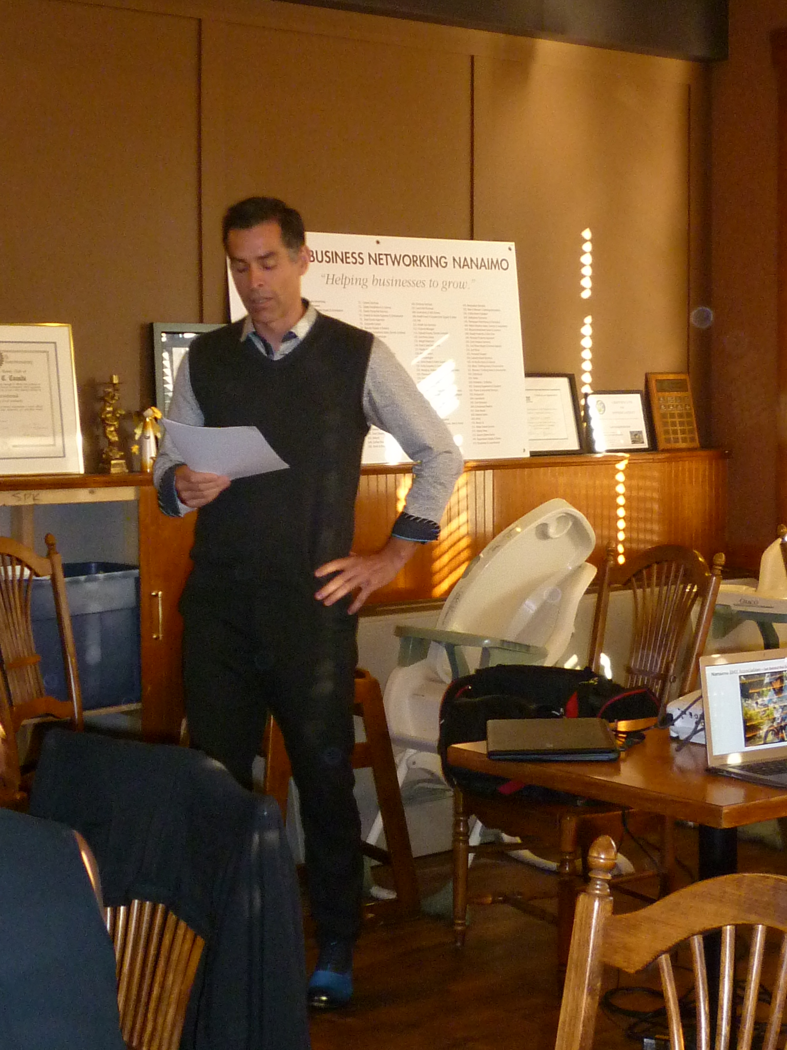

Nanaimo BMX is a 35 year old not for profit registered society promoting the family sport of bicycle motocross (BMX). The sport began in the early 1970’s in Southern California. Today, there are over 150,000 riders of all ages, riding and racing, at permanent tracks in North America. In 2008, BMX became a full medal Olympic sport.

The Nanaimo Club has 300 members ranging in age from 2 years old to 60 +. Several world BMX champions had their start with Nanaimo BMX, thanks to BMX coaching & mentors and Nanaimo BMX facilities.

Nanaimo BMX has a licensing agreement with the City of Nanaimo. Their $35,000 operating budget is supported by membership dues and the generosity of their donors. Race nights are a very affordable $ 8 per night and are open to everyone who wants to ride. The environment is positive & supportive with lots of cheering and coaching from parents and the ongoing mentoring by older members.

Currently, the Club, with the support of Nanaimo Parks & Recreation, is working on a major upgrade to the existing facilities. The plan is to replace the starting gate, upgrade infrastructure and redesign and build a larger start hill. This project will ensure that the track continues to attract and host local, provincial and international events. Total project cost is estimated at $ 350,000. Ongoing conversations have flagged this project for 2020 ‘Legacy’ 5-Club Rotary support.
SUBMISSIONS, UPCOMING EVENTS

August 26th - Rotary Youth Exchange Social
Nanaimo Curling Club
Contact person – Stephen Cochrane

September 11th – TEDx Speaker – Port Theatre
Dr. Nadya Zhexembayeva
Contact person, Don Tamelin

October 5th – Cowichan Valley Wine Tour $ 130 All day, 5 wineries, lunch, transport
Presented by Nanaimo North Rotary
Contact person - Barney Sharp

“The future belongs to those who believe in the beauty of their dreams.” Eleanor Roosevelt

OUR SINCEREST CONGRATULATIONS
TO BEV HILTON
NANAIMO/LANTZVILLE ADG 2015-2018

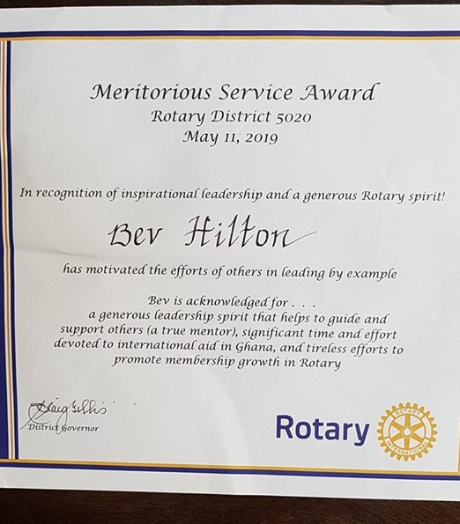
MEMBERSHIP & NEW CLUB DEVELOPMENT
August in Rotary is known as Membership and New Club Development Month. Membership is essential to every aspect of a Rotary club. In the beginning each and every new Rotary club starts with 20 people interested in joining and upholding Rotary’s ideals and values.
Nothing in a club gets done without its members. Rotary members run club meetings, hold club offices, and chair club committees. Rotary members contribute to The Rotary Foundation, become Paul Harris Fellows, and leave part of their estate to Rotary as Benefactors. Rotary members lead community service projects, support Youth Exchange, run Golf tournaments and build parks. Rotary members are an essential component for club survival. And like our bodies, we often need new oxygen to survive.

And thus it is, we focus on membership attraction to make new friends. We focus on membership to make a bigger difference in our communities. We focus on membership so that our legacy is a changing organization that overcomes real obstacles to eradicate Polio and “create lasting change across the globe, in our communities, and in ourselves.”

PLEASANT FEEL GOOD THOUGHTS

- Having a good conversation
- Giggling
- Enjoying a milkshake

- Making new friends or spending time with old ones
- Getting out of bed every morning and being grateful for another beautiful day

- Laughing for absolutely no reason
- Bubble baths; sweet dreams; hot showers
- Knowing you have done the right thing, no matter what other people think.

