“Rotary: Be The Inspiration”

August 16th, 2018
Membership & Extension Month

IN THE LANCE THIS WEEK

Visit from DG Craig

FUTURE EVENTS
Aug 23rd – NO Meeting
Aug 25th – Breakfast at 7-10 Club
Aug 28th – Meet the Youth Exchange Students
Aug 30th – Returning Exchange Student(s)

“VISITING” ROTARIANS
Bob Wall – Nanaimo “Daybreak”
Craig Gillis – Campbell River, Daybreak
And our District Governor

VISITORS and GUESTS
Greg Devonish – prospective new member
Don Hubbard – guest of Joy C
James Williams – former member

BIRTHDAYS & ANNIVERSARIES
 |  | DUTY ROSTER
DATE | GREETERS |  | CASH | Sgt-At-Arms | Invocation | INTRO | Foundation | Rotary  Minute
Aug 23rd | NO MEETING
Aug 30th | Kilner & Ribicic |  | Cohn | Lobay | Manikel | Kilner | Sparkes | Lemmon
Sep 6th | Litchfield & Bell |  | Lemmon | McFadden | Rodgers | Litchfield | Williams | Litchfield
If you cannot make your duty, it is your responsibility to find a replacement.
Joy & George – their 4th on Aug 20th.
Mark & Helen Taylor – their 25th on Aug 21st.
Dale & Geri Werezak – their 24th on Aug 24th.

HEALTH of the CLUB
We’re healthy – as far as we know..

ROTARY CLUB OF LANTZVILLE
MISSION STATEMENT
Joining in fellowship to support growth and development in education and health for those less fortunate in our local and international communities.

“Presidential” Observations
Feedback from her survey about breakfast – 21 replied:
- 7 – prefer just coffee and tea
- 7 – would like a continental breakfast
- 7 – opted for the full breakfast.
More to come on this after we talk to Vojto.

In response to the question about frequency of meetings: a [small] majority favoured weekly meetings – so, we shall go back to weekly meetings starting September 6th.

FOUNDATION
$80 donated to the Rotary Foundation. THANKS!

Sergeant-at-Arms
Don T was the Sgt this morning and recognized by David L for being the “low amateur” at a recent golf tournament. DG Craig tried to tell a joke. ☹ Barry complained about Randy’s deer. Jodie collected lots of wine – for the Youth Exchange fund raiser. James has been adding storage space to his garage. Don C was officiating at golf – with some very good golfers! Tessa stayed dry on Saturday. Bob W saw some humpbacks off his front yard. Harry made lots of wands in Coombs. Mike W glad to be back from China [badminton, what else?] Pres Jan going on a “European Vacation”. Brian McF had a story about Randy & Greg. Jamal is impressed by his granddaughter.
Jamal failed to find the joker, so the pot at our next meeting will be $50!


Breakfast at the 7-10 Club
Thanks for your support!
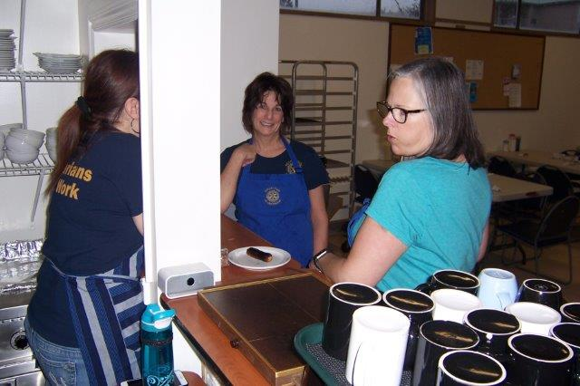
The front line – hard at work…?? ☺
Next breakfast – Saturday, August 25th.

News, Updates & Reminders
Annual dues ($220) are now due and payable to Harry – cash, cheque or credit card. Please.

- The members approved the amendments to the Club’s Policies. The 2018-2019 policies have been posted to the Club’s website: Member Area -> Organization -> Documents.

Coming Events”
- The 5-Clubs will be hosting a Youth Exchange Program Fundraising evening at the Cavallotti Lodge, Tuesday August 28th, 6PM. All are welcome. Contact Jodie if you would like to attend.
- There will be a 5-Club Friendship Dinner with Rotarians visiting from New Zealand at the Nanaimo Yacht Club, Tuesday, September 11th. All are welcome.
- There will be a 5-Club PolioPlus Awareness event, to promote Rotary in Nanaimo, October 24th. More details coming soon.

Community Service
The members approved a motion to contribute $1,000 (from Gaming Funds) to the Nanaimo-Ladysmith Schools Foundation 2018 “Stock the Locker” campaign – to go towards providing schools supplies, food, clothes, etc to less-fortunate students in School District 68.

Rotary Minute
- Why did you join Rotary?
- Why have you stayed in Rotary?
- How have you benefited from being a Rotarian?

Words of Encouragement from DG Craig
District Governor Craig Gillis is a member of the Rotary Club of Campbell River Daybreak and a retired school teacher. He has been active with the District in many ways for many years.
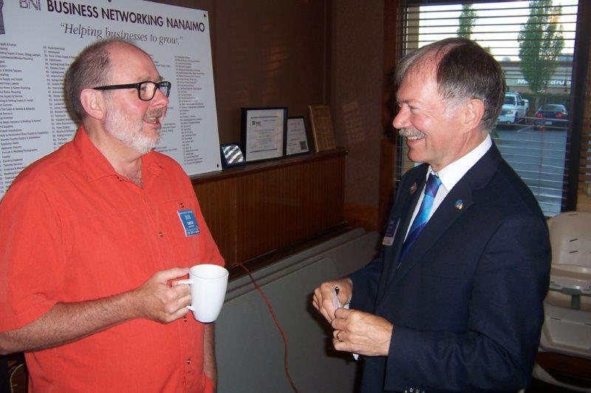
The visit provided an opportunity to meet and enjoy a laugh or two with members of our Club.
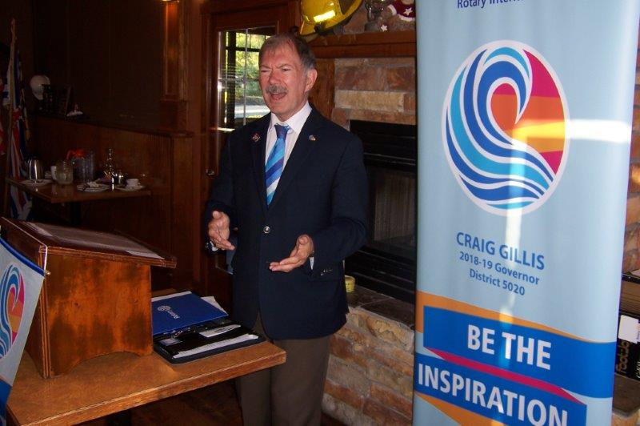
He answered some questions: Why join Rotary? Why bother with training? Why does the DG visit all the clubs?
With more hearts and more hands, we can do more and give more back to our communities.
Rotary can (and does) recognize ordinary people doing extraordinary things.
Supporters do not give “to” Rotary; they give “through” Rotary.
Rotary’s new vision statement: "Together, we see a world where people unite and take action to create lasting change — across the globe, in our communities, and in ourselves."
DG Craig encouraged us to take a moment and send “Craig’s Card” to say thank-you to someone who had an impact on your life.
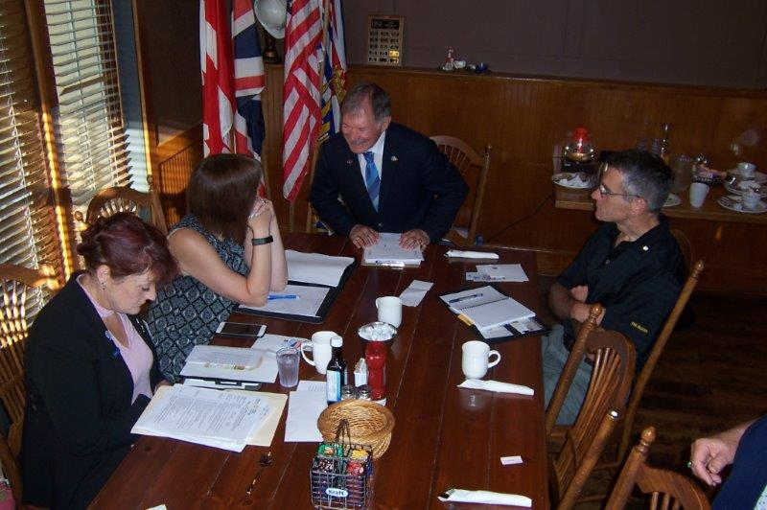
After the meeting, DG Craig met with the Board, provided some words of encouragement and learned about our goals for the coming year.

ROTARY INFO
You can find out where and when all the Clubs in District 5020 meet on the 5020 website:
www.clubrunner.ca/portal/Organization/Meetings.aspx?accountid=50092
Rotary International: http://www.rotary.org
Member’s access: https://www.rotary.org/myrotary/en
District 5020: www.rotary5020.org
Our website: www.clubrunner.ca/Lantzville
Our Facebook Page: www.facebook.com/RotaryClubofLantzville
Check it out – you might be surprised…

BEAUTIFUL BC – Campbell River




"May you always be granted…

A sunbeam to warm,
A moonbeam to charm,
A sheltering Angel,
so nothing can harm,
Laughter to cheer,
Faithful friends near,
And whenever you pray,
that Heaven will hear."

