

“ROTARY CONNECTS THE WORLD”

August 1st, 2019
Membership Development Month

IN THE LANCE THIS WEEK

Jamal’s West Coastal Trail Experience

Rotary Information

FUTURE EVENTS

August 7th - Directors’ Meeting

August 8th - Jennifer VanderSchaaf
Nanaimo Conservatory of Music

August 15th - Dr. Glen Reed
Rebuilding Nanaimo BMX

DUTY ROSTER – August 8th

Greeters : Bergin/Williams Cash: Walker
Sgt-Arms : McFadden Invocation: Tamelin
Introductions: Cochrane Foundation: Valsangkar
Rotary Minute: Robertson

ROTARY CLUB OF LANTZVILLE
MISSION STATEMENT
Joining in fellowship to support growth and development in education and health for those less fortunate in our local and international
communities.

VISITORS AND GUESTS

Joining us for breakfast was Troy deJong – Price’s Alarms and James Williams.

BIRTHDAYS AND ANNIVERSARIES

On August 2nd, Mike Walker is one year older and becoming way more experienced.

HEALTH OF OUR CLUB

Brian McFadden reported former member John King is recovering nicely from his visit to NRGH for multiple stents. Soon, he and Judy will be on the road in their motorhome. Happily, Doug’s wife Heather is now 100% healthy.

CLUB PRESIDENT - BARRY SPARKES

Barry extended a warm rotary welcome. On behalf of everyone, a big thank-you to Jim and Diane Tucker for hosting our Club BBQ. Also, thank-you to members for their work. It was a good day, with great food and very enjoyable Rotary fellowship.

On a different note, Barry asked us to be more mindful of our breakfast visitors and guests. Get to know them, make them feel welcome. Reminder, we still need volunteers for Club committees.

Barry knew – on August 1st, 1498 Christopher Columbus was the first European to set foot in Venezuela; 1957 marked the beginning of NORAD.

‘Without positive attitude success is called luck, with positive attitude success is called achievement.’

FOUNDATION
$ 140 contributed to the Rotary Foundation. Many thanks! Rachel Robertson was the lucky holder of the draw for $ 18.

Please note, all contributions will go the Annual Fund unless you direct Barry otherwise.
SERGEANT AT ARMS - DOUG SLOWSKI

Happy bucks, sad bucks, announcements –this is an interesting, entertaining part of our weekly meeting. Perhaps added bonus, when you catch the editor’s attention, sometimes an opportunity to get mentioned in the Lance. Mark happily contributed an advertising buck for his front page coverage in the Business Examiner. Good stuff! Stephen’s upcoming holiday plans include house renovations. Holiday maybe – rest is not in the picture. Stephen needs volunteers for a new youth mental health awareness project. Jody also needs volunteers for the Fall Terry Fox run. Dave had a big thank-you for our support at the 7-10 breakfast. Troy enjoyed his Saturday duties. Randy and Anne are looking forward to a family reunion in Manitoba. Jodie & James freezer is almost full with rewards from their great garden. Harry enjoyed his company, happy to return to more normal days. In early December Jamal & Liz will welcome a second grandchild. Drum roll, Jodie’s ticket was drawn for the $ 300 pot. No joker!

CLUB SERVICE

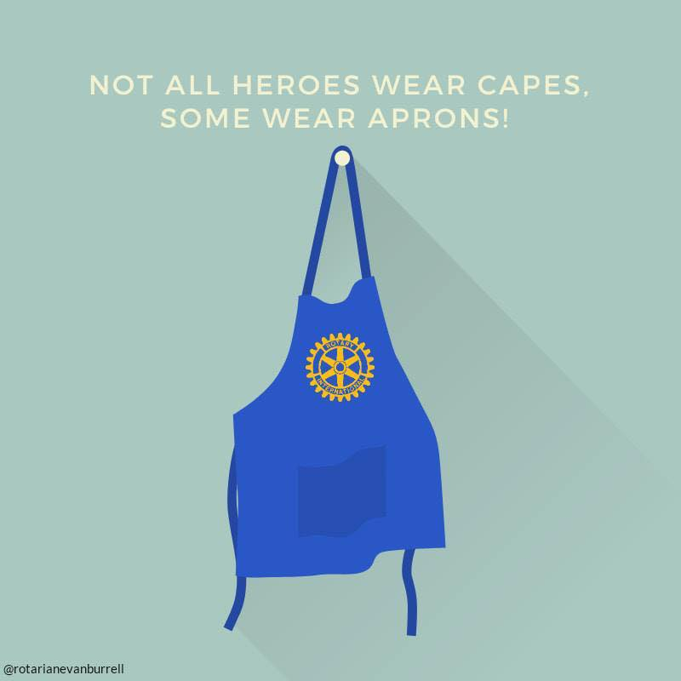
THE WEST COAST TRAIL

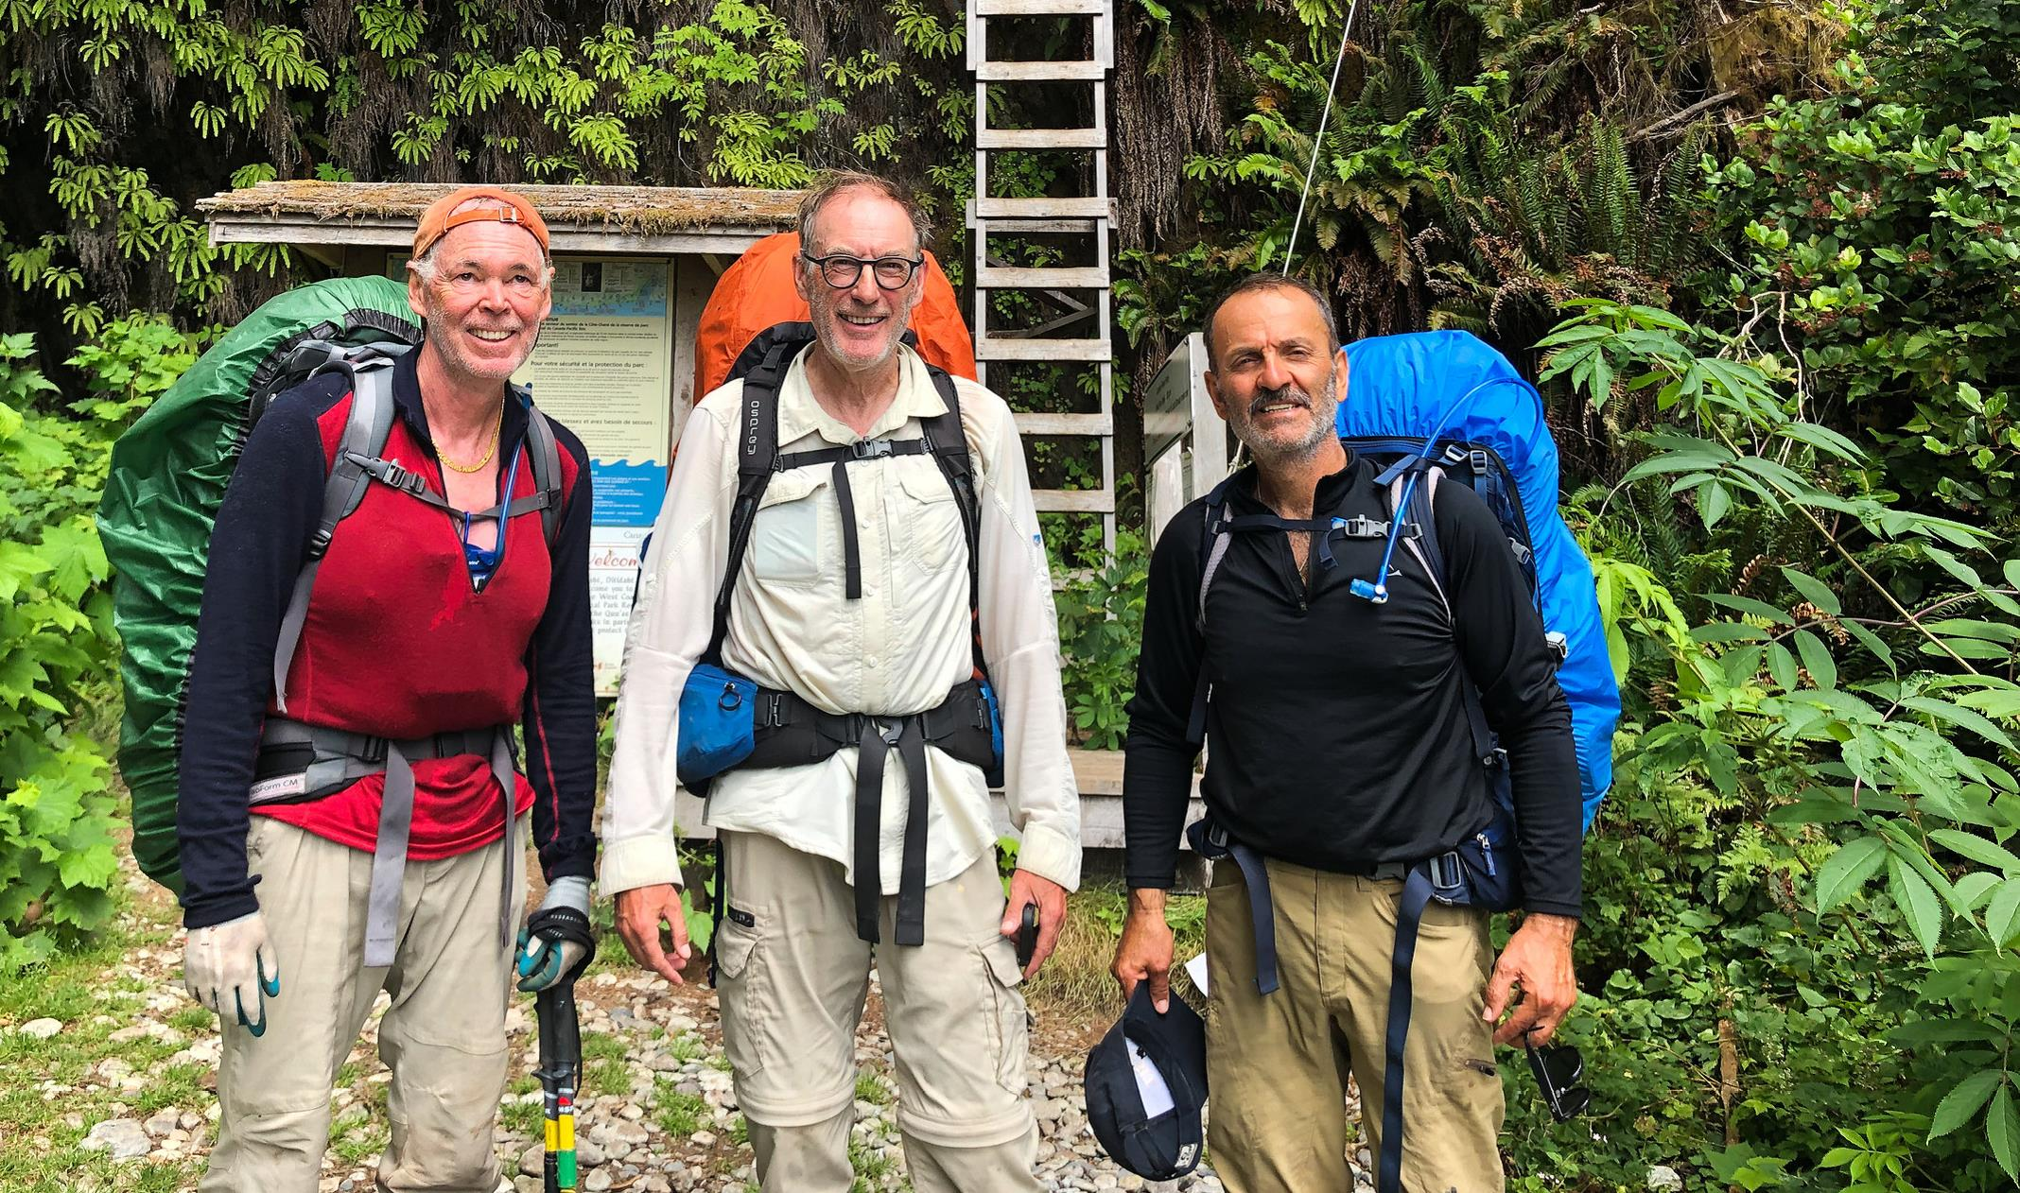

MARSHALL COOPER, IAN DOUGLAS, JAMAL

“Hiking from north to south is the original route of the life-saving trail. An experience that can bring even the most experienced hikers to their knees. Hikers climb more than a hundred ladders with a 50 pound pack, trudge through deep mud, and push through whatever weather the Wild West coast delivers. Two buddies and myself faced and conquered this grueling test of endurance from Tuesday July 9 to Monday, July 15, and came out of it humbled, happy and feeling like we accomplished something huge.”

Listening to Jamal describe the journey, their trek was an amazing accomplishment. This is the stuff they write movies about. Slimy, slippery, fallen trees! Beautiful scenery! Pouring rain! Pristine beaches! Abundant wild llife! Broken bridges! Ugly mud and big tree roots! Scary rock faces! Nightmarish boulders! Meeting cheerful, friendly hikers from everywhere in the world! Jamal, thank-you for sharing. We all admire your success.

‘The 75-km WCT is part of the trading routes travelled by First nations before the foreign sailing ships started to arrive off this coast over 200 years ago. As the years passed and the number of ships sailing the Juan de Fuca Straight increased, so too did the number of shipwrecks and drownings along the coast. The trail became known as the graveyard of the Pacific and in 1973 it became part of the Pacific Rim National Park Reserve.’

MINETOWN DAYS – September 7th

A community fair, Minetown Days is a significant all day family event in Lantzville. Early morning the RCL hosts a pancake breakfast. Next is the parade along Lantzville Road. In Huddleston Park, 11-3pm, there is fun for everyone – contests, exhibits, food vendors, live stage entertainment, etc.
Our Rotary Club of Lantzville is an exhibitor. The challenge, what do we want to do with this opportunity? Please give this some thought and share your suggestions with Mark or Barry.

SUBMISSIONS, UPCOMING EVENTS

August 21st - Friends of Aldea Maya Tea Party
Qualicum Beach 2-4 pm
Admission by donation
Contact person – Tessa Bell

August 24 - Ride To Conquer Cancer
Lower Mainland, 2 days, 200 K Participating in the ride is VGH
Surgeon Sita Ollek. For more info,
Contact JoyCameron/Sucha Ollek

August 26th – Rotary Youth Exchange Social
Nanaimo Curling Club
Silent auction, beer & burgers
Contact person – Stephen Cochrane

CLUB BBQ – OUR COOKS

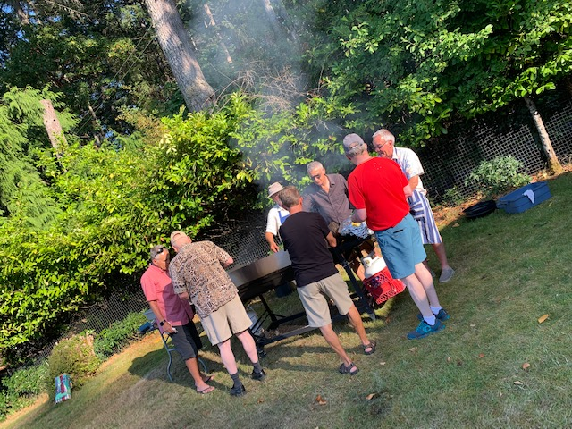
ROTARY PERSONAL MEMBERSHIP OPPORTUNITIES
- To work with others to improve our community
- To develop an expanded network Rotarians are eager to help each other
- To gain membership opportunities: to be one, and to have one
- To meet new friends and new people
- To learn more about your community and your world
- To gain opportunities to travel and immerse yourself in new cultures through Rotary projects
- To have input into the choice of projects the Rotary Club of Lantzville chooses.

THANK YOU DON!

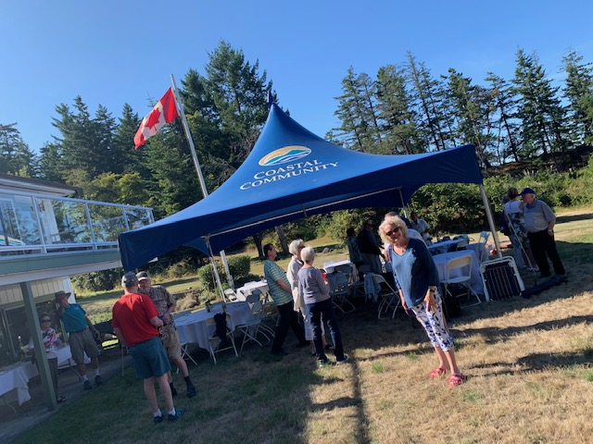

FUN STUFF

- Behind every angry woman stands a man who has absolutely no idea what he did wrong.
- A wise man once said – nothing.
- In my defense, I was left unsupervised.
- Camping: Where you spend a small fortune to live like a homeless person.
- Instead of “single” as a marital status, I prefer “independently owned and operated”.

