“Rotary: Be The Inspiration”

August 23rd, 2018
Membership & Extension Month

IN THE LANCE THIS WEEK

Visit from DG Craig

FUTURE EVENTS
Aug 25th – Breakfast at 7-10 Club
Aug 28th – Meet the Youth Exchange Students
Aug 30th – Returning Exchange Student(s)
Sept 6th - Regular morning meeting
Sept 13th – Regular morning meeting
Sept 19th – Board meeting – usual place
Sept 20th – Club Business meeting

“VISITING” ROTARIANS

VISITORS and GUESTS

BIRTHDAYS & ANNIVERSARIES
 |  | DUTY ROSTER
DATE | GREETERS |  | CASH | Sgt-At-Arms | Invocation | INTRO | Foundation | Rotary  Minute
Aug 30th | Kilner & Ribicic |  | Cohn | Lobay | Manikel | Kilner | Sparkes
Sept 6th | Litchfield & Bell |  | Lemmon | McFadden | Rodgers | Litchfield | Williams | Litchfield
Sept 13th | Lobay & Cameron |  | McFadden | Slowski | Ribicic | Lobay | Cohn | Lobay
If you cannot make your duty, it is your responsibility to find a replacement.
Dale & Geri Werezak – their 24th on the 24th. ☺

HEALTH of the CLUB
We’re healthy – as far as we know…

ROTARY CLUB OF LANTZVILLE
MISSION STATEMENT
Joining in fellowship to support growth and development in education and health for those less fortunate in our local and international communities.

“Presidential” Observations
Reminder that we will go back to meeting weekly (every Thursday morning) starting August 30th.
As Jan will be away on her European Vacation until mid-September, we will have special (surprise) leaders for the next 3 weekly meetings.
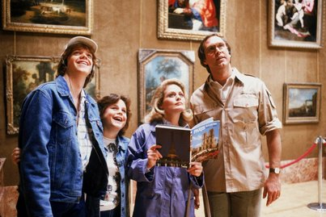

FOUNDATION
Your contributions to the Rotary Foundation will be directed to the Annual Fund – until we achieve our goal for this year of $2,800USD. THANKS!

Sergeant-at-Arms
 Who is this? What role did he play?? In what movie???

No one has found the joker, so far - so the pot at our next meeting will be $50!


Breakfast at the 7-10 Club
Thanks for your support!
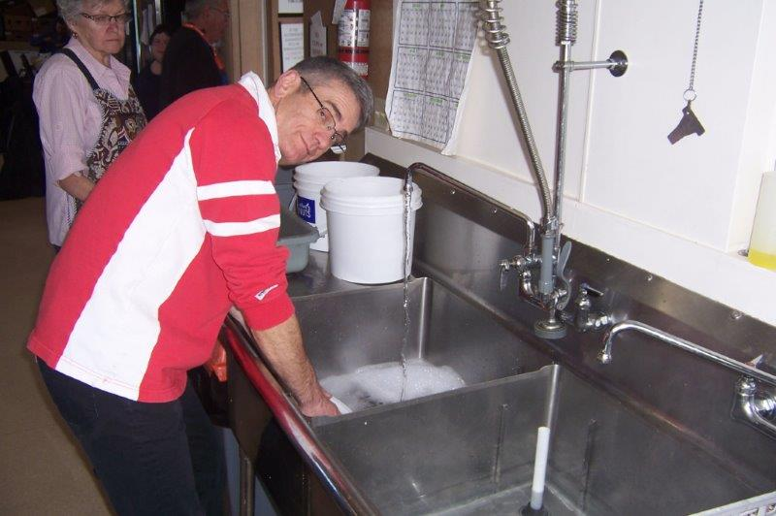
That endless line of dirty dishes…
Next breakfast – Saturday, August 25th.

News, Updates & Reminders
Annual dues ($220) are now due and payable to Harry – cash, cheque or credit card. Please.

Starting next week – another option for breakfast. Coffee only for $6. [$3.50 for the coffee (what the restaurant charges), $1 for set-up and tip, and $1.50 for the club.]

Coming Events”
- The 5-Clubs will be hosting a Youth Exchange Program Fundraising evening at the Cavallotti Lodge, Tuesday August 28th, 6PM. All are welcome. Contact Jodie if you would like to attend. Tickets also available at the door!
- There will be a 5-Club Friendship Dinner with Rotarians visiting from New Zealand at the Nanaimo Yacht Club, Tuesday, September 11th. All are welcome.
- There will be a 5-Club PolioPlus Awareness event, to promote Rotary in Nanaimo, October 24th. More details coming soon.

Rotary Minute
- Why did you join Rotary?
- Why have you stayed in Rotary?
- How have you benefited from being a Rotarian?

A Reason to Smile
Ricardo Román was shopping with his wife at a department store in Chile in 2012 when a woman in her early 20s approached him. He didn’t recognize her, he confesses through an interpreter, but there were two good reasons: He had last seen her more than a decade earlier – and her smile had changed drastically.
Román, a member of the Rotary Club of Reñaca, Chile, is the national coordinator of a program that has helped thousands of children in Chile with cleft lips, cleft palates, and other birth defects – including this stranger who now wanted to give Román a hug. “She told me, ‘This is my Rotarian smile,’” he recalls, his voice full of emotion. “It was a very gratifying moment.”
The project got its start in 1993 when San Francisco (California) Rotarians, led by Peter Lagarias and Angelo Capozzi, sponsored a medical mission that performed reconstructive surgeries in Chile. That was the beginning of Rotaplast (http://rotaplast.org ), a program that evolved into a nonprofit organization that has since sent teams to 26 countries.
In 2004, Rotarians in Chile assumed leadership of the program in their country. Over the years, Chilean doctors became more involved and eventually the program expanded to include breast reconstruction for cancer patients.

Surgeons Lena Pinillos, centre, and James Lehman (left) talk with a father about his child.
You can read the whole story on-line at: https://www.rotary.org/en/rotarians-across-continents-team-reconstructive-surgeries

ROTARY INFO
You can find out where and when all the Clubs in District 5020 meet on the 5020 website:
www.clubrunner.ca/portal/Organization/Meetings.aspx?accountid=50092
Rotary International: http://www.rotary.org
Member’s access: https://www.rotary.org/myrotary/en
District 5020: www.rotary5020.org
Our website: www.clubrunner.ca/Lantzville
Our Facebook Page: www.facebook.com/RotaryClubofLantzville
Check it out – you might be surprised…

BEAUTIFUL BC – Helmcken Falls in Wells Gray Provincial Park


Thank goodness for little old ladies…
A minister decided to do something a little different one Sunday morning. He said "Today, in church, I am going to say a single word and you are going to help me preach.
Whatever single word I say, I want you to sing whatever hymn that comes to your mind.
The pastor shouted out "CROSS " Immediately the congregation started singing in unison, " THE OLD RUGGED CROSS ."
The pastor hollered out "GRACE " The congregation began to sing "AMAZING GRACE, how sweet the sound"
The pastor said " POWER" The congregation sang " THERE IS POWER IN THE BLOOD "
The Pastor said " SEX " The congregation fell into total silence. Everyone was in shock. They all nervously began to look around at each other afraid to say anything. Then all of a sudden, way from in the back of the church, a little old 87-ear old grandmother stood up and began to sing " PRECIOUS MEMORIES ."

Seniors’ Logic, eh?
Last year I replaced all the windows in my house with those expensive, triple-pane, energy-efficient kind.
Today, I got a call from Home Depot who installed them. The caller complained that the work had been completed a year ago and I still hadn't paid for them.
Helloooo! Just because I'm a Senior Citizen doesn't mean that I am automatically mentally challenged. So, I told him just what his fast-talking sales guy told me last year --that these windows would pay for themselves in a year —
Hellooooo? It's been a year, so they're paid for, I told him. There was only silence at the other end of the line, so I hung up.
He never called back. I bet he felt like an idiot.



