

August 27th, 2020
Membership & Club Extension Month

IN THE LANCE THIS WEEK

ROTARY MINUTE

BIG BROTHERS – BIG SISTERS

VISITORS AND GUESTS

Happy to have Linda Murray and Barry Sparkes join our ‘zoom’ meeting.

BIRTHDAYS & ANNIVERSARIES

President Mark is looking forward to celebrating his birthday with a visit to Quadra Island.

ROTARY CLUB OF LANTZVILLE
MISSION STATEMENT
Joining in fellowship to support growth and development in education and health for those less fortunate in our local and international communities.

MEETING NOTES

Thanks to President Mark, we began our meeting with a visual presentation of O’Canada. It was good to see our co-host Don T., having returned from his vacation travels.

Of great significance, this week Africa was certified as wild polio-free after four years without a case. As Rotarians, we are one of the six core partners in the Global Polio Eradication Initiative. Worldwide only Pakistan and Afghanistan continue to see wild poliovirus transmission.

From Troy, a big thank-you to everyone who helped with the 7-10 breakfast. Rave reviews came from attendees at the sold-out event.

OUR ROTARIAN OF THE YEAR!

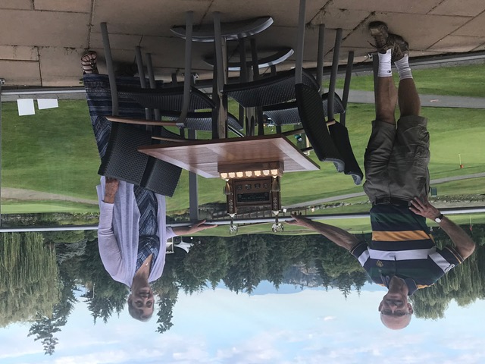

Congratulations Jodie – we love that you are so positive and thorough with everything you do.

Today’s quote…

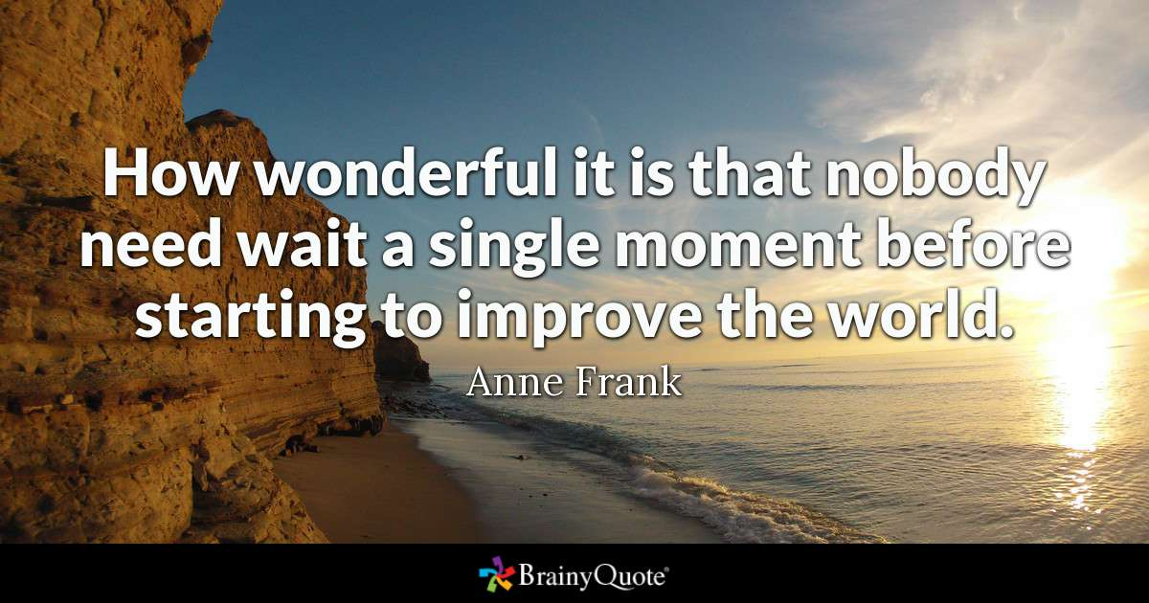
ROTARY MINUTE – DON TAMELIN

While on vacation in Thailand in 2002, Don met a student from the Netherlands taking part in a co-op programme for young professionals. Seeing the value of this experience, gave him inspiration to apply to participate in the Rotary Club of Duncan, 2004 Group Study Exchange (GSE) to Mexico. (GSE is a unique cultural and vocational exchange opportunity for young business and professional men and women between the ages of 25 and 40 in the initial years of their professional life.)

During the exchange, participants learn the language and culture, stay with host families, visit work places, tour the country side and attend Rotary meetings. One host Rotary club worked with a special needs school in La Barka. The Rotary Club partnered with a global wheelchair foundation member. The GSE team attended the club’s presentation of a wheel chair to a 6 year old boy. The impact of seeing someone with first time ever mobility thanks to the work of Rotarians was inspiring. Looking to help, the GSE team learned the school was in need of a handy-dart bus.

Back home, the group took on this project. With the help of District 5020 Rotarians, a bus was purchased, renovated and delivered to the school in Mexico and…it was packed with wheel chairs.

In Don’s words, for Rotarians, it is not about the $$’s we spend; it is about the time and energy that one gives. It’s about the connections we have. It’s about the satisfaction that comes from seeing and knowing that working together, we can make an impact. Thank-you Don for sharing your very powerful ‘why I am a Rotarian’ story.




Stephen Cochrane began with a catchy power point presentation about the new colours and branding for Big Brothers Big Sisters. The three-lined logo represents the key elements in helping a young person forge a path forward: Family, BBBS and Mentors. BBBS Central Vancouver Island is one of 108 member agencies serving more than 1100 communities across the country.

It is well known that mentored youth see positive results in life, in community and at work. Through a wide range of mentoring programs, in 2019 BBBS CVI, facilitated 225 matches with 100 mentors contributing 15,788 volunteer hours. Studies have identified that every $ 1 invested produces an economic return of $ 23.

Spring 2020 saw the collapse of close to 200 mentoring matches – and on a happier note the continuance of a few.

Going forward, staff at BBBS is back to working full time and are learning how to work with COVID. Service delivery requires new and different methods and skills. The Fall programs will be a combination of virtual, in-person and hybrid mentoring.

Information on how to become a mentor can be found on the BBBS CVI website. Mentors are screened, vetted, trained and monitored. What are needed are commitment and a genuine interest in helping youth.

Funding for BBBS comes from several sources including BC community gaming grants, business organizations, service clubs and individual donations.

Thank-you Stephen for the work you do and for your presentation!

WHAT’S UP

From David Lobay, a thank-you to Troy for his assistance in putting the club gaming grant application on line.

From Don Tamelin, a reminder about the Nanaimo Hospital Foundation “month of golf” tournament in September at Fairwinds. Please tell your friends.

Rachel tells us Solly is going to school in September to get a degree in kinesiology.

AUGUST 20TH CLUB SOCIAL

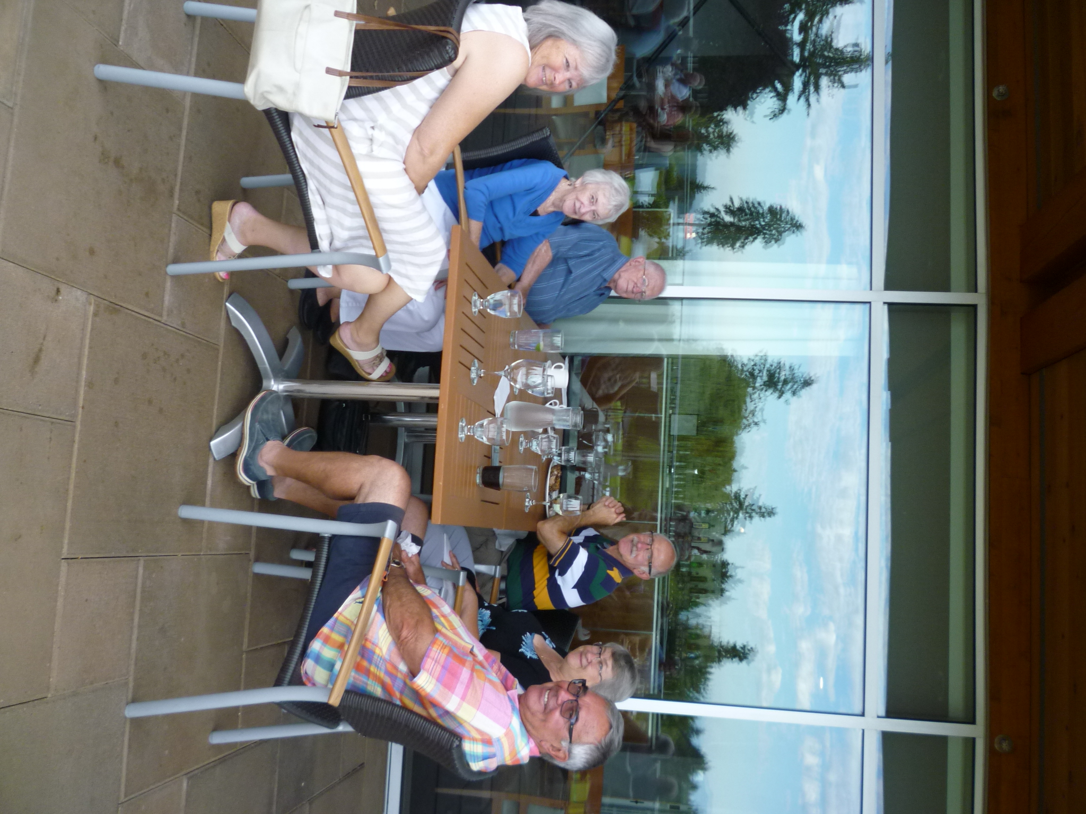
FITNESS IN THE PARK DJ

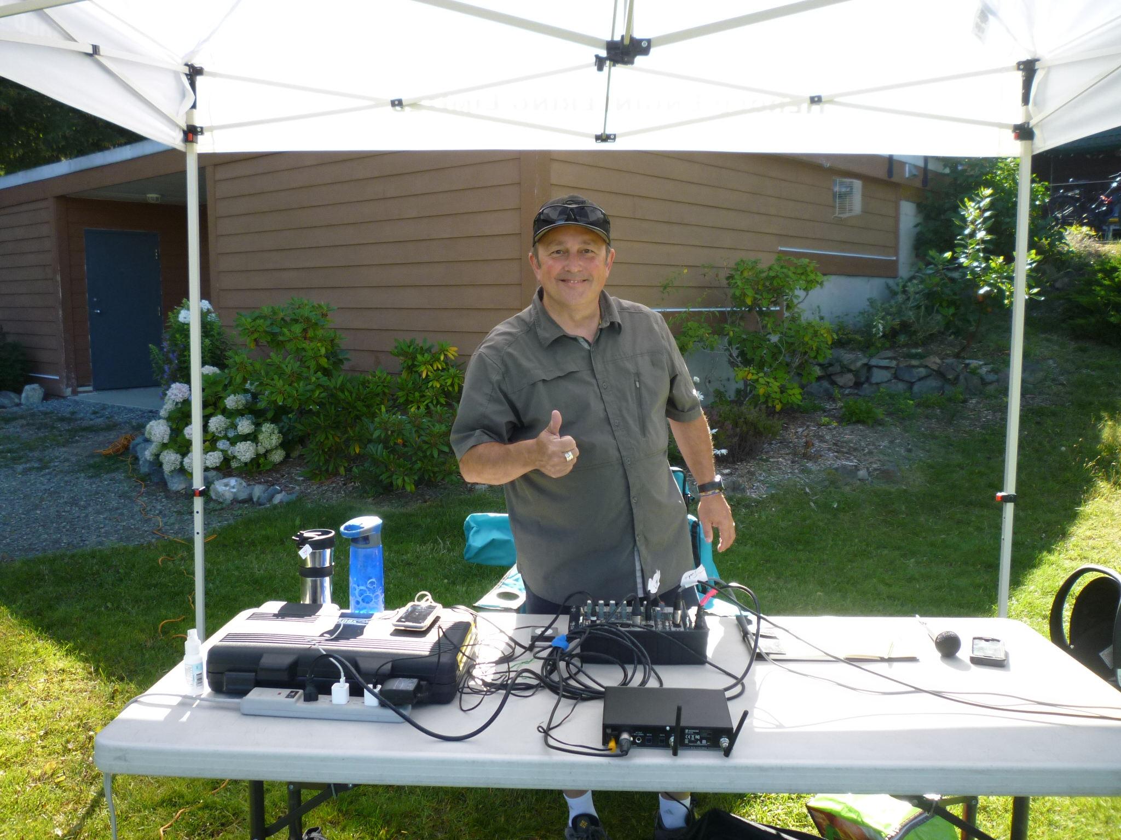
Our Rotary Contacts

Club President:
Mark Taylor

Past President:
Janice Stromar
Vice President:
Lee Rowley

Club Secretary:
Greg Devenish
Club Treasurer:
Harry Helfrich

Club President Elect:
Jodie Williams
International Service Director:
Tessa Bell
Community Service Director:
Dale Werezak
Member Service Director:
Troy deJong

Rotary Foundation Director:
Lee Rowley
Youth Service Director:
Stephen Cochrane
Public Image Director:
Greg Devenish

Club Administration/Newsletter Publisher:
Joy Cameron
Assistant Governor Area 4:
Wayne Anderson

District Governor 2020-2021:
Greg Horn

RI President 2020-2021:
Molger Knaack

Today there are 1.2 million Rotarians in 110 countries committed to our Rotarian mottos’
“Service above Self”
“One profits most who serves best”.

