



***August 12th, 19th, 26th, 2021***

***‘Membership &New Club Development’***

**IN THE LANCE**

**Club News**

**Speaker Presentations**

**Rotary Minute**

**CELEBRATIONS**

Congratulations to Brian & June, Dale & Geri, Tom & Jan, George & Joy on their wedding anniversaries. Birthday wishes to Mark Taylor.

**VISITING ROTARIANS**

DG Lorna Curtis, ADG Ken Hammer

**UPCOMING VOLUNTEER EVENT**

September 18th - Minetown Day

RCL will have a tent, provide water & popcorn, judge the bike contest and help with water melon eating and nail hammering competitions. If you can help with one or more activities, let Mark know.

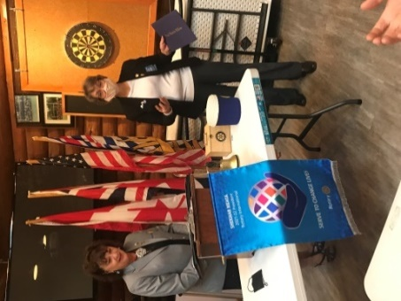

**DG Lorna Curtis - President Jodie**

**CLUB NEWS**

Congratulations to Jodie, our newest Paul Harris Fellow and to Michael Ribicic who became a member of District 5020 PolioPlus Society.

Thanks to Don, Randy and Ryner, RCL volunteers - our 5 week participation at Men’s Golf night at

Fairwinds raised in excess of $ 12,000.

We received a certificate of appreciation for our

$ 7,000 contribution that made 100,000 meals a reality for food starved residents in Nepal.

Sadly, August brought to an end 5 ½ years of breakfasts @ the 7-10 Club. Over the years, we made many, many people happier.

On a positive note, Club members approved partialdistribution of Harbour City Bingo Society funds of $ 5,600 to the Boy’s and Girl’s club for building garden beds & facility renovations; $5,000 to Camp Caillet for construction activities and$5,500

for first phase work at Lavendar Park.These projects will present us with several new volunteer participation opportunities.

Our weekly meetings are well attended. Michael is doing an excellent job on speakers, the duty roster is working, everyone is happy to join our in person meetings follow health rule guidelines.

**INSPIRATION**

“Ships don’t sink because of the water around them: ships sink because of the water that gets in them. Don’t let what’s happening around you get inside you and weigh you down.” ~unknown~

“Coming together is a beginning, staying together is progress, and working together is success.”

~ Henry Ford

**SERGEANT AT ARMS– BITS AND PIECES**

In advance of Fitness in the Park, Rachel & Charlotte visited Rotarians at Oceanside, Nanaimo & Nanaimo North. The event was a ‘fantastic’ success.

This week ‘Jackson’ joined Doug at Puppy training class.

Stephen is now the program development/job training coordinator for ‘Project Rise’ – an Island Crisis Care Society initiative.

Busy & frustrating time for Realtors - a recent sale had 33 multi party offers on a $ 500,000 listing.

TY to Randy for the audio version of O’Canada. Decidedly, our singing is a work in progress.

Seen out and about, Bob & Debbie Milne are currently living in Nanaimo. Bob…we need you.

The Ad-hoc addition of muffins to our weekly meeting has been well received.

Happy $$$’s from Lee for golf; Don for playing hockey; Mike W. for upcoming trip to Denmark in October; Greg for visiting daughter Alison; James for having completed painting the new ‘Old’ car.

Having backed into hit a fire hydrant, a sad $ from Michael R.

Winning the ‘Chase the Joker’ draw, Michael did not draw a joker for the $110 pot.



Rachel’s presentation was an interesting insight into her background and informative as to the work she does.

As a certified Kinesiologist and Pilate’s instructor, Rachel helps clients of all ages recover from injuries, improve their flexibility& agility and alleviate pain. Rachel completed her Kinesiology degree at the University of Western Ontario in 2009 and worked full-time at a Pilate’s studio following graduation. For several years she coached competitive figure skating and basketball.

Rachel moved to VI in 2012. In 2017 she started ‘Return’ to Form’. Today, she spends her businessdays teaching Pilates, fitness and circuit training classes and working with those recovering from an injury through exercise. All the while, she and husband Sully are baby Charlotte’s full-time loving parents.

For Rachel and Sully, Kettlebell is a passion. In 2015 and again in 2017, Rachel represented Team Canada at World kettlebell championships in Dublin and Seoul. She wongold medals in two events.

Today, Rachel describes herself as an athlete, business owner & minion lover.

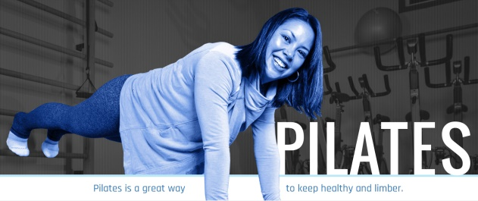

**DISTRICT GOVERNOR LORNA CURTIS**

Packed with lot’s of information, filled with positive messagaging, Lorna’s speech was awesome!

“Rotary is a service organization – are you a Rotarian or just a member of a Rotary club? What do you need or want from your Rotary membership – has anyone asked you? There are different types of members on the Rotary bus. There are the drivers – those are the people who have vision and leadership, the Navigators – those are the people who navigate the vision to meet the goals and there are the passengers – those who want and should get the best possible experience out of the ride!”

“Let’s increase diversity” …we must welcome all people to join as passengers on our Rotary bus and hopefully one day they will navigate or even drive the bus.”

As a single mom in 1997, Lorna’s early years in Rotary were financially challenging. She worked on club projects and fundraisers. In Lorna’s work life, she saw the impact one Rotary Ambassadorial Scholar had on a young man’s family in Rwanda.

In her Rotary life, Lorna spoke about the many opportunities there are to ‘Serve to Change Lives’. In Victoria, 10 Rotary clubs working together opened a Food Security Distribution Centre that serves daily over 35,000 people with 8,000- 10,000 lbs of collected, repurposed food.

“So, whether you are a driver, navigator or passenger on the Rotary bus, the more you put into your ride the more you will get out of it!. Get the most out of your bus ride by being engaged, wear your pin and Rotary shirt with pride – remember we are all ambassadors of Rotary – we have bragging rights for all the good we do! This world is a better place because of people like you! Be a face in the community and lift people up with a smile. Be of service where you can HAVE FUN AND ENGAGE WITH ROTARY!

logo

RCL member and president elect, Lee Rowley is a professional engineer and managing principal of Herold Engineering. Nanaimo based, they are a consulting civil & structural engineering company with 80 employees providing services to a broad range of clients on Vancouver Island & British Columbia.

In his presentation, Lee told us about his career journey, gave us insite into the engineering profession &shared pictures showing the many interesting & challenging projects he has worked on. To name a few, in the UK - the Channel Tunnel Freight Terminal in Birmingham, damage survey following the 1996 IRA Manchester bombing, Westbrook, Kelloggs & Braehead construction projects; in Calgary – South Calgary Health Centre, the Zoo, Canmore Nordic Centre Upgrades; – in Nanaimo – the Cruise Ship Terminal, Wellington School addition and seismic upgrade, VIU Trades Building.

**MEN’S NIGHT AT FAIRWINDS**

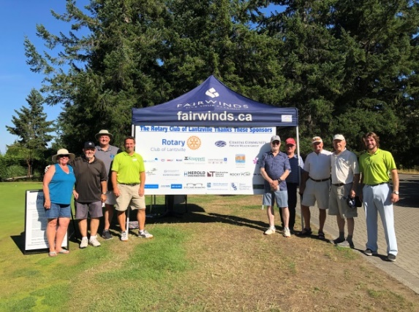

Carol Sharpe (Rotarian) Dave Feaver (MN), Lee Rowley (Sponsor), Ryner Wilson (Staff), Ken Hall (MN), Lee White (MN), David Bodnar (MN), Michael Kosich (MN), Kailem Chappelle (Staff)