“Rotary: Be The Inspiration”

August 30th, 2018
Membership & Extension Month

IN THE LANCE THIS WEEK

Returning Exchange Students

Nanaimo-Ladysmith Schools Foundation

FUTURE EVENTS
Sept 6th – RestOR International
Sept 11th – RFE Meet & Greet at the Yacht Club
Sept 13th – Emergency Preparedness
Sept 19th – Board meeting – usual place
Sept 20th – Club Business meeting
Sept 22nd – Breakfast at 7-10 Club

“VISITING” ROTARIANS
Gill Campbell – Nanaimo, North
Jason Bradley - Nanaimo

VISITORS and GUESTS
Greg Devenish – potential new member
Crystal Dennison – Nanaimo Ladysmith Schools Foundation
Grace Bradley – returning Exchange student
Lena Herringer – returning Exchange student

BIRTHDAYS & ANNIVERSARIES
 |  | DUTY ROSTER
DATE | GREETERS |  | CASH | Sgt-At-Arms | Invocation | INTRO | Foundation | Rotary  Minute
Sept 6th | Litchfield & Bell |  | Lemmon | McFadden | Rodgers | Litchfield | Williams | Litchfield
Sept 13th | Lobay & Cameron |  | McFadden | Slowski | Ribicic | Lobay | Cohn | Lemmon
Sept 20th | Manikel & Cohn |  | Elgie | Tamelin | Slowski | Manikel | Rodgers | Lobay
If you cannot make your duty, it is your responsibility to find a replacement.
Mark T – another year more mature on Sept 1st.

HEALTH of the CLUB
We’re healthy – as far as we know…

ROTARY CLUB OF LANTZVILLE
MISSION STATEMENT
Joining in fellowship to support growth and development in education and health for those less fortunate in our local and international communities.

“Presidential” Observations
Reminder that we have gone back to meeting weekly – every Thursday morning.
A busy agenda with a full house and a good buzz…

FOUNDATION
$70 contributed to the Rotary Foundation this morning. THANKS!

Sergeant-at-Arms

David L was the Sgt this AM, looking for money. Jodie thought the RYE fundraiser on Tuesday was a great success. [Jason appreciated the loan of our BBQ.] Randy thought last Saturday’s breakfast was a great success – everything ran smoothly. Tessa attended a MIG meeting – an amazing group. William’s Mom came to visit. Barry asked Michael R (prospective city councilor) to investigate the high cost of gas in Nanaimo. Harry is taking a week off – going to Idaho. Brian R, Doug S, et. al. are happy that we’re back to meeting weekly. Don C glad that our exchange students returned safely. Brian R went to North Bay – for a family reunion. Ralph so happy to be here! Brian McF failed to find the joker - so the pot at our next meeting will be $60!


Breakfast at the 7-10 Club
Thanks for your support!

Pancake, pancakes and more pancakes…
Next breakfast – Saturday, September 22nd.

News, Updates & Reminders
Annual dues ($220) are now due and payable to Harry – cash, cheque or credit card. Please.

As of August 30th, we have another option for breakfast. Coffee only for $6. [$3.50 for the coffee (what the restaurant charges), $1 for set-up and tip, and $1.50 for the club.]

Coming Events”
- There will be a 5-Club Friendship Dinner with Rotarians visiting from New Zealand Tuesday, September 11th. 6PM at the Nanaimo Yacht Club. All are welcome.
- There will be a 5-Club PolioPlus Awareness event, to promote Rotary in Nanaimo, October 24th. More details coming soon.

Stock the Lockers
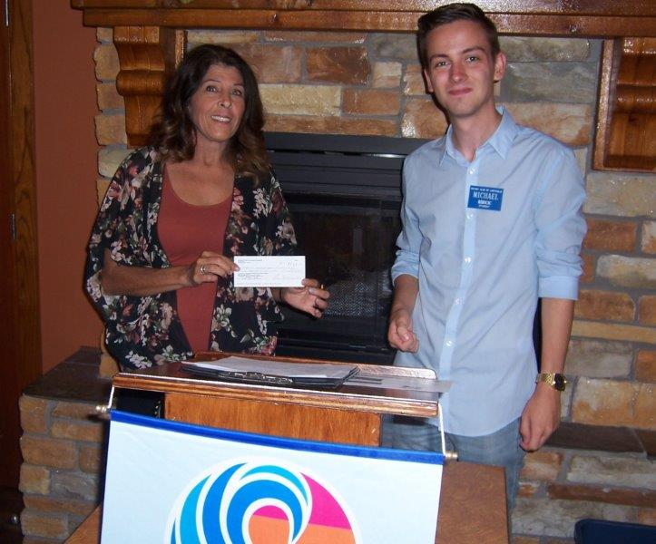
This morning we gave a cheque for $1,000 to the Nanaimo Ladysmith Schools Foundation to go toward their “Stock the Lockers” campaign. Their aim is to ensure that all children show up at school ready to go – all ages, all schools. The Foundation provides funds for supplies, fees, clothes and food.
Crystal Dennison, on the left above, also thanked us for the two scholarships we support. This year, $1,000 each was awarded to Christine (studying in a design program at VIU) and Kyle (taking humanities at U of T).

Youth Exchange Students
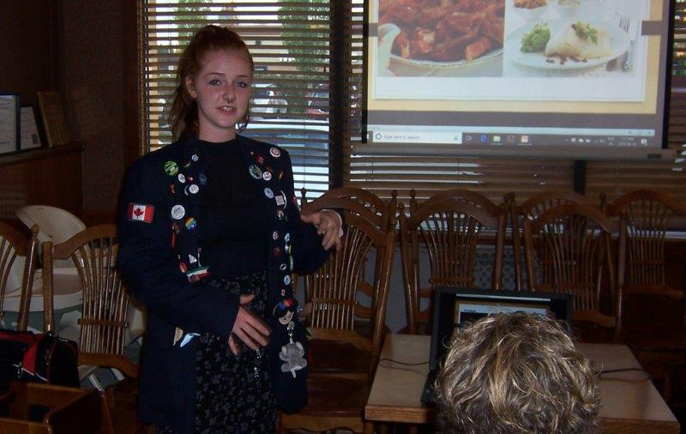
Grace Bradley spent last year in Larvik, a small Norwegian town just south of Oslo. And, attended the Thor Heyerdahl High School – a big school. She was looked after by three “amazing” host families and liked most(?) of the Norwegian food she tried.
With the other Exchange students in Norway, she enjoyed a 10-day bus trip around Norway.
Grace is in Grade 12 at Wellington, plans to travel for a year, then go back to school…
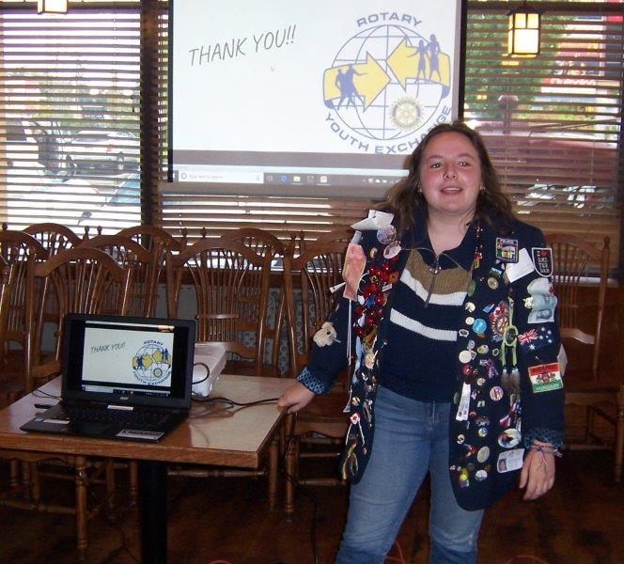
Lena Herringer, currently a Grade 12 student at Dover SS, spent last year in Bern, Switzerland. They speak a different type of German there, so languages presented a challenge at the start. She enjoyed the support of 3 great host families, loved Bern (a beautiful city), became hooked on public transport (very efficient in Switzerland and Europe), went skiing at Christmas, and travelled the country with the other Exchange students.
The highlight was the 17-day EuroTour that took them by bus the “long way” from Paris to Venice.

Both young ladies were very confident, well-spoken and profuse in their thanks to Rotary for giving them the opportunity to travel and to learn.
“Recruiting” for next year’s Exchange program will take place September 24th. It you’d like to help, and it is a rewarding experience, talk to Jodie.

ROTARY INFO
You can find out where and when all the Clubs in District 5020 meet on the 5020 website:
www.clubrunner.ca/portal/Organization/Meetings.aspx?accountid=50092
Rotary International: http://www.rotary.org
Member’s access: https://www.rotary.org/myrotary/en
District 5020: www.rotary5020.org
Our website: www.clubrunner.ca/Lantzville
Our Facebook Page: www.facebook.com/RotaryClubofLantzville
Check it out – you might be surprised…

BEAUTIFUL BC – Hudson Bay Mountain, Smithers


- Did you know:
- The roar that we hear when we place a seashell next to our ear is not the ocean, but rather the sound of blood surging through the veins in the ear.
- Nine out of every 10 living things live in the ocean.
- The banana cannot reproduce itself. It can be propagated only by the hand of man.
- Airports at higher altitudes require a longer airstrip due to lower air density.
- The University of Alaska spans four time zones.

Sitting by the window in her convent, Sister Barbara opened a letter from home one evening. Inside the letter was a $100 bill her parents had sent. Sister Barbara smiled at the gesture.
As she read the letter by the window, she noticed a shabbily dressed stranger leaning against the lamp post below.
Quickly, she wrote, "Don't despair. - Sister Barbara," on a piece of paper, wrapped the $100 bill in it, got the man's attention and tossed it out the window to him. The stranger picked it up, and with a puzzled expression and a tip of his hat, went off down the street.
The next day, Sister Barbara was told that a man was at her door, insisting on seeing her. She went down, and found the stranger waiting. Without a word, he handed her a huge wad of $100 bills.
"What's this?" she asked.
"That's the $8,000 you have coming Sister," he replied. "Don't Despair” came in first and paid 80-to-1."

