



***July 29th, August 5th, 2021***

***‘Membership &New Club Development’***

**IN THE LANCE**

**Meeting Notes**

**Speaker Presentations**

**Rotary Minute**

**CELEBRATIONS**

Anniversary congratulations to Stephen & Shawna Cochrane and Tom & Jan Stromar.

**VISITORS**

Nick Scott, George Robbins, Corrie Corfield Charlotte Robertson

**UPCOMING EVENTS**

August 21st - 7-10 breakfast

Fitness in the Park



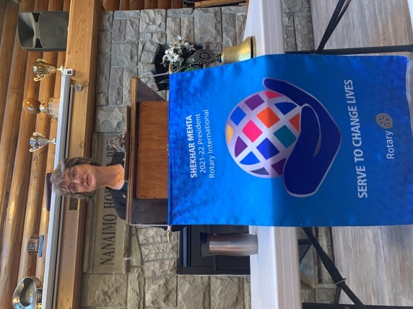

**MEETING NOTES**

Opening remarks, President Jodie welcomed every to our weekly meeting which is located in the traditional territory of the Snaw-naw-as First Nation.

Jodie spoke about RI president ShekharMehta’s call to action membership goal – Each One, Bring One. The vision is to increase membership to 1.3 million by July 2022. As Rotarians, we are all part of the membership committee.

Thanks to Don, Randy and Ryner, our participation @ Men’s night at Fairwinds is going well.

We have been invited to participate in the September Mine Town Days. As this evolves, Mark will have more details.

Sadly, this month, redevelopment of the Prideaux Street site will bring to an end the7-10 Club Society free breakfast programs.

On a positive note, let us think about, actively look for new volunteer participation opportunities.

**INSPIRATION**

*Stephen read the classic beloved poem, ‘House by the Side of the Road’ written by Sam Foss. Every house, Foss implies in the poem, qualifies, as long as the occupant is “a friend to man”.*

*Rachel shared quotes from athletes who overcame amazing challenges to win gold in their sport.*

**Sergeant at Arms – Bits & Pieces**

Appropriately, lots of commentary about Tokyo 2020. Seems most everyone has been watching.

At long last, Mike W. had unlimited viewing of badminton.

Everywhere, including the VI Military Museum, we are seeing lots of out of province tourists.

On a very hot day, Jodie and James enjoyed the 100+ vendor Art in the Garden event in Nanoose.

Mark looking forward to Vancouver visits at son’s newly purchased condo.

A very angry $ from Doug – while hiking, the catalytic converter was stolen from visiting family’s car.

Brian enjoyed recent visit with a very busy 3 month grandchild.

**DUTY ROSTER – AUGUST 12TH, 2021**

Greeter: Lee Cash: Greg

Sgt-Arms: Brian Inspiration: Ralph

Introductions: Michael Foundation: Jodie

Rotary Minute – David Lobay

**SPEAKER**

Rachel Robertson, Kinesiologist

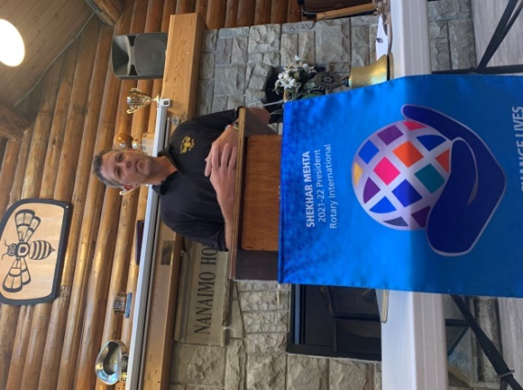

**NICK SCOTT - PRESIDENT**

**NANAIMO HORNETS**

**RUGBY FOOTBALL CLUB**

Nick gave an interesting presentation about the Club, Rugby and his background.

The Nanaimo Hornets were originally formed in 1888. In the early 1970’s the Club moved to May Bennett Park, built the 3500 square foot club house and cleared and built the field. Nanaimo Hornets RFC is a non-profit society. Its players, members and families are dedicated to creating, promoting, and encouraging an active interest in rugby in the Nanaimo area. Their players come from all over the world. Rugby in Nanaimo is one level below the highest level nationally.

According to Nick, rugby is an awesome melting pot. Within the game, everyone is always trying to grow and get better. Pre-CoVid, the Club had 220 paid members. Moving forward, they are looking for members who like to be around other people. Their goal is to reconnect with the community and schools and build rugby in Nanaimo.

Living in Australia, looking for opportunity, Nick came to Nanaimo 10+ years ago through a rugby connection. He stayed because of people, lifestyle and community.

**Rotary Minute**

George Robbins took the opportunity to speak about his Father, GlenRobbins. He was part of the Victoria cyclist team that competed in 3 events at the 1932 Olympics in Los Angeles. Having limited resources, they traveled to Los Angeles in coach Torchy Peden’s 1928 Ford touring car with their bikes and gear stacked on top. With limited space for passengers each day they would take turns biking or running some distance alongside the car. Their biggest thrill for the Games was the opening ceremonies when the Canadian contingent of 102 competitors was greeted by 105,000 spectators.

.

Although all three of Victoria’s best young cyclist came away empty handed, they were consoled when told ‘For strictly amateur young athletes, a trip to another country, as representatives of Canada, is an ample reward.’ In 2008, Glen Robbins, Lew Rush and Stanley Jackson were inducted into the Victoria Sports Hall of Fame.

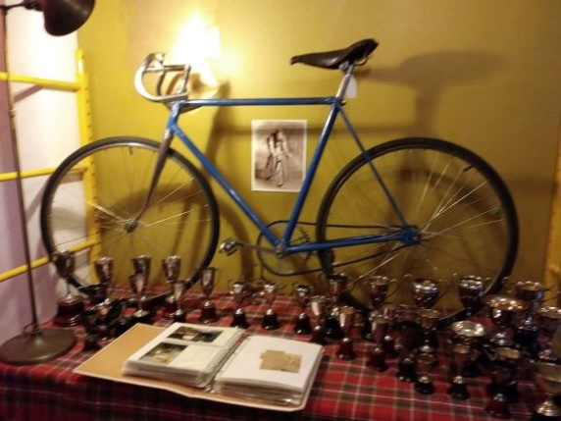

Officially known as the X Olympiad, 1,334 athletes representing 37 countries participated in 117 events in Los Angles.

The XXXII Olympiad in Tokyo 2020 had 11,200 athletes, from 206 nations participate in 339 events.

**Island Crisis Care Society (ICCS)**

Corrie Corfield, assistant executive director, spoke about the many programs and services provided by ICCS.

ICCS is a registered non-profit society that provides programs & services in Nanaimo and Oceansideincluding supportive housing facilities, transitional housing, emergency shelter, outreach, assisted living for people with serious mental health issues, a recovery house & sobering and assessment beds.

Their flagship program, Samaritan House was established on Nicol Street in 1981 to provide shelter and supportive housing for women in crisis. Opening in 2022, a new ‘Samaritan House’ with 29 emergency response beds is under construction on Prideaux Street. Today, ICCS is the service provider at multiple locations including Newcastle Place (77 beds), Orca Place (52 beds) & Hirst House (6 beds). Their Outreach program provides rent subsidies.

Corrie spoke about what is & why we have homelessness. Personal factors include culture, education, violence, systemic barriers, disability & discrimination. Her key messages – this is not black and white -& everyone has a unique story.

Project Rise Community Connection is the newest ICCS program. Recently, they bought the Nanaimo Bakery using funds from the sale of the Nicol Street property. The business will provide employment experience for ICCS clients and stable funding for ICCS programs. The Society is setting up a related program to assist people facing barriers to employment. The 3,000 sq.ft. upper floor of the building will house the offices of ICCS and they are looking at other options for the space.

Rightfully so, Corrie was ever so excited about ‘Project Rise’. Our community looks forward to following and being part of this new journey. Corrie, thank-you for your presentation