“Rotary: Making a Difference”

December 12, 2019
Disease Prevention and Treatment Month

FUTURE EVENTS

Dec 26th – No Meeting, but Golf at Fairwinds
Dec 28th- 7-10 Breakfast
Jan 2nd- Regular Breakfast Meeting
Jan 23rd Golf Tournament Planning Breakfast
Feb 6th VIU Library tour and Discovery Room

VISITING ROTARIAN
None this week

VISITORS and GUESTS
Zoe Oshun and Ezra Breingan, RYLA participants

BIRTHDAYS & ANNIVERSARIES
 |  | DUTY ROSTER
DATE | GREETERS |  | CASH | Sgt-At-Arms | Invocation | INTRO | Foundation | Rotary  Minute
Dec 19 | Devenish/Rowley |  | Walker | Slowski | Manikel | Stromar | Elgie | Ribicic
Dec 26 | NO MEETING
Jan 2nd | Manikel/Litchfield |  | McFadden | Valsangkar | Devenish | Cochrane | Rodgers | Elgie
Jan 9th | Werezak/Youssef |  | Elgie | Lobay | Valsangkar | Slowski | Walker | Rowley
If you cannot make your duty, it is your responsibility to find a replacement.
None observed.
HEALTH of the CLUB
Brian R back and in good health.

President Barry’s Opening Remarks
Barry thanked all members who helped make Breakfast with Santa a huge success. Even with our modest ticket price, we managed to have a surplus of $220 which was donated to the Lantzville Fire Dept. Christmas Hamper fund.
Barry also reminded us to carry a few Breakfast Invitations with us. A good way to encourage new members is for them to experience one of our lively meetings.
Foundation
$160 collected today, Randy M winner of $16. Thanks everyone.
Sargeant-At-Arms
Sargeant Raph made the rounds this morning. Mark T is off to UK for Christmas.
Stephan said he really enjoyed being MC at Breakfast with Santa (it showed!).
Joy (via email this morning) reported on a Make-Up Meeting at the Cochella Valley club (La Qunita, CA). -their small club sponsors 40-50 RYLA participants each year.
Jamal had a good cruise with the Tuckers and has returned as a expert cribbage player.
Harry says he needs to start shopping, Michael says that he is all finished his!
The pot had grown to $490 today, and although there was only 5 cards remaining, Brian M. was unable to secure the Joker!

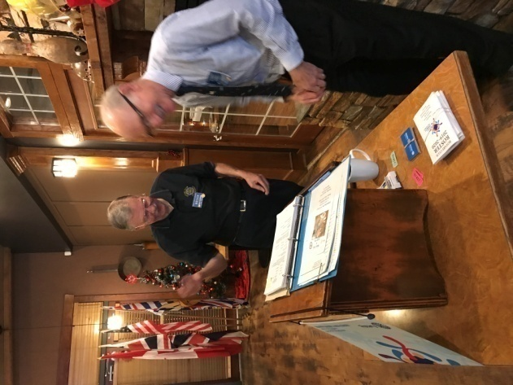
Next Week: $500 with only 4 cards remaining. Better be there!

Rotary Minute
Jamal spoke on the history of the 4-Way Test. It was originally developed by a Herbert Taylor as a way of guidance for his company’s staff. It was adopted by Rotary International in 1943, and continues to be a guiding principle to this day.

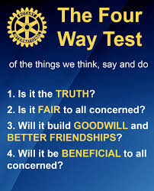

REMINDERS
Rotary Golf at Fairwinds on Dec 26th and on Jan1st. Encourage your friends to come out and golf by donation. With cooperative weather, this is a good fundraiser for our club, and provides “Rotary Recognition” in the Fairwinds community.

VIU Library Tour and Discovery Room Dinner on Feb 6th. We’ll have a private tour of the library as well as dinner (for 25 people) in the Discovery Room. You’ll be able to select a fabulous 3 course meal from an interesting menu. A chance for an enjoyable evening with your fellow Rotarians and partners!
“The Discovery Room is Vancouver Island University’s full-service learning restaurant connecting students with our community patrons. Learning by doing, Hospitality Management and Culinary Students together serve up a contemporary dining experience.”

ROTARY INFO
You can find out where and when all the Clubs in District 5020 meet on the 5020 website:
www.clubrunner.ca/portal/Organization/Meetings.aspx?accountid=50092
Rotary International: http://www.rotary.org
Member’s access: https://www.rotary.org/myrotary/en
District 5020: www.rotary5020.org

Our website: www.clubrunner.ca/Lantzville
Our Facebook Page: www.facebook.com/RotaryClubofLantzville
Check it out – you might be surprised…
Rotary Youth Leadership Awards (RYLA)
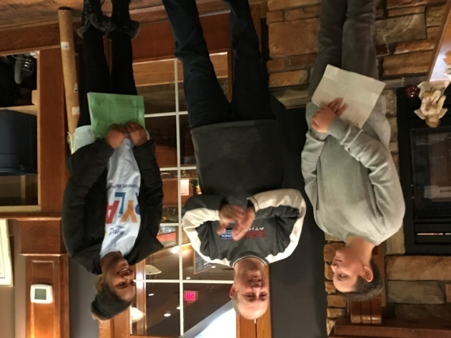Our club was pleased to sponsor Ezra Breingan and Zoe Oshum to the RYLA assembly held at Camp Quanos, (Crofton) on Nov 15-17. Both Ezra and Zoe said that they learned a lot from the presentations, group exercises and being together with other youth from Vancouver Island and Washington state. The two students were very appreciative of the opportunity to attend this event and said they would encourage others at their school to attend next year.

Annual General Meeting Highlights

President’s Report-Barry Sparkes
Barry is pleased with the year so far: good fellowship during meetings and activities, our membership is diverse and growing and we are generous supporters of the Rotary Foundation. Barry also related that within 2 years, our club should receive close to $20,000 from the winding- up of the Harbour City Bingo Society which we have been members for many years. We will have to develop a strategy for using this money.
President-Elect Report-Mark Taylor
Mark is happy to hear about the $20,000, and is planning hands-on community service projects for next year.
Treasurer’s Report-Harry Helfrich
Our accounting software is past its useful life so Harry and Rachel have developed a bookkeeping program on Excel. This will be easier and cheaper in the future.
Administration Report-Joy Cameron via email
We have had an interesting mix of speakers so far this year, and several social events. Joy reminded us of the upcoming library tour and dinner on Feb 6th. And a reminder that if you cannot fulfill your assigned weekly duties, please look after finding a replacement (yourself).
Community Service-Dale Werezak
We still have unrestricted funds to spend, and awaiting additional gaming funds. The challenge is to get the word out in the community that we are willing and able to offer financial help.
Rotary Foundation-Lee Rowley
Our club has generously met our annual target for the Foundation; everyone but 2 members has contributed this year.
International Service-Tessa Bell
We have spent approximately 50% of our annual budget of $6,100 with contributions to various projects. The meeting approved the motion to contribute $1,000 to the RC Nanaimo Oceanside’s project of providing maternity ward equipment to a Sunyani Ghana hospital.
Public Image-Greg Devenish
We will take part in the 100 year anniversary of Rotary in Nanaimo in May. The Rotary Garden project will be finished by then.
Youth Services-Jodie William
Jodie and her team have been very active this year. She has nominated Stephen Cochrane to assume duties of Director for 2020-21.

Officers and Directors 2020-2021
President Mark Taylor
President Elect Jodie Williams
Vice-President Vacant
Treasurer Harry Helfrich
Secretary Greg Devenish
Administration Joy Cameron
Community Service Dale Werezak
Foundation Lee Rowley
International Service Tessa Bell
Membership Troy de Jong
Public Image Greg Devenish
Youth Services Stephan Cochrane

