“Rotary: Be The Inspiration”

December 27th, 2018
Disease Prevention & Treatment Month

IN THE LANCE THIS WEEK

2018 – The Year in Review

FUTURE EVENTS
Jan 1st – New Year’s Day Golf at Fairwinds
Jan 3rd – Shawn Kilner, Travel Advisor
Jan 10th – Managing Home Depot
Jan 15th – Monthly Board Meeting
Jan 17th – R.O.A.R.
Jan 26th – Monthly Breakfast at 7-10 Club

“VISITING” ROTARIANS

VISITORS and GUESTS

BIRTHDAYS & ANNIVERSARIES
 |  | DUTY ROSTER
DATE | GREETERS |  | CASH | Sgt-At-Arms | Invocation | INTRO | Foundation | Rotary  Minute
Jan 3rd | Lobay & Ribicic |  | Sparkes | Elgie | Rodgers | Lobay | Taylor | Youssef
Jan 10th | Litchfield & Slowski |  | Walker | Lemmon | Ribicic | Litchfield | Williams | Bell
Jan 17th | Manikel & Sparkes |  | Williams | Lobay | Slowski | Sparkes | Elgie | Cochrane
If you cannot make your duty, it is your responsibility to find a replacement.

HEALTH of the CLUB
We hope that you all survived Christmas Day and are hale and healthy as the New Year approaches!

ROTARY CLUB OF LANTZVILLE
MISSION STATEMENT
Joining in fellowship to support growth and development in education and health for those less fortunate in our local and international communities.

“Presidential” Observations
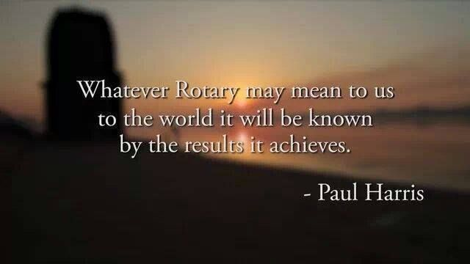

FOUNDATION
Thank-you for your contributions to the Rotary Foundation. It has been a good year.
We have achieved our goal for contributions to the Annual Fund for this Rotary Year.
Future contributions will be directed to the PolioPlus Fund unless you tell Barry otherwise.

Sergeant-at-Arms

Thanks to those Rotarians who served as Sergeant-at-Arms over the past year. You contributed to the fun of our morning meetings and made several people happy when they won the morning draw – until we ran into trouble with the Joker!☺
Breakfast at the 7-10 Club
Thanks for your continuing support.
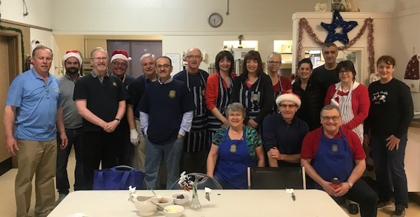
What a team – on December 22nd!
Next breakfast – Saturday, January 26th, 2019

News, Updates & Reminders
Year-end Golf.
Boxing Day at Fairwinds – for the first time in several years, we did not have to cancel due to the weather. However, the weather was not great and only a few hardy golfers took advantage. But, there was $122.45 in the bucket at the end of the day – much more than the last couple of years.
- Thanks to James & Jodie and Greg & Rachel for ‘manning the shack’.

2019 Golf Tournament. It will be held at Fairwinds on Friday, May 3rd. It is our major fundraiser that helps us help our community.
- Who should be our Major Beneficiary this year? We normally allocate 25% of the next proceeds Up to $5,000) to a specific organization – but, we need your suggestions/approval.
- We’ll also be looking for sponsors (that’s where we get most of the money), prizes (to reward golfers and to sell via a silent auction).
- The more golfers the merrier – 132 is a good number.
- And, we’ll need your help on the Committee, golfing experience is not a criteria.

Rotary Minute
Just about everybody has had a chance to explain why they joined Rotary – so, we’re changing the format of your Rotary Minute. Just talk for a couple of minutes about something to do with Rotary. Almost anything related to Rotary…
Sources are The Rotarian (the monthly magazine from RI), www.Rotary.org, or, heaven forbid, “Google”!

2018 – Our Year in Review
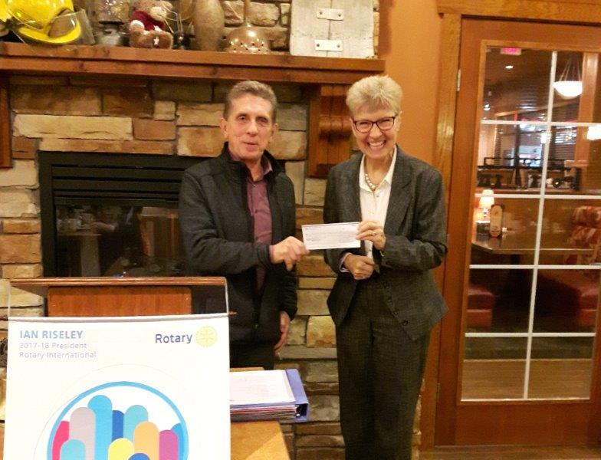
January – our first cheque of the year: $2,000 to the Nanaimo & District Hospital Foundation – towards the purchase of a new “Echo” machine – the first of many Harry would write over the next 12 months.
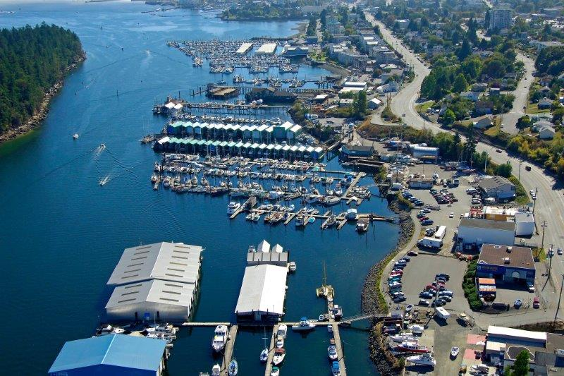
February – we continued to enjoy a good variety of speakers throughout the year (thanks to Randy, then Joy), including an alternative look at the governance of Nanaimo’s Harbour by the Nanaimo Marine Association.
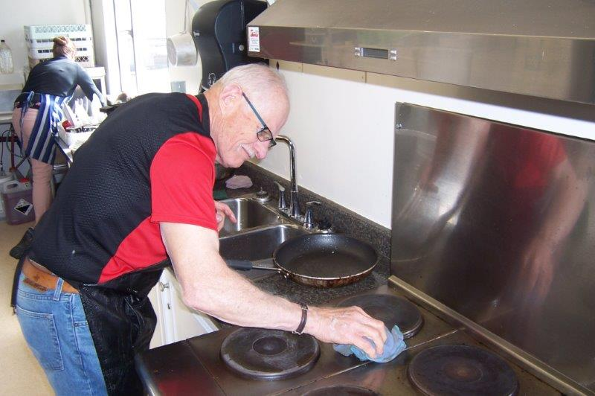
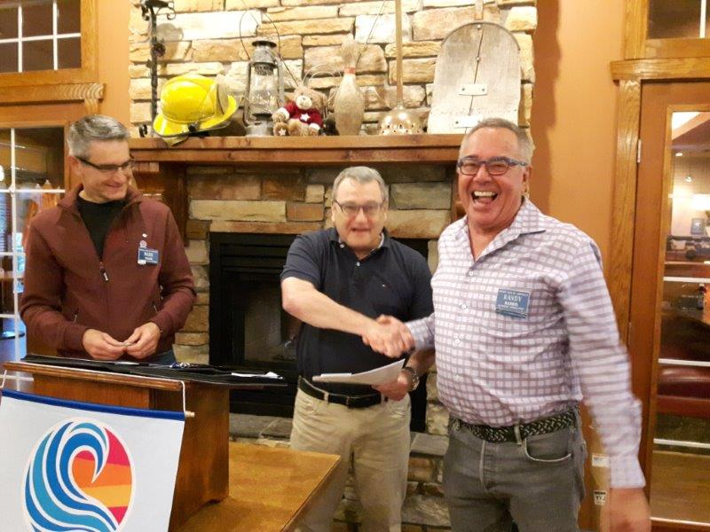
March – we started a trial of only two meetings a month. And, we started to focus on our upcoming Golf Tournament. And, we enjoyed a social evening at Simon Holt Restaurant. And, Don C learned that coffee is not a good cleaner for sausage grease.
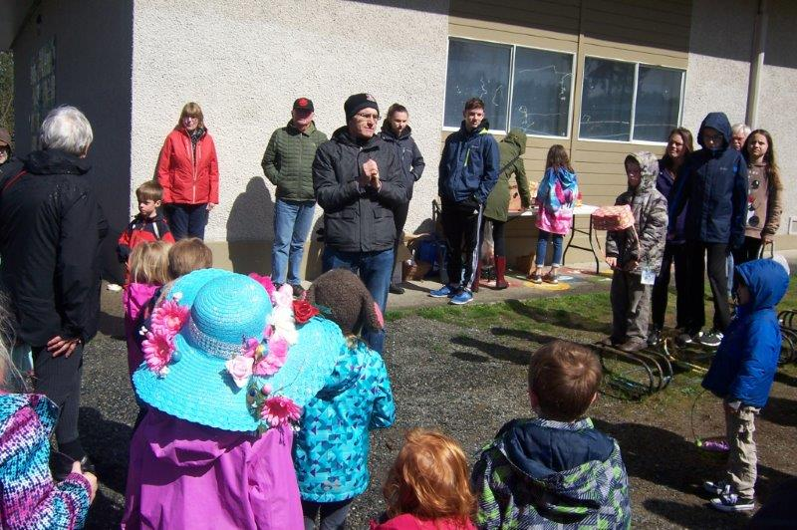
April kicked off with our Annual Easter Egg Hunt with Mark T filling in, admirably, for Bob M.

May – we finished our “Sanala Playground and Garden Project” – with some hard work from some dedicated Rotarians! Supported, in part, by a District Community Grant (from the Rotary Foundation).
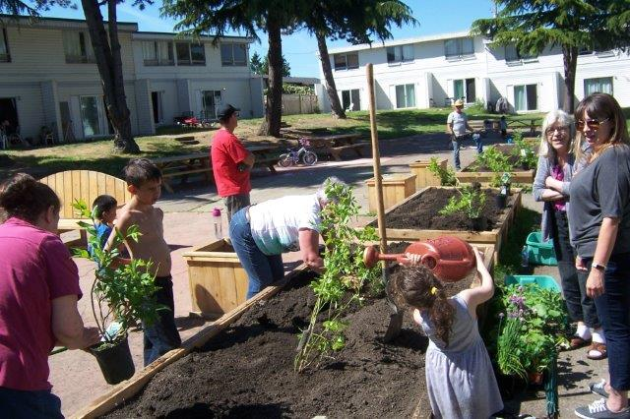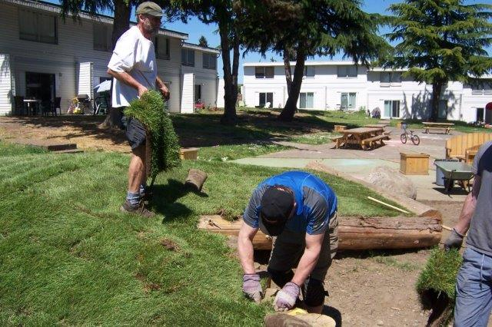
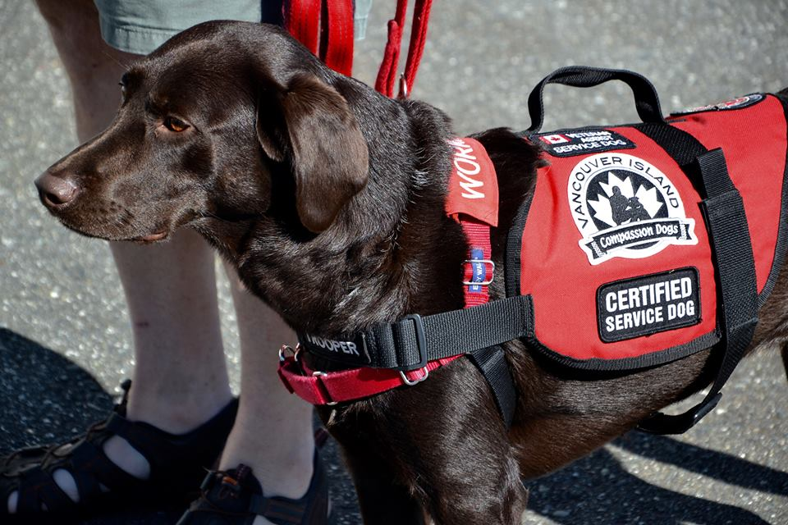
June – our 21st Annual Golf Tournament from which we donated $5,000 to the Vancouver Island Compassion Dogs Society. We also installed Jan Stromar as our President for 2018-2019.
July – another thoroughly enjoyable evening at the Tuckers’ for our Summer BBQ
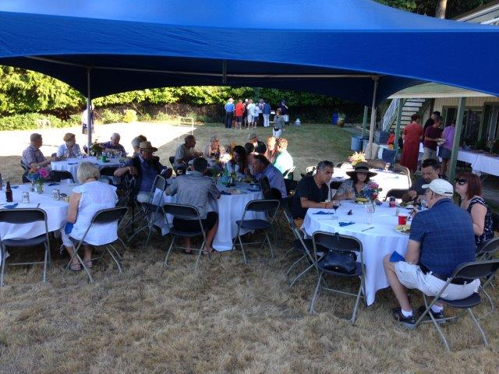
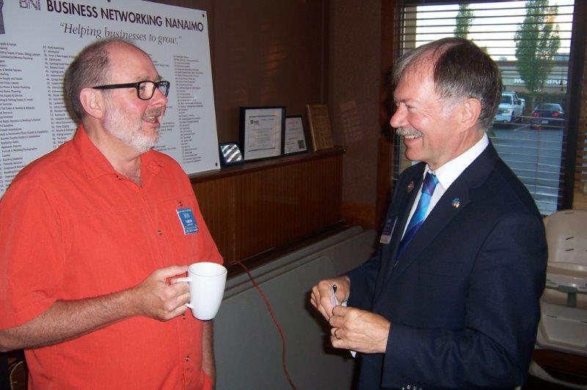
August – District Governor Craig Gillis paid us a visit. And, we introduced a coffee-only option for breakfast.

September – we inducted Greg D – the first of four new members we would welcome into our club over the next couple of months. And resumed meeting every week!

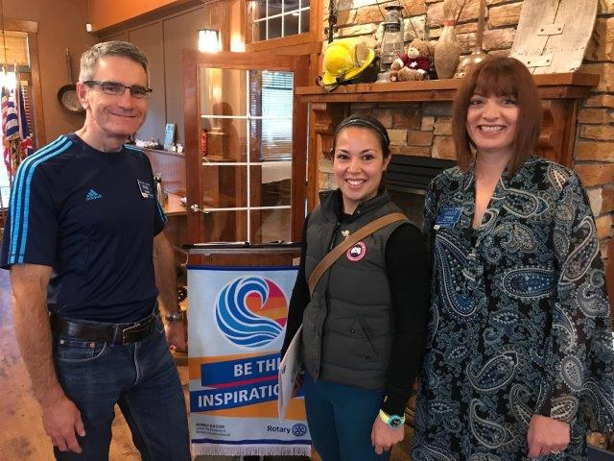
October – we learned a little bit more about The Rotary Foundation as club members continued to be excellent supports of TRF with their weekly contributions to the Annual Fund and the PolioPlus Fund. And we added Rachel R to our membership – bringing down the average age by quite a few years.
November – seems to have been a quiet month…notwithstanding the induction of Lee R and Stephen C into our Club. ▼
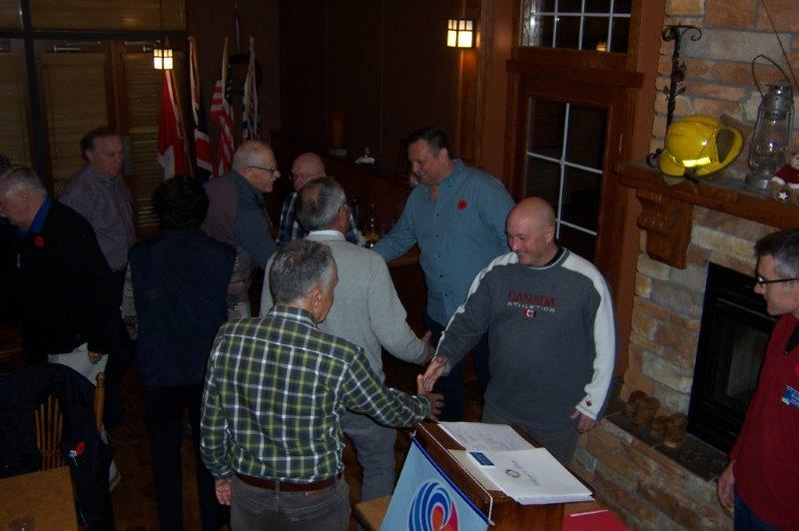

December – we ended the year in style with Breakfast with Santa, our Christmas Social, our 45th monthly breakfast at the 7-10 Club and, despite the departure of Don C, increasing our membership for the first time in a few years. ☺

From all the staff here at LANCE PUBLISHING HOUSE, our best wishes that the New Year brings you lots of Happiness and Good Health.


