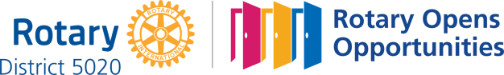

December 3rd, 2020
Rotary Disease Prevention &Treatment Month

IN THE LANCE THIS WEEK

Snaw-naw-as, Nanoose First Nation
Councillor Brent Edwards
Rotary Minute
Club Notes

VISITORS AND GUESTS

Visiting Rotarians – RCL honorary memberBarry Sparkes,Rotary Victoria Linda Murray, Nanaimo Rotaract Kimberly Barrett & our beloved Charolotte.

BIRTHDAYS – ANNIVERSARIES

Birthday greetings to Ralph Lemmon and James Williams. Anniversary congratulations to Cheryl and Derek Prince.

ROTARY CLUB OF LANTZVILLE
MISSION STATEMENT
Joining in fellowship to support growth and development in education and health for those less fortunate in our local and international communities.

SALVATION ARMY KETTLE

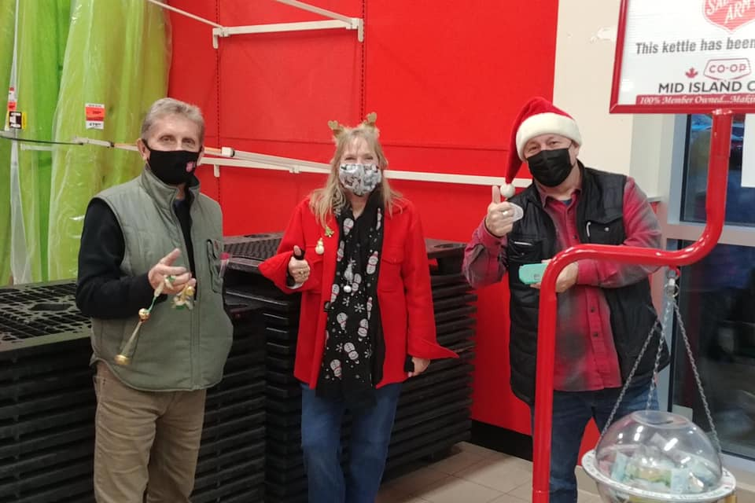
DALE, SHAWN, STEPHEN
A big thank-you to Dale for coordinating a RCL day on the Kettle and to everyone who was able to do a 2 hour shift. If you are able to work a shift in December, give Dale a call.

7-10 CLUB BREAKFAST
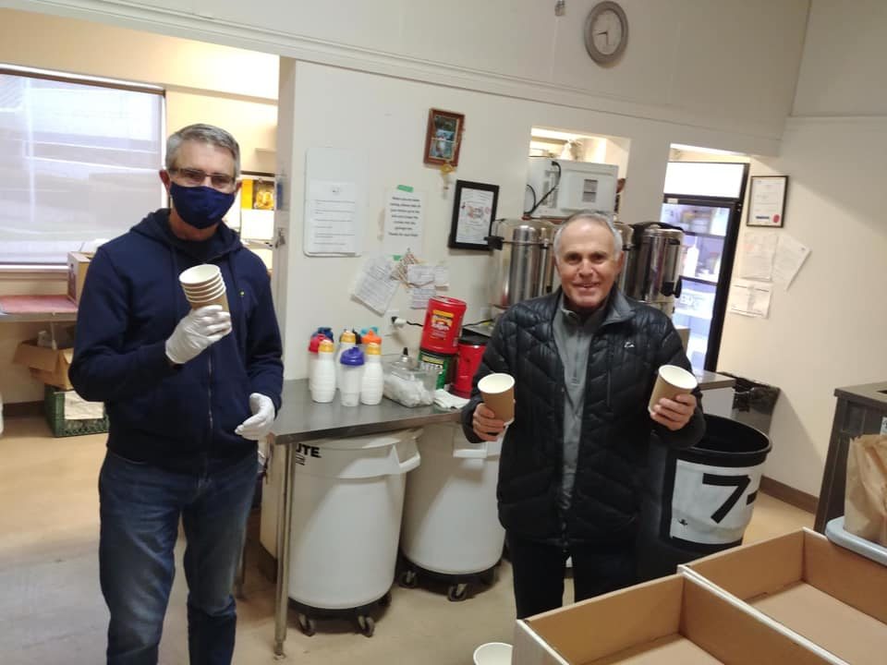
PRESIDENT MARK, TEAM CAPTAIN DAVE

Upcoming Zoom Meetings

December 10th - AGM

December 17th -Christmas Social
Members, spouses, past members

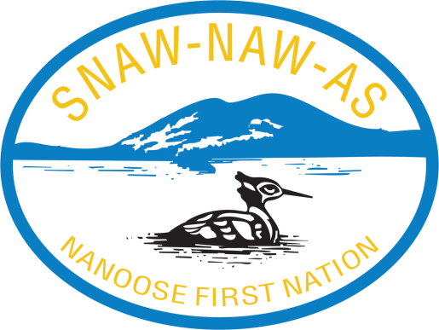

Councillor Lawelchtun BrentEdwards gave an interesting, informative presentation about the Nanoose First Nation band, economic initiatives and some of their challenges.

They are a small band residing on 160 acres, with 230 registered members in 96 homes. They have a state of the art health clinic, some community amenities and shared service agreements with the District of Lantzville for water and fire protection. Ongoing they look for opportunities and ways to improve on existing infrastructure and further improve community interests.

The Gas Bar initiative is doing well, providing training and employment to band members. 40,000 people a day travel this stretch of the highway. Annual band revenue through their master limited partnerships (and Brent was quick to point out not profit) is approaching $ 20 million. Revenues come from billboards, forestry operations, aquaculture (leases, licenses, processing), the campsite, revenue sharing agreements with the province and the Federal government. Currently, they are working on a new revenue sharing initiative with the MasterCard Foundation.

Challenges are many – access to and development of the 60 acres adjacent to the Island Corridor Foundation & development being very high on the priority list. Brent believes this can and will be resolved by working collaboratively and believing we are all in when to comes to protecting and developing our communities.
CLUB MEETING NOTES

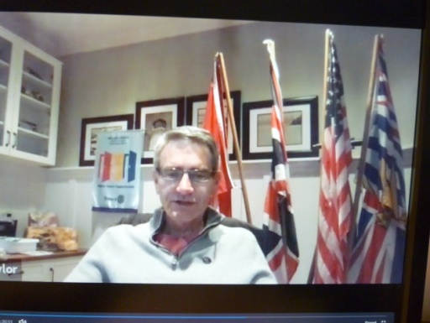

Sergeant @ Arms Randy got us off to a timely start, followed by our National Anthem& acknowledgement by President Mark that our meeting takes place on the traditional territory of the Snaw-naw-as First Nation.

Thank-you’s to Stephen for ‘Inspiration’, Rachel for ‘Introductions’,James for Rotary Minute.

Brief discussion about Saturday 7-10 breakfast.

Update on the Lantzville Food Drive & December 12th Santa Breakfast. Because of CoVidrestrictions, very limited opportunity for club member participation. Mark, Cheryl, Cor are our ‘club workers’ on the Lantzville events.

Troy reminded us about the Sleigh Full of Deals.

Kimberly brought greetings from Nanaimo Rotaract.

12/10/2020 = Club AGM. For 2021-2022 we need director members for - treasurer, youth service & international service.

Mark followed up the meeting with a lengthy email thank-you to Brent Edwards expressing our interest in building a stronger connection between Rotary and Snaw-naw-as.

“Never flinch, never weary, never despair”
~Winston Churchill

ROTARY MINUTE – JAMES WILLIAMS

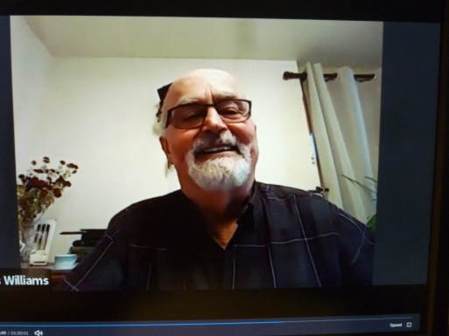
James shared with us the excitement of one of his last hiking experiences. Six years ago in Nelson with the Alpine Club of Canada, 9 hikers and 2 guides spent 6 days on the Kokanee Glacier. Average age was late 60’s, one lady was 70. They overnighted in a youth hostel and a cabin on the glacier. Each day there was a planned hike. The last hike was a 2 kilometer hike to the top of the glacier. Hikers geared up with special boots, ice axes, helmets and harnesses. The experience was hard work, very scary and tremendously exciting. WOW!

MOM AND CHARLOTTE

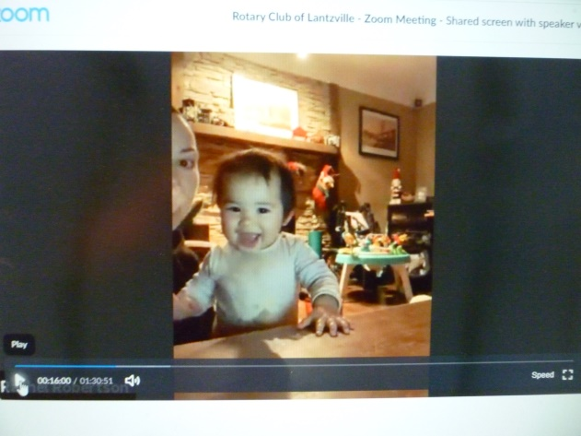

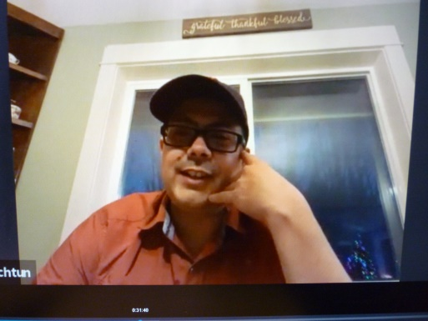
COUNCILLOR BRENT EDWARDS

Brent is the economic development officer for Nanoose First Nation. He is also the band representative and treasurer for Kw’umutLelum Child and Family Services. Established in 1996, Kw’umut Lelum is an aboriginal based agency located in Snuneymuxw territory that provides caregiving services, community programs and services to nine First Nations.

Excellence

“Going far beyond the call of duty.
Doing more than others expect.
This is what excellence is all about.

It comes from striving for and maintain
the highest standards,
looking after the smallest detail
and going the extra mile.

Excellence means caring,
it means making a special effort to do more.”

~Ron Southern

