February 11th, 2021
World Understanding
Service Month

IN THE LANCE THIS WEEK

Club Meeting Notes
Youth Protection Training

FUTURE EVENTS

February 18th CM – Rotary Information
J-Van…Suzi Johansson
20th Coldest Night of the Year Walk
25th CM – Harbour City Bingo
Lynn Peachey

VISITORS AND GUESTS

Visiting RotarianADG Wayne Anderson – Nanaimo, Joseph Quinn – Lakeside, WA.

CELEBRATIONS

On February 15th, birthday wishes to Jan.

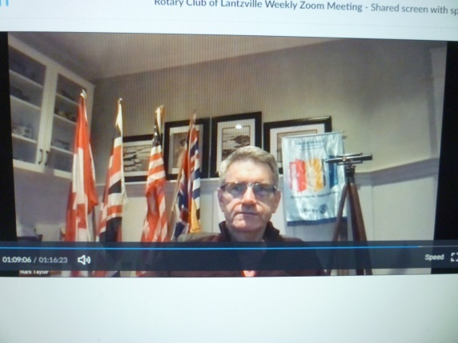

Club Meeting Notes

Reports from Troy and David on 7-10 breakfast.
Big thank-you’s to Shawn, James, Jodie, Gayle, Tessa, Sheila. Our next event is February 20th.

As presented last week, grants from gaming funds to Nanaimo & District Hospital Foundation, Scouts Canada Camp Caillet and Coast Emergency Community Association were approved.

Doug briefed us as to the impact enhanced radio communications will have on emergency search work in remote areas.

Tessa reported the Nepal project has been completed and the final report received. A big TY to Tessa and Jodie for their work on this.

Early March, Nanaimo RYLA is hosting a ‘Rotary’ trivia quiz night. Stephen needs us to send RCL trivia questions.

Inspiration

February 14-20th isRandom Acts of Kindness Week.Shared thoughts on how to make yourself and someone else feel good – say hello to a stranger with a smile, leave a generous tip, share a favourite recipe, do the unexpected&enjoy doing your part in making the world a little bit happier.

Youth Protection Training

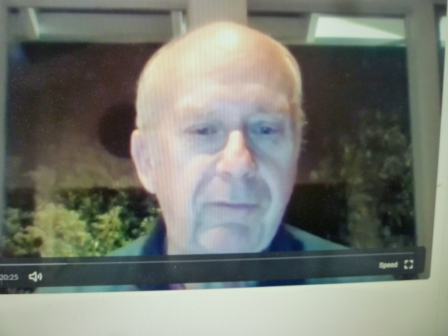

Joe Quinn faciliated good group conversations on identifying bullying, sexual harassment and inappropriate behaviours.Recognition is essential to ending bad behaviours. Follow-up is the responsibility of everyone who becomes aware of a problem.

Youth Protection 101 – District 5020 is committed to doing the hard work neeeded to keep young people, volunteers and members safe. This includes Club certification for every club, individual certification for all volunteeers who have more than casual contact with youth, training for all volunteers, and the Rotary Statement of Conduct for Working with Youth. The District goal is that every Rotarian and non-rotarian volunteer complete the online Youth Protection Awareness course.

For questions, concerns on this issue, Jodie Williams is our club Youth Protection Officer.

-------------------------------------------------------------

“Although no one can go back and make a brand new start, anyone can start from now and make a brand new ending.” ~~~Carol Bard

