February 18th, 2021
Peace and Conflict Prevention
Service Month

IN THE LANCE THIS WEEK

Club Meeting Notes
JVAN – Suzi Johansson
Rotary Minute

FUTURE EVENTS

February 25th CM – Harbour City Bingo
Lynn Peachey

March 4th CM – VIU
Ashleigh Martinflatt

VISITORS AND GUESTS
We happily welcomed Suzi Johansson.

ROTARY CLUB OF LANTZVILLE
MISSION STATEMENT
Joining in fellowship to support growth and development in education and health for those less fortunate in our local and international communities.
Club Meeting Notes

This past week, President Mark presented Paul Harris certificates to Greg, Dale and David. Lee presented Doug with a Paul Harris ruby pin.

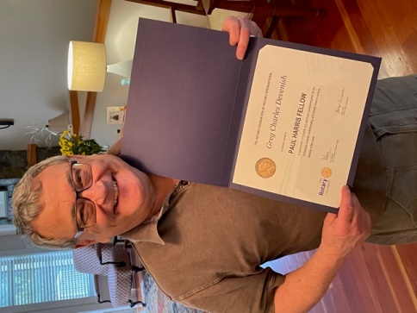

In the mail, the club received a District appreciation certificate for financial support for the End Polio Now Countdown campaign.

On March 8th, everyone is invited, RI president nominee Jennifer Jones will be speaking at the Banbridge Island Rotary club.

Registration for the ‘free’ March 13th, online District training classes is now open. Barry commented on how impressed he was with the 2020 offerings – well run, good variety, and good use of time.

Inspiration- In her work, Cheryl has learned you can never fully help someone until you have been welcomed into their life.

President Mark is in conversations with Mayor Swain to identify opportunities for RCL members with Lantzville projects.

If your actions inspire others to dream more, learn more, do more and become more, you are a leader.” John Quincy Adams
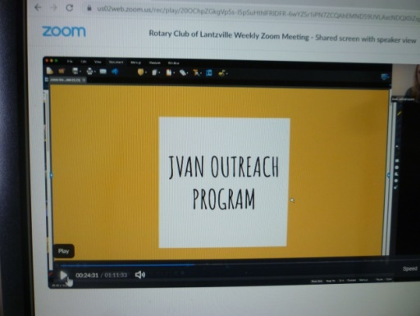

“We honour families in affordable housing throught caring, encouraging and supportive relationships with the hope of seeing families thrive.”

Suzi Johansson, outreach coordinator, showed great photo’s and gave an interesting presentation about JVAN’s work and programmes. For over 15 years, Suzi and her co-volunteers have worked alongside low income families providing educational support,fun learning activities and healthy snacks to children aged 4-12.

Currently, bi-weekly, JVAN arrives at one of two complexes with materials to meet the needs of 50 children. As part of promoting numeracy & literacy the JVAN serves as a mobile lending library. A larger van would make it possible to provide a safe, indoor welcoming space for program participants.

“We honour families in affordable housing throught caring, encouraging and supportive relationships with the hope of seeing families thrive.”

JVAN is 100% funded by donations. The current year operations were funded by the Lantzville Heritage Church.

President Mark echoed our thoughts in “thanking Suzi for all the great work you do in the community. Your presentation showed your passion and enthusiasm for what you do and for giving back to the community. You are an inspiration to us as Rotarians.”

WORLD COMMUNITY SERVICE UPDATE

Lesotho is a small enclave country within the border of South Africa. They are one of the poorest in the world countries with an exceptionally high illiteracy rate and ongoing threats from many diseases.

Reading the email from Peg Herbert’s, ‘Help Lesotho’ executive director gives one insight into CoVId 19 life in third world countries. ‘Help Lesotho’ provides programs to children & youth and their extended families to support them with education and life skills training.

www.helplesotho.org/pegs-letters-from-lesotho

In 2019, the Rotary Club of Lantzville, with Tessa’s help, secured funding for a successful 40 person teacher training project.

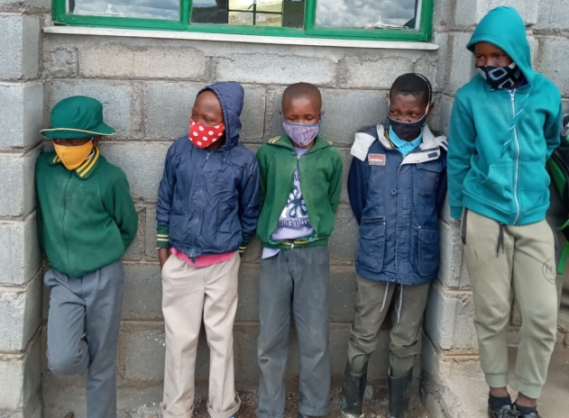

Lesoth Children with locally made masks.

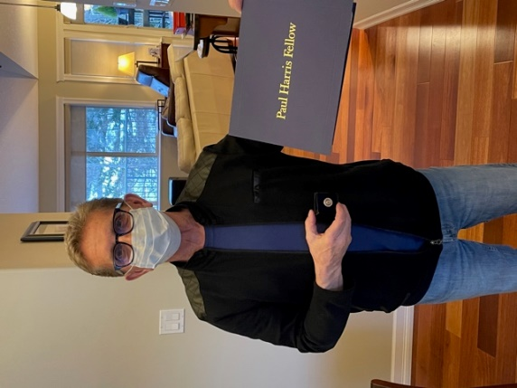

ROTARY MINUTE – DALE WEREZAK

Dale’s Rotary Minute message was about how much he appreciates the opportunity through Rotary to give back.

In his early 20’s, Dale was stranded (financially) in Amsterdam. An understanding stranger took him under wing, provided job & social opportunities to get him back home. Always, Dale was appreciative and inspired to look for avenues for him to ‘pay forward’ the support he received from Mr. H.

For Dale and for most of us, Rotary opens doors to working with and giving to our bigger community.
Through Rotary, we have amazing opportunities to learn, to give and to be inspired. Until one starts, you have no idea on what you can do. And in the doing, frequently one gets a great deal of pleasure.

PEACE BUILDING

Rotary is the perfect vehicle for making a positive impact toward world peace. There are few other non-religious groups the size of Rotary that are so globally united in their actions and interests. The Rotary Action Group for Peace provides an official entity that empowers and supports Rotarians by offering structure, guidance and resources to further our collective peace efforts.

The impact that Rotary’s global network can have on peace will be tremendous. Consider the triumph of what Rotarians have done for polio. We can to the same for peace.

- We are working together to bring about peaceful societal systems to replace the machinery of war, aggression and coercion.

- We voluntarily choose to interact peacefully, learn more about the science of peace and create service projects that truly deepen our communities’ commitment to a more prosperous, healthy, fair and tolerant society.

- We have collectively come to the conclusion that peace is best for all, and its time has come.

- We share a belief that there is a worldwide, societal shift towards peace.

Rotary Action Group for Peace – Our passion is PEACE. We are a group of committed Rotarians, Rotarians’ spouses, Rotaractors, Rotary Peace fellows and other Rotary program alumni working together outside club structures with the help of telecommunications and driven by the common interest of peace.

“In the end, we will remember not the words of our enemies, but the silence of our friends.”
~Martin Luther King, jr

