February 25th, 2021
Peace and Conflict Prevention
Service Month

IN THE LANCE THIS WEEK

Club Meeting Notes
Harbour City Bingo – Lynn Peachey
Rotary Minute

FUTURE EVENTS

March 4th CM – VIU
Ashleigh Martinflatt 11th CM – Nanaimo Hospital Found Foundation
Janice Perrino

VISITORS AND GUESTS

Joining us was past president Barry Sparkes
& Lynn Peachey, CEO Harbour City Bingo.

CELEBRATIONS

Congratulations to Ralph & Shirley on their 41st wedding anniversary.

CLUB MEETING NOTES

President Mark began by acknowledging we meet in the traditional territory of the Snaw-naw-as
First Nation.

Mike W. shared an inspirational quote from Douglas McArthur:

“A true leader has the confidence to stand alone, the courage to make tough decisions, and the compassion to listen to the needs of others. He does not set out to be a leader, but becomes one by the equality of his actions and the integrity of his intent.”

Greg presented information on a new 5 club public image initiative. Each month for 6 months there will be an ad sponsored full page in the Nanaimo Bulletin dedicated to Rotary. The content will promote Rotary Club projects & programs; strengthen the Rotary brand; educate readers as to what Rotary does in Nanaimo.

Closing thought from Mark…“Everything should be made as simple as possible, but not simpler.”
~ Albert Einstein

ROTARY MINUTE – DAVE ELGIE

“It appears to be coming to a town near us.”

Dave shared thoughts and reflections on the changing dynamics at play in our CoVid world and future. People have embraced new technologies, they have learned they can work remotely, they have discovered quieter communities with cheaper housing and they are moving from large cities in pursuit of better lifestyles.

Daily we see the change with surging real estate prices and a steady influx of newcomers in our community. With our booming construction industry and recent major Port expansion announcement, Nanaimo is on the cusp of serious growth and change.

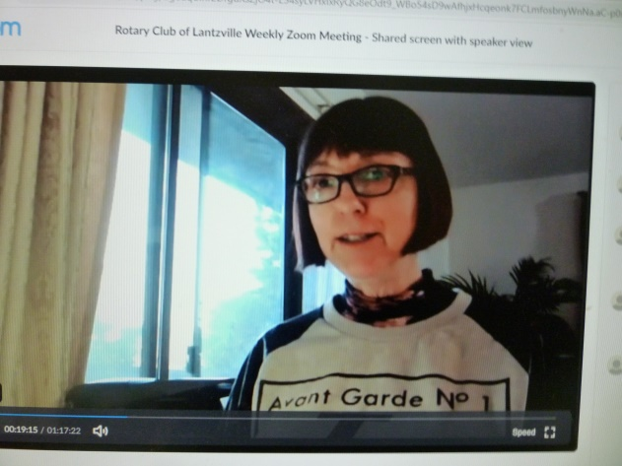

LYNN PEACHEY

HARBOUR CITY BINGO

Lynn has been the CEO of the soon to be dissolved Harbour City Bingo Society (HCBS) for 20 years. She was raised in Nanaimo and completed a business administration program at VIU.

HCBS was formed with 50 local nonprofit groups in 1995 to run daily bingos. Over time, changes in gaming regulations lead to the creation of a new entity, HCB Inc. which became responsible for running the bingos. Realization that re-opening the hall was a long way away, last year, the decision was made to not renew the monthly $ 25,000 bingo hall lease and to dissolve both entities’.

As a society member, RCL will receive substantial
funds, this Spring, following CRA HCBS dissolution approval. Small dividends will also flow over the next 2-3 years from the dissolution of HCBI.

Lynn expressed her sincere gratitude for the opportunity to work with HCBS members and extended her thanks for all the volunteer work members do in the community. We wish Lynn well in her search to find a new employer.

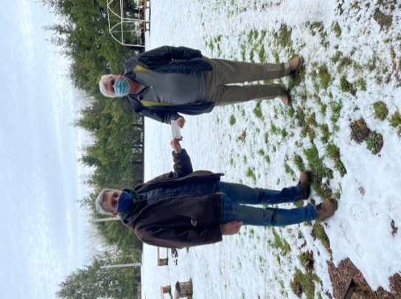

DOUG SLOWSKI
RCL SCOUT CHEQUE PRESENTATION

GAMING

Lynn shared thoughts on running commercial and non-commercial bingos. Bingo operations are highly regulated and very complex. Having said that, she was aware of two pre-CoVid local non-profit bingo operations. In both cases, the non-profits own their premises.

The one time cost for bingo equipment is perhaps
$ 6,000 with further investment needed for bingo paper, change machines and CoVid protocols. Each event requires a designated facilitor to obtain the gaming license and 4-5 dedicated volunteers.

With the disappearance of the Nanaimo commercial bingo, there is a big opportunity for new post CoVid bingo operators.

Lynn also spoke about spending opportunities for RCL with monies received from the dissolution of HCBS. These are not gaming funds and therefore not subject to the more restrictive gaming grant rules. Discussion & planning for fund disbursements is on the March agenda at both the Directors’ and Club Member Information meetings.

BITS AND PIECES

Our condolences and best wishes for a quick recovery to Dale with his recent sports injury.

Dave E. tells us Cindy is greatly enjoying working with her newly purchased serger.

Registration for the March 13th, District Leadership training is now open.

The recent snow presented a great day of skiing for Mark and son at Mt. Washington.

Last week, Lee – Doug and friends, enjoyed great fellowship, had good fun with their virtual whiskey tasting evening.
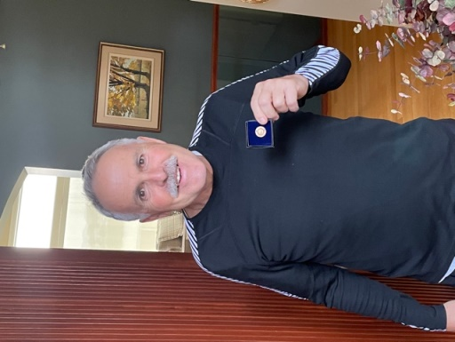

DAVID LOBAY
PHF CONGRATULATIONS

FUN STUFF

An elderly woman died last month. Having never married, she requested no male pallbearers.

In her handwritten instructions for her memorial service, she wrote, ‘they wouldn’t take me out while I was alive, I don’t want them to take me out when I’m dead.’
~~~~~~~~~~~~

A police recruit was asked during the exam, ‘What would you do if you had to arrest your own mother?’ He answered, ‘Call for backup.’

~~~~~~~~~~~~
Attending a wedding for the first time, a little girl whispered to her mother, “Why is the bride dressed in white?”

The mother replied, “Because white is the color of happiness, and today is the happiest day of her life.”

The child thought about this for a moment then said, “So why is the groom wearing black?”

