“Rotary: Be The Inspiration”

February 28th, 2019
Peace & Conflict Prevention/Resolution Month

IN THE LANCE THIS WEEK

Lots of Rotary Information

FUTURE EVENTS
Mar 7th – Just Sort It!
Mar 14th –
- Followed by Golf Planning Meeting
Mar 19th – Board Meeting
Mar 21st –
Mar 23rd – Monthly Breakfast at 7-10 Club

“VISITING” ROTARIANS
No visiting Rotarians this morning…

VISITORS and GUESTS
…and no guests or visitors. ☹

BIRTHDAYS & ANNIVERSARIES
 |  | DUTY ROSTER
DATE | GREETERS |  | CASH | Sgt-At-Arms | Invocation | INTRO | Foundation | Rotary  Minute
Mar 7th | Rodgers & Cameron |  | Elgie | McFadden | Devenish | Rodgers | Taylor | Kilner
Mar 14th | Robertson & Devenish |  | Lemmon | Slowski | Elgie | Robertson | Walker | Lemmon
Mar 21st | Rowley & Elgie |  | McFadden | Tamelin | Kilner | Rowley | Williams | Litchfield
If you cannot make your duty, it is your responsibility to find a replacement.
Ralph & Valerie – their 39th on Mar 1st.
William L – another year closer to CPP on Mar 6th.
Sheila B – celebrating on March 7th.

HEALTH of the CLUB
Sadly, we have learned of the passing of Don Day, a long-time (’01 – ’13) member of our Club. Our condolences to his wife, Marilyn.
Nice to see James Williams, looking good, at breakfast last Saturday.
Joy’s cataract surgery seems to have been successful.

ROTARY CLUB OF LANTZVILLE
MISSION STATEMENT
Joining in fellowship to support growth and development in education and health for those less fortunate in our local and international communities.

“Presidential” Observations
Pres Jan – thanked all those who were able to help at breakfast last Saturday. It was busy and it was “interesting”.

FOUNDATION
$80contributed to the Rotary Foundation. THANKS!
Future contributions will be directed to the PolioPlus Fund unless you tell Barry otherwise.

Sergeant-at-Arms
Ralph was the [smiling] Sgt this AM. Barry is “going back to sea for a few weeks”. David L is going to Mexico. Stephen’s kids are excited about going to Disneyland next month [so is Stephen ☺ ]. Rachel won a gold medal in kettle ball lifting. CONGRATULATIONS! Harry (and Jamal) found some snow on the top of Mt Benson. Jamal nicely tanned – but wished Harry had let him sleep in a bit… Sheila pulled the wrong “J” – the Jack of Clubs, not the Joker, so the pot next week will be $120!

Breakfast at the 7-10 Club
Thanks for your continuing support.
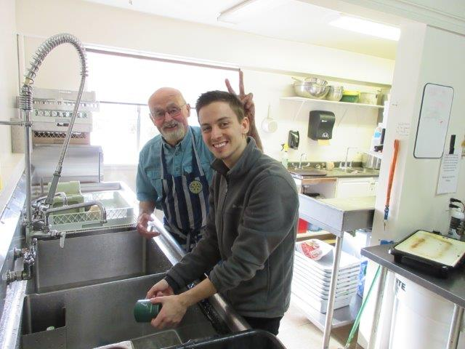
Dishwashers – old & new! Note the difference in the chin stubble ☺
Next breakfast – Saturday, March 23rd, 2019

News, Updates & Reminders
2019 Golf Tournament. Our major fundraiser that helps us help our community - will be held at Fairwinds on Friday, May 3rd.
- We/you need to spread the word to potential sponsors, prize donors and golfers.

District Training and Conference. It will take place in Victoria, May 9th to 11th. It’s open to all Rotarians –learn lots about Rotary, meet lots of Rotarians, and have lots of fun. You can learn more about it and register online: https://portal.clubrunner.ca/50092/sitepage/2019-district-training-and-conference/event-overview
The club will reimburse some of your costs.
Check out DG Craig’s invitation on the District Website: https://portal.clubrunner.ca/50092. You just have to scroll down the home page a bit…

Rotary Minute
Harry investigated why the Rotary fiscal year ends June 30th. Way back when, the Annual Rotary Convention used to be held in August and the auditors recommended a year ending June 30th so the books could be wrapped up before the Convention.
But in 1917 … the powers-that-be decided to move the Convention ahead to June (at bit cooler than August), but did not change the end of the fiscal year.
Harry would like to see them move it to the end of February…

Notes from a [busy] Rotary Information Meeting
Treasurer (Harry):
- $20,170 in the General Account and $15,377 in the Gaming Account.
- A good discussion about the use of Gaming Funds – how, for what, and by when…
International Service (note from Tessa):
- The teacher training symposium in Lesotho has been delayed by a teachers strike.
- She has asked Tumaini for some photos of the school uniforms that we provided funds for.
Membership (note from Mark):
- 5 new members, so far, this year. Neil will be inducted next week and there are a couple of ‘expressions of interest’ Mark is working with.
- Just ask … your friends and colleagues to come to breakfast one Thursday morning.
Foundation (Barry):
- We have achieved our goal of $2,800 US to the Annual Fund.
- We will achieve our goal of $700 to PolioPlus.
- We’re a couple members short of achieving Every Rotarian Every Year (EREY).
Administration (Joy):
- A great turnout at our social evening at Simon Holt, although it was difficult to mingle…
- Joy has some good speakers coming up next month, but suggestions are welcome.
- Installation of the 2019-2020 Officers and Directors will be at the Nanaimo Golf Club, the last week in June. Details coming…
Youth Service (Jodie):
- We (all 5 Clubs) will be helping the Interact Club at a Beach Cleanup at Pipers Lagoon, May 10th.
- Only one outbound Youth Exchange student next year.
- We are sponsoring a student to attend “Adventures in Leadership” in Ottawa in April
- Lots of discussion about the need for Criminal Record Checks – for youth protection…
Community Service (Doug for Dale):
- The members approved a motion to donate $1,000 from General Funds to Gymnaestrada (Nanaimo) to attend the World Gymnaestrada.
- The members approved a motion to donate $2,000 from Gaming Funds to ROAR to help them sponsor a LGBTQ refugee from Syria.
- The board previously approved a donation of $500 from Gaming Funds to the Cottle Creek Park development project.
Projects and Events:
- Golf Tournament – just two months away. Next planning meeting will be held Thursday, March 14th – after our regular morning meeting.
- The Nanaimo Wine Tasters has asked us to provide “drives home” after their wine tasting competition on May 25th. They will give us a donation.
- FoamFest – after-meeting e-mail. It will be held June 8th. They have asked and Harry has accepted for us to run the beer (and hot dog) tent again. It’s a bit of work but does bring in some money for us…

ROTARY INFO
You can find out where and when all the Clubs in District 5020 meet on the 5020 website:
www.clubrunner.ca/portal/Organization/Meetings.aspx?accountid=50092
Rotary International: http://www.rotary.org
Member’s access: https://www.rotary.org/myrotary/en
District 5020: www.rotary5020.org
Our website: www.clubrunner.ca/Lantzville
Our Facebook Page: www.facebook.com/RotaryClubofLantzville
Check it out – you might be surprised… ☺



GOLF TOURNAMENT – MAY 3RD
- The major beneficiary will be the Island Crisis Care Society – for their operation of Samaritan House which provides services for women in crisis.
- Because we are bit earlier this year, Fairwinds has given us a bit of a deal on the green fees, $700 off the normal cost.
- Sponsorship and Registration Forms were e-mailed to all members Tuesday, as were letters you can use to ask for a sponsorship and/or a prize.
- Sheila & Rachel will be tracking registrations.
- Randy will be tracking sponsors. If you give him a good lead, he will follow up.
- Dave E will be tracking prizes – that you bring in from our supporters. “Good” prizes, please.
- Jodie will be coordinating volunteers. We will need some Rotarians to help with set-up in the AM and out on the course during the event.
- Next planning meeting after Don T and Randy get back from the sun -- Thursday, March 14th, immediately after our regular morning meeting.


