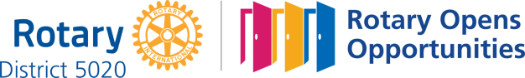

February 4th, 2021
World Understanding
Service Month

IN THE LANCE THIS WEEK

Club Meeting Notes
Rotary Minute
Mayor Krog

FUTURE EVENTS

February 11thCM – Club Youth Protection
18th CM – Rotary Information
20th Coldest Night of the Year Walk

VISITORS AND GUESTS

Visiting Rotarian Linda Murray, Victoria.

“Life is 10% what happens to you and 90% how you react to it.” ~Charles R. Swindoll.

“If you can dream it, you can do it.”
~Walt Disney

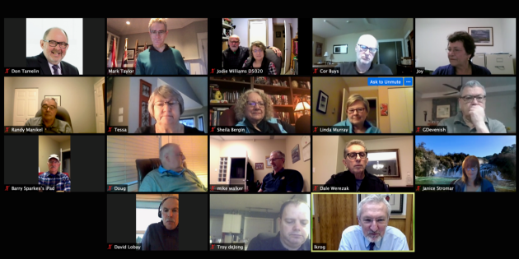

Club Meeting Notes

President Mark began the meeting with a’great’ Canadian Brass version of O’Canada.

Dale presented notices of motion, to be voted on next week, for funding:

1. Nanaimo & District Hospital Foundation - $7,500.00 from Restricted Funds (Gaming);

2. Scouts Canada Camp Callet - $1,800.00 from Restricted Funds (Gaming)

3. Coast Emergency Community Association (CECA) - $1,800.00 from Gaming.

Supporting information will be mailed to members.

Don Tamelin, Randy Manikel had preliminary discussions with Fairwinds for a virtual golf tournament. If this comes together, it will be a very different event.

Mark received thank-you letters from our bursary receipient and from the Kradyk family.

Linda told us about a ‘Music Bingo’ online event.

Several members spoke about their activities, communications with family and Rotary friends.

Inspiration – Randy Manikel

There is a vast array of opinions, occupations and backgrounds, in Rotary. But we seem to do a very good job of coming together to achieve the overall goals of Rotary, and setting aside, or overlooking our differences. This may partly be because of the Rotary tradition of leaving all discussion of politics or religion at the door.

Hopefully we are able to practice this trait in our daily lives outside of Rotary by focusing on the things that we bind us together as a community or country, rather than poking away at the ways we are different.

The Dalai Lama summed it up nicely in this way:
"People take different roads seeking fulfillment and happiness. Just because they're not on your road doesn't mean they've gotten lost.”
Something for us to keep in mind!

ROTARY MINUTE – TROY DeJONG
The month of February is very special in the Rotary calendar since it is designated World Understanding Month. The month also includes the anniversary of the first meeting of Rotary held on February 23, 1905, now designated World Understanding and Peace Day.
In designating World Understanding Month, RI asks all Rotary clubs to plan programs for their weekly meeting and undertake special activities to emphasize "understanding and goodwill as essential for world peace."
World Understanding Month is a chance for every club to pause, plan and promote the Fourth Avenue of Service (international service) and Rotary's continued quest for goodwill, peace and understanding among people of the world.

HIS WORSHIP MAYOR LE0NARD KROG

Mayor Krogdelivered an amazing, inspirational presentation about the City – our history, who we are, where he sees us going.

With a population of 1,000 and coal as the driving force, Nanaimo was incorporated in 1874. Today, at 100,000 we are the 2nd largest centre on Vancouver Island. In 2020, the City issued 6,280 business licenses. We are a port city and we have been discovered!

With amalgamation in 1975, the City grew to 91.3 square kilometers. In Mayor Krog’s words, a lot of turf to be managed and ongoing very expensive. Fun facts include that Nanaimo has 567km. in paved roads, 324km of sidewalks; 586km of sewers & 108K in supply mains. We have 3 dams with a 1 year supply in reserve in part thanks to a very successful water conservation program. Today, there is much pressure on City infrastructure and a genuine shortage of industrial zoned land. Comparatively, City debt is low.

Moving forward, last week Council approved the re-institution of a stand-alone economic development corporation. On another initiative, preparation for work on opportunities to rebuild Nanaimo based on recommendations from the ‘Mayor’s Task Force on Recovery and Resilience is underway.

In the Q&A, Mayor Krog offered optimism with the current Provincial commitment to address the needs of people with mental health issues, addictions & the homeless. Currently Nanaimo has 880 units of low income housing finished, under construction or planned.

President Mark thanked Mayor Krog for an nformative and very refreshing talk about what the City is doing and where it is heading.

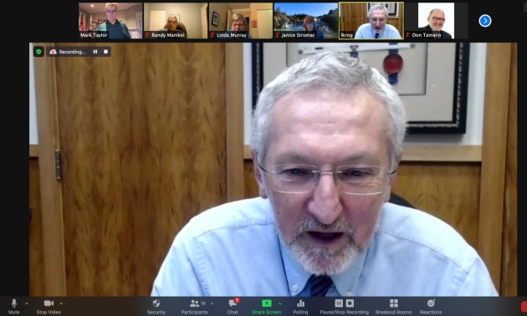

ABOUT MAYOR LEONARD KROG

Leonard Krog was elected mayor in 2018. Prior to that, he served Nanaimo as MLA for 18 years.

Today, Leonard is a practicing lawyer, in partnership with wife Sharon, son Parker.

Leonard was born in Nanaimo, raised in Coombs, has 2 children and 3 grandchildren.

FUN STUFF –Getting older…

I am at a place in my life where errands are starting to count as going out.

I do not mean to brag, but I finished my 14-day diet food supply in 3 hours and 20 minutes.

It’s weird being the same age as old people.

I am getting tired of being part of a major historical event.

You don’t realize how old you are until you sit on the floor and then try to get back up.

A recent study found women who carry a little extra weight live longer than men who mention it.

ROTARY INTERNATIONAL MEDIA RELEASE 12/20
For the 13th consecutive year, The Rotary Foundation has received the highest rating — four stars — from Charity Navigator, an independent evaluator of charities in the U.S.
The Foundation earned the recognition for adhering to sector best practices and executing its mission in a financially efficient way, demonstrating both strong financial health and commitment to accountability and transparency. Only one percent of the organizations Charity Navigator evaluates have received 13 consecutive 4-star evaluations.
The rating reflects Charity Navigator's assessment of how the Foundation uses donations, sustains its programs and services, and practices good governance and openness.

