January 14th, 2021
Vocational Service Month

IN THE LANCE THIS WEEK

Club Meeting Notes

Nanaimo Rotaract

VISITORS & GUESTS

Visiting Rotarian, ADG Wayne Anderson; Rotaractor Kimberley Barrett.

CELEBRATIONS

Celebrating birthdays are Greg Devenish and Brian Rodgers.

ROTARY CLUB OF LANTZVILLE
MISSION STATEMENT
Joining in fellowship to support growth and development in education and health for those less fortunate in our local and international communities.

CLUB MEETING NOTES

Welcome remarks from President Mark with acknowledgment that our meetings take place in the traditional territory of the Snaw-naw-as First Nation.

Business…
Thanks to Dale& William, we have a Super bowlpool with bonus prizes from Panago Pizza.

Plans for RYLA Vancouver Island are well underway. All Nanaimo Clubs are asked to recruit students for this event.

S/A Happy bucks…sad bucks…

-Dale, Mike – happy for the Maple Leaf win!
-Tess, happy because her brother is here to help with estate paperwork.
-Both Joy, David enjoying the great weather- working in their gardens.
-Sad to watch what’s happening in the US.
-Lee’s looking forward to longer days, more golf.
-everyone is happy that the vaccine is happening!

"Life is change. Growth is optional. Choose wisely.” Karen Kaiser Clark, author

“Some people see the glass as half full; others see it as half empty; I just see a glass that’s twice as big as it needs to be!” George Carlin

Nanaimo RotarAct member Kimberley Barrett

Presented us with information about the Club. It is a registered club with the VIU Students’ Union. They have 15 current & past VIU student members.

Kimberly spoke about challenges because of high member turnover and member demographics. Student stresses include academic demands, financial pressures and food insecurity. Last year, the club adopted education as their theme. They have been active in promoting virus education and addressing CoVid misinformation.

The 2020 transition to zoom meetings has been beneficial. Ongoing, social and community contacts are very important for everyone’s well-being. Club fun activities have included game nights, Trivia contests &Arts/Crafts activities. Currently, Kimberley is working to build Nanaimo and area RotarAct/Rotary connections with a quiz night. Also, club members are looking for volunteer opportunities with Rotary and they are interested in attending Rotary meetings.

Kimberley concluded her presentation with an invitation for us to sit in on one of their 7:30 pm Monday meetings. Thank-you Kimberley!

About Kimberley…Currently, Kimberley is studying cougar populations in Alberta as part of her Masters of Science degree at the University of Alberta. She graduated with a biology degree from VIU in 2019 and won two awards for her VI marmot research project.
ROTARY MINUTE

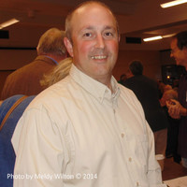

Stephen shared a thoughtful video titled “What do you think is the best PR for Rotary?”

The message from the presenters was that we Rotarians need to take every opportunity to talk about ourselves. Many of our friends, family, work mates and clients are not aware of the powerful things we do locally and internationally. We need to make people aware of ‘the great jewel that’s Rotary.’

Upon learning about who we are, what we do, Stephen made his decision to join our club.

Thank-you Stephen for sharing.

FUN DEFINITIONS

Father – A banker provided by nature.

Classic – Books, which people praise, but do not read.

Smile – A curve that can set a lot of things straight.

Experience – The name we give to our mistakes.

Life Insurance – A contract that keeps you poor all your life so that you can die rich.

Marriage – An agreement in which a man loses his bachelor degree and a woman gains her masters.
ABOUT ROTARACT

RotarAct was founded on March 13th, 1968 in North Charlotte, Carolina.

Prior to 1968, there were several youth clubs sponsored by Rotary clubs under various names. These clubs experienced significant growth – in part due to the creation of the Interact program by RI in 1962.

The new program’s name, RotarAct, was created by RI as a combination of the words “Rotary’ and “Action’. The aim of the program was stated to be “to develop leadership and responsible citizenship through service to the community.”

In 2019, RIamended constitutional documents to include RotarAct clubs as a membership type. Beginning in July 2022, university based clubs will begin paying annual dues of $ 5.00 per member.

Worldwide RotarAct membership totals over 184,000 with 8,000 clubs in 163 countries.

Promo @ Nanaimo RotarAct Facebook Page

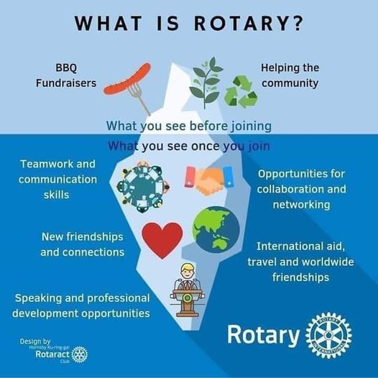

VOCATIONAL SERVICE

The Object of Rotary is a philosophical statement of Rotary’s purpose and the responsibilities of Rotarians. The concept of vocational service is rooted in the Second Object, which calls on Rotarians to “encourage and foster”:

Those objectives are:

- To encourage and foster high ethical standards in business and professions, to recognize the worthiness of all useful occupations, to dignify the Rotarian's occupation as an opportunity to serve society.
- To apply the ideal of service in personal, business and community life.
- To advance international understanding and goodwill, and peace through a world fellowship of businessmen and professional men and women united in the ideal of service.
Paul Harris wrote: "Each Rotarian is a connecting link between the idealism of Rotary and their trade or profession".

Vocational Service is the way Rotary fosters and supports the application of the Ideal of Service to the pursuit of all vocations.

It is the shared responsibility of both the Rotary Club and its members.

Source: Rotary District 7080

