“Rotary: Making a Difference”

January 16th, 2020
Vocational Service Month

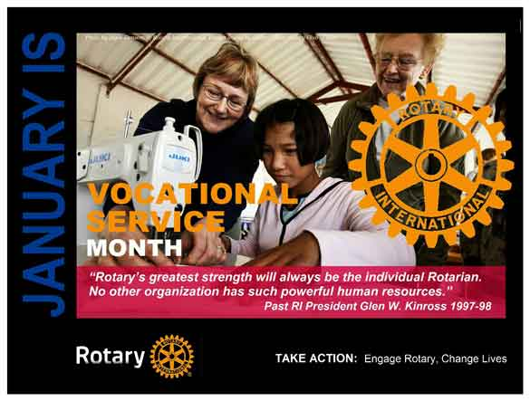

January 13th – 15th were snowy days.
The roads were slippery.
The forecast was for more snow on the Wednesday.
So – our weekly meeting was cancelled.
So – no Lance for January 16th.
Just an eclectic selection of photos of interest.

ROTARY CLUB OF LANTZVILLE
MISSION STATEMENT
Joining in fellowship to support growth and development in education and health for those less fortunate in our local and international communities.

Momma and Charlotte – a few days after December 22nd, 2019.


Don T spotted at the World Junior Hockey Championships in Ostravar, Czech Republic

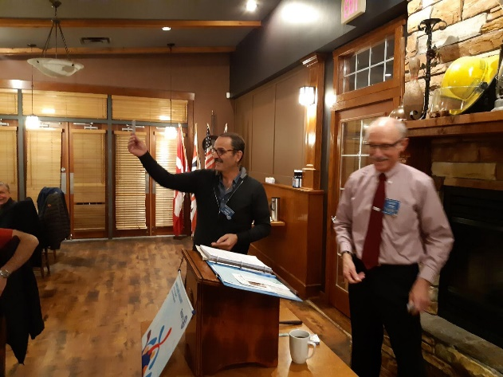
January 9th - Jamal pulled the Joker, finally ☺
Rotarians at work – helping build a fence around Cambie Park in south Nanaimo (January 11th)

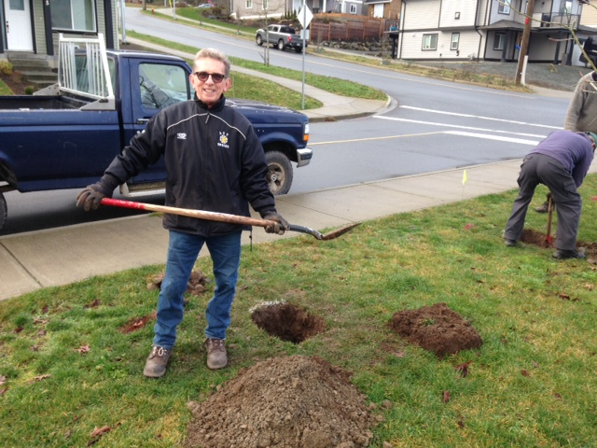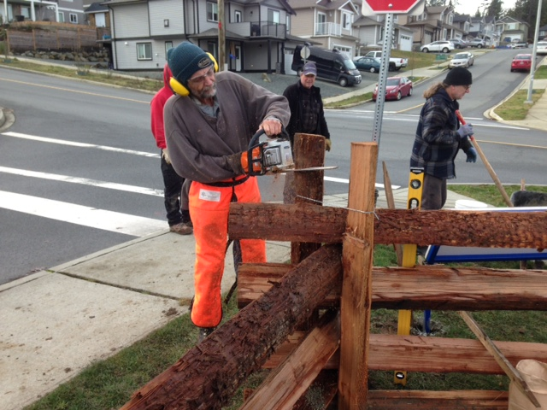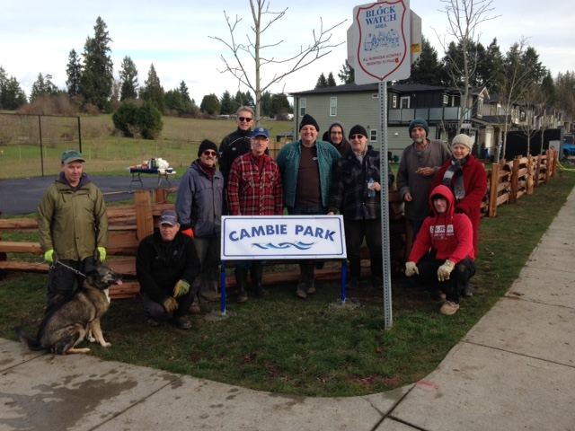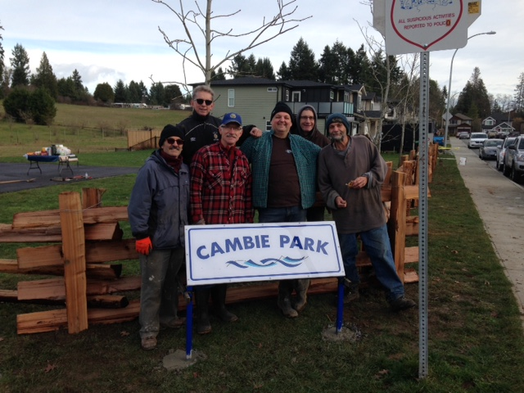
There were six of us – but I couldn’t squeeze all the photos into this small space.

Rotarians having “fun” – at “Breakfast with Santa” last December in Lantzville. Yes, it’s a bit of work but it’s also a time for socializing and serving our community.
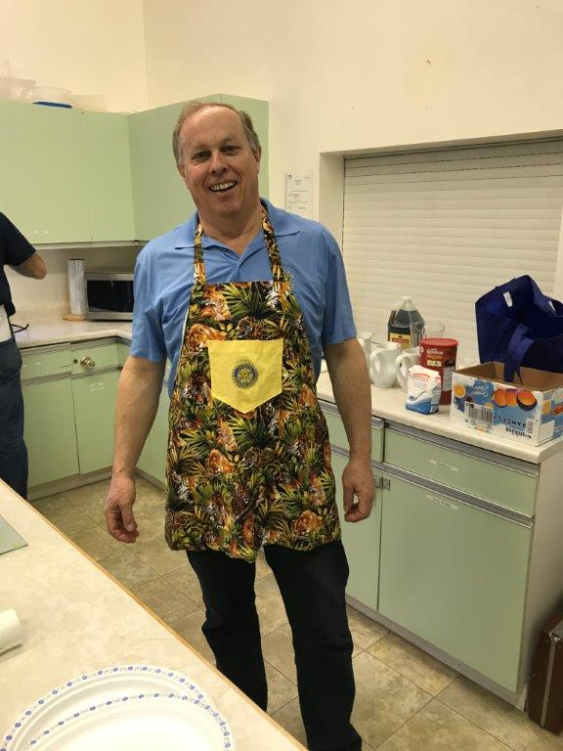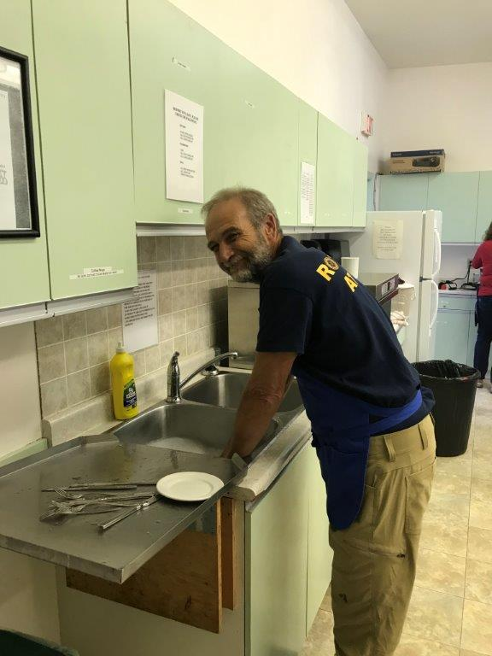
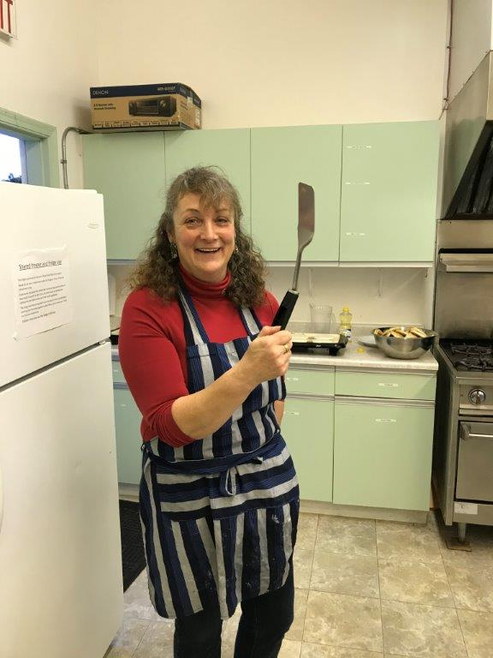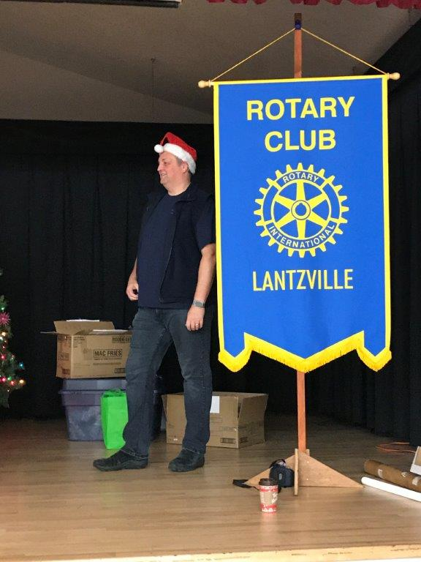

Thank-you for your ongoing support of The Rotary Foundation – both the Annual Fund and the Polio Plus Fund.
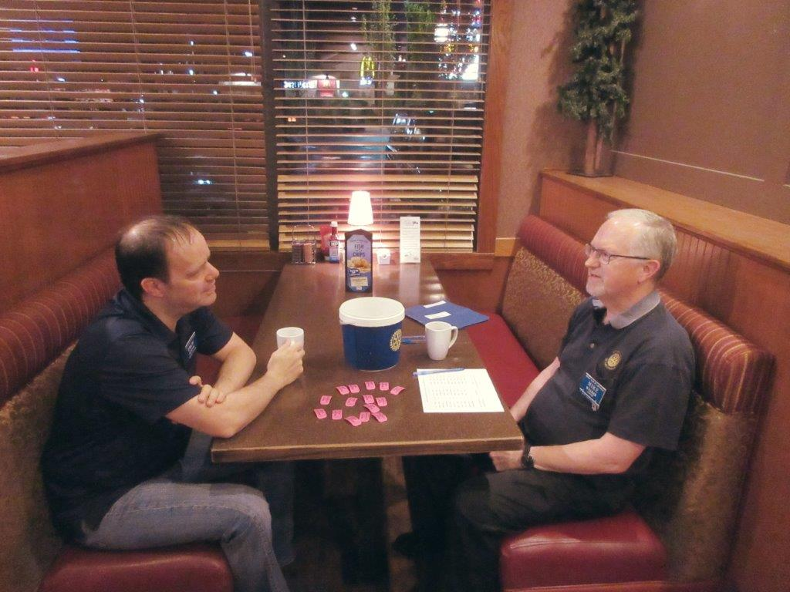

With the financial “help” of a Community Gaming Grant, we served 12 hot, healthy breakfasts at the 7-10 Club throughout 2019.
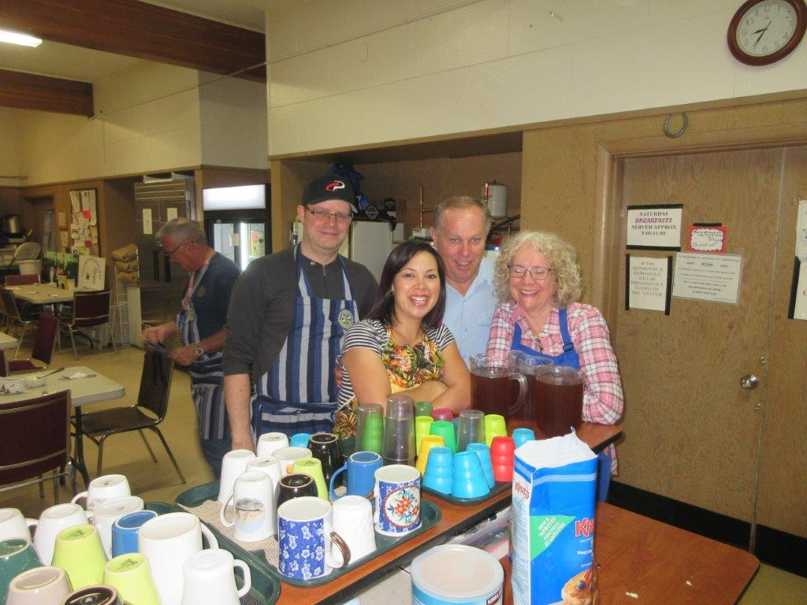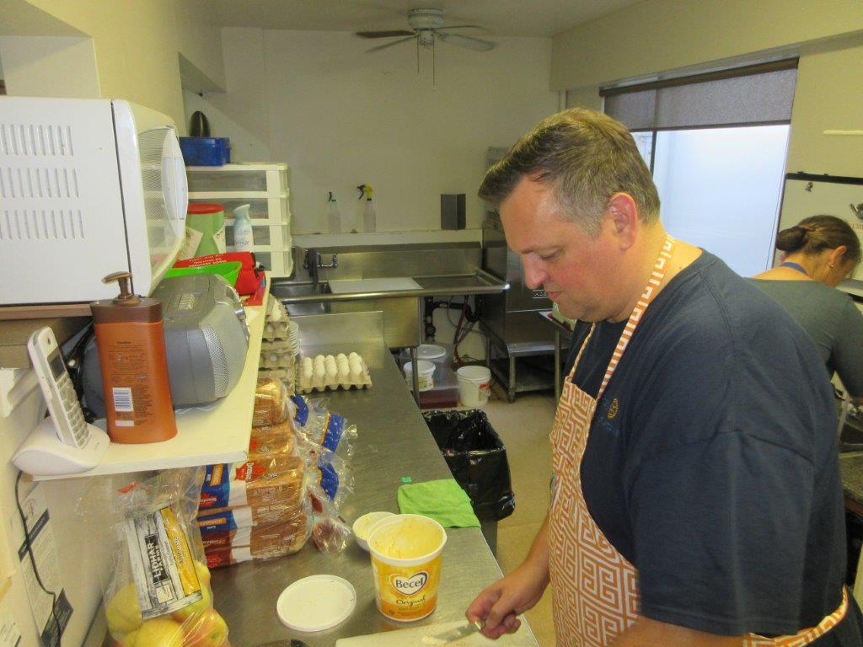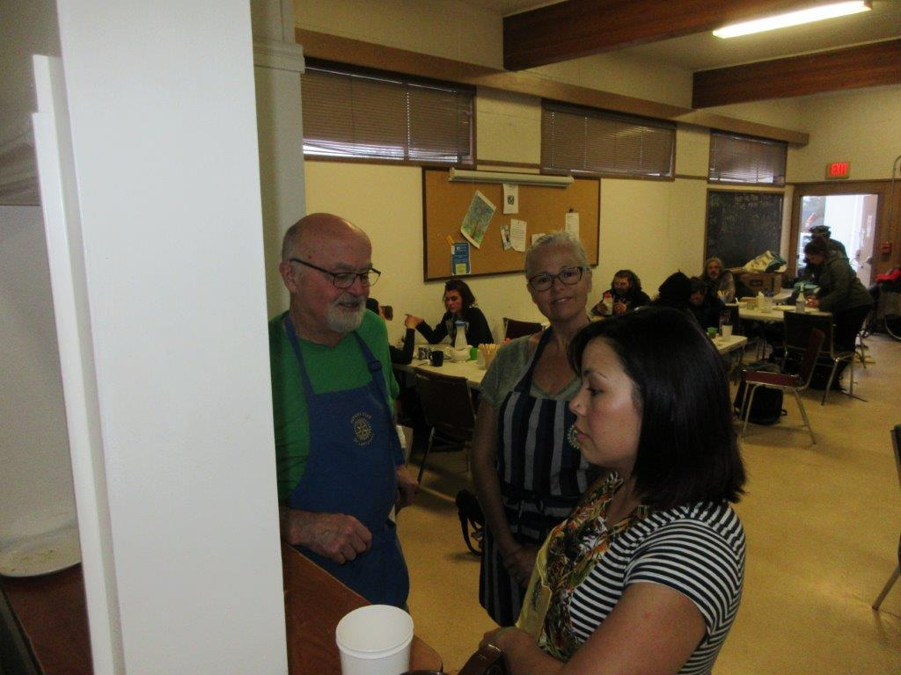

And, Mother Nature smiled on us for our Golf by Donation days at Fairwinds where generous golfers contributed almost $1,900 to our Club.
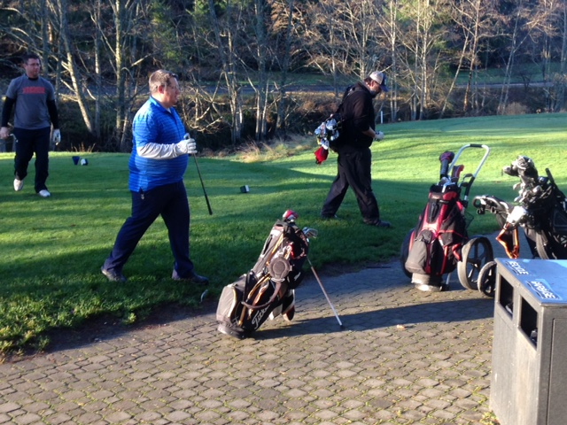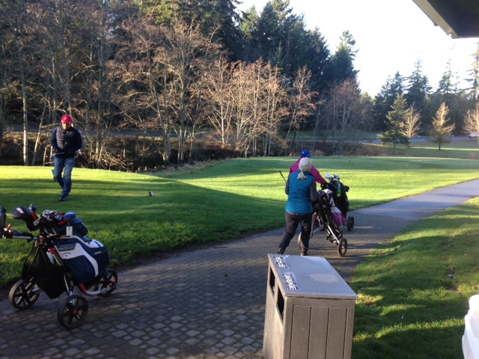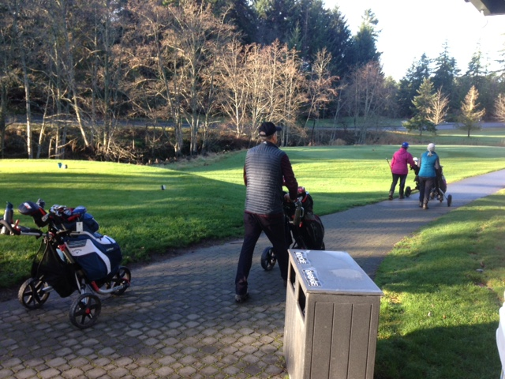

Which is a natural segue to our Annual Golf Tournament coming up May 29th at Fairwinds.
This is our major fundraising event of the year.
…Kick-off planning meeting – as part of our weekly meeting January 23rd. Bring your ideas.
Who should be our major beneficiary for this year?
Your input and support is much needed – as are sponsors ($$$s), prizes givers and golfers. And, as always, some volunteers to make the day run smoothly. THANKS! ☺

