January21st, 2021
Vocational Service Month

IN THE LANCE THIS WEEK

Club Meeting Notes
Rotary Minute

FUTURE EVENTS

January 28th - CM - Project Amigo
February 3rd Club Directors’ Meeting
4th CM – Mayor Krog

OUR CHARLOTTE
A VERY SPECIAL WEE VISITOR!
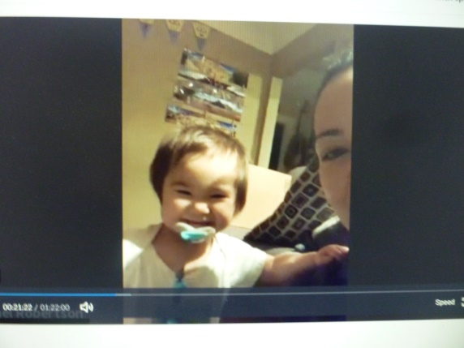

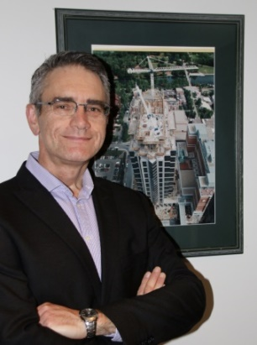
PRESIDENT MARK

From Mark, a warm friendly greeting to everyone. and acknowledgement that RCL meets on the traditional territory of the Snaw-naw-as First Nation. A very special hello to Brian Rodgers – you have been missed. Thank-you’s to everyone in the Duty Roster.
From Rod & Jill Mont, TY for support given to the Kraydi family. From Crystal Dennison, TY forour ongoing support of the SD 68 Foundation.

CLUB BUSINESS
Dale has been very busy out and about selling Super Bowl Tickets. 1st pool is sold out, 2nd is at 50% with two more weeks to go.
Troy is delighted with the impressive response to the Club 7-10 fundraising letter. At last week’s breakfast, we served 55 guests.
As a member of the Harbour City Bingo Society,
our club will receive substantial gaming funds in April. Timely dispersal will be discussed by the Directors’, brought back to club members for discussion in April.
From Jodi, registration for the RYLA NorthwestMarch virtual conference is open. Also, open for registration is District 5040 Adventures in Health Care Online. This free event is available to grade 8-12 students, live March 13ththrough to April 30.

SERGEANT @ ARMS, DOUG SLOWSKI

Doug began the meeting by commenting on how greatly our world has changed in the past 12 months – the time when we just started to hear about the virus.
Happy $$$’s from several members about the emotions surrounding the inauguration of President Biden. Good that it went off without violence, the presence of diversity and the very inspirational presentation by poet laureate Amanda Gorman.

Dave Elgie reflected on the fact that democracy is tenuous and sensitive, that it takes a lot of work, that we be aware of how quickly things can change.

Ralph’s inspiration = we all need each other to grow. Members are the dirt & water that make it happen.

Cor lamented about the disappearance of small town newspapers.
Stephen, two weeks into his new job @ Home Depot, very happy to have lost weight thanks to lots of walking and lifting.

Congratulations from Neil to Troy on the great fundraising start. Letters by committee are not easy.

Barry had a call from Vojto& all is well.

Doug is very happy with wood purchased from the Scout Camp. He is busy making cutting boards.

“Almost everything will work again if you unplug it for a few minutes, including you.”
~~Anne Lamott, American novelist
ROTARY MINUTE – NEIL VALSANGKAR

Neil gave a very interesting presentation about his Fall participation in an organization called Spring Activator.

“I participated online as one of nineteen Investors in the Spring Investor Challenge in Fall 2020. The goal was to bring together entrepreneurs and business investors to develop Companies that create a more sustainable, equitable and resilient world, as envisioned in the United Nations Sustainable Development Goals.

Over 200 entrepreneurs applied to the program and the organizers selected 20 to do an initial presentation to us. Through a two week process, we selected five finalists and then worked with them for a 10-week period providing mentoring and participating in training sessions with lawyers, accountants and impact investment specialists.

Two example Companies were:

Emkao Foods – Founded by an immigrant from Camaroons, they have started a chocolate manufacturing facility in BC with a vision to develop “Fair Trade” business practices for the chocolate industry.

Indiegraf – In the media industry, they are developing a technology and business platform to help small, independent media outlets and journalists that have been shutting down in recent years to continue publishing.

The five Companies did a final pitch to the Investors and a winner was selected, Indiegraf, which received a $100,000 investment from my Investor Group.”

More information about Spring Activator can be found at www.spring.is.

Neil’s presentation was a great example of how Rotarians can so vocational service.

WORLD COMMUNITY SERVICE UPDATE

Received this month, was the 1/4ly Aldea Maya newsletter. Aldea Maya is a VI registered Canadian charity working in the Guatemalan Highlands, a region of intense poverty. In 2016, our club partnered with RI to purchase industrial sewing machines in Chuk Muk. With funds raised, Aldea Maya directly sponsors over 70 students.

“As 2020 draws to an end we are happy to share the fantastic news that 5 of our sponsor students are graduating university this year. The common denominator to all the students is that they would not have continued past grade 6 without the Chuk Muk middle school started by Aldea Maya in 2012. 4 of the 5 students were in our first graduating class.”
Received last month, was a thank-you note from Gordon and Joyce Graham thanking us for personal and monetary us for monetary and personal support for the Peace International School completion project in Rwanda. Construction will start on January 25th.
One of many Rotary Action Groups, WASH (Water – Sanitation – Hygiene), undertakes a variety of projects around the globe. They produce a monthly newsletter, interesting webinars and You Tube videos. In the upcoming years, the Wash Rotary Action Group is encouraging clubs and districts to focus on improving Water – Sanitation – Hygiene in health care facilities.

The Rotarian Code of Conduct is one piece within Rotary’s vocational service objectives.

Here is the updated Code of Conduct as amended January 2019:

As a Rotarian, I will:

- Act with integrity and high ethical standards in my personal and professional life

- Deal fairly with others and treat them and their occupations with respect

- Use my professional skills through Rotary to: mentor young people, help those with special needs, and improve people’s quality of life in my community and in the world

- Avoid behaviour that reflects adversely on Rotary or other Rotarians

- Help maintain a harassment-free environment in Rotary meetings, events, and activities, report any suspected harassment, and help ensure non-retaliation to those individuals that report harassment (January 2019 Mtg., Bd. Dec. 119).

Source: RI COL January 2019

