

“Rotary: Making a Difference”

January 23rd , 2020
Vocational Service Month

IN THE LANCE THIS WEEK
Annual Golf Tournament
Club Business

FUTURE EVENTS

January 30th - Sheila Bergin, Travel

February 6th - Kidney Foundation of Canada
February 6th - VIU Library Tour, 5:00 pm
VIU Discovery Room Dinner

February 13th - Extreme Science, Ray Penner
VIU Department of Physics

Duty Roster – January 30th, 2020

Greeters: Rowley/Manikel Cash: Walker
Sgt-Arms: deJong Invocation: Lobay
Introductions: Manikel Foundation: Taylor
Rotary Minute: Litchfield

ROTARY CLUB OF LANTZVILLE
MISSION STATEMENT
Joining in fellowship to support growth and development in education and health for those less fortunate in our local and international communities.
VISITORS

We had a wee, very well behaved welcome visitor this morning - baby Charlotte!



BIRTHDAYS & ANNIVERSARIES

In typical Rotary tradition, we sang a belated Happy Birthday to Brian Rodgers.

PRESIDENT BARRY SPARKES…

-Announced that our gaming grant application for
$ 18,000 was approved. Barry recommends we allocate a portion of the monies approved for the breakfast programme to the purchase of much needed pots and pans.

-Had a big thank-you to Jodie and James Williams. They are coordinating the March 12th – 15th 5 club RYLA programme and will be chaperoning the students.

-Read us a thank-you note from Rachel, Solly & Charlotte for the gift card. They will use it on getting a fun play centre for Charlotte. And we also received a thank-you note from Laurie & David Pelly. Our donation to the Ayalik Fund ‘will make a difference in the lives of Inuit youth.

-Asked us to consider adopting Emanuel Litt’s Christmas Food Drive in Lantzville.
SERGEANT-AT-ARMS – DON TAMELIN

Don guided us through a good time early start with lots of energy, mostly fun exchanges about club and member activities this past week few weeks. On a very happy note, with the coordination of Neil Valsangkar and a Big Brothers Big Sisters partnership thanks to Stephen Cochrane, our elementary school shoe program is being resurrected. The targeted four schools are Seaview, Fairview, Brechin and Georgia Avenue. Positive feedback about the Cambie Street Park fence building work party. A good time was had by all. Back from Europe, Sheila had a great time. More to follow next week. Doug reminded us about the Air Cadet bottle drive. Donations can be deposited in his truck next Thursday. Imagine 30 years in Rotary – kudo’s to Doug. Same to Brian Rodgers. James is very excited about his possible purchase of a 1923 McLaughlin-Buick. Stay tuned! Food for thought – Stephen shared his today blessings = a roof on my head, food on the table & money in the bank. How fortunate most of us are compared to so many people elsewhere in the world. On a very sad note, long time Daybreak Rotarian Craig Clarke is no longer with us. Craig was a great supporter of Rotary, the Rotary Foundation and several community initiatives. He will be missed.

As to the draw for $ 10, Mark Taylor did not pull a Joker.

FOUNDATION

$ 130 was contributed to the Rotary Foundation.

Special Thanks !!!

Winner of the draw for $ 19 was Sheila Bergin.

Food for thought... “Everyone you meet is fighting a battle you know nothing about. Be kind. Always.”

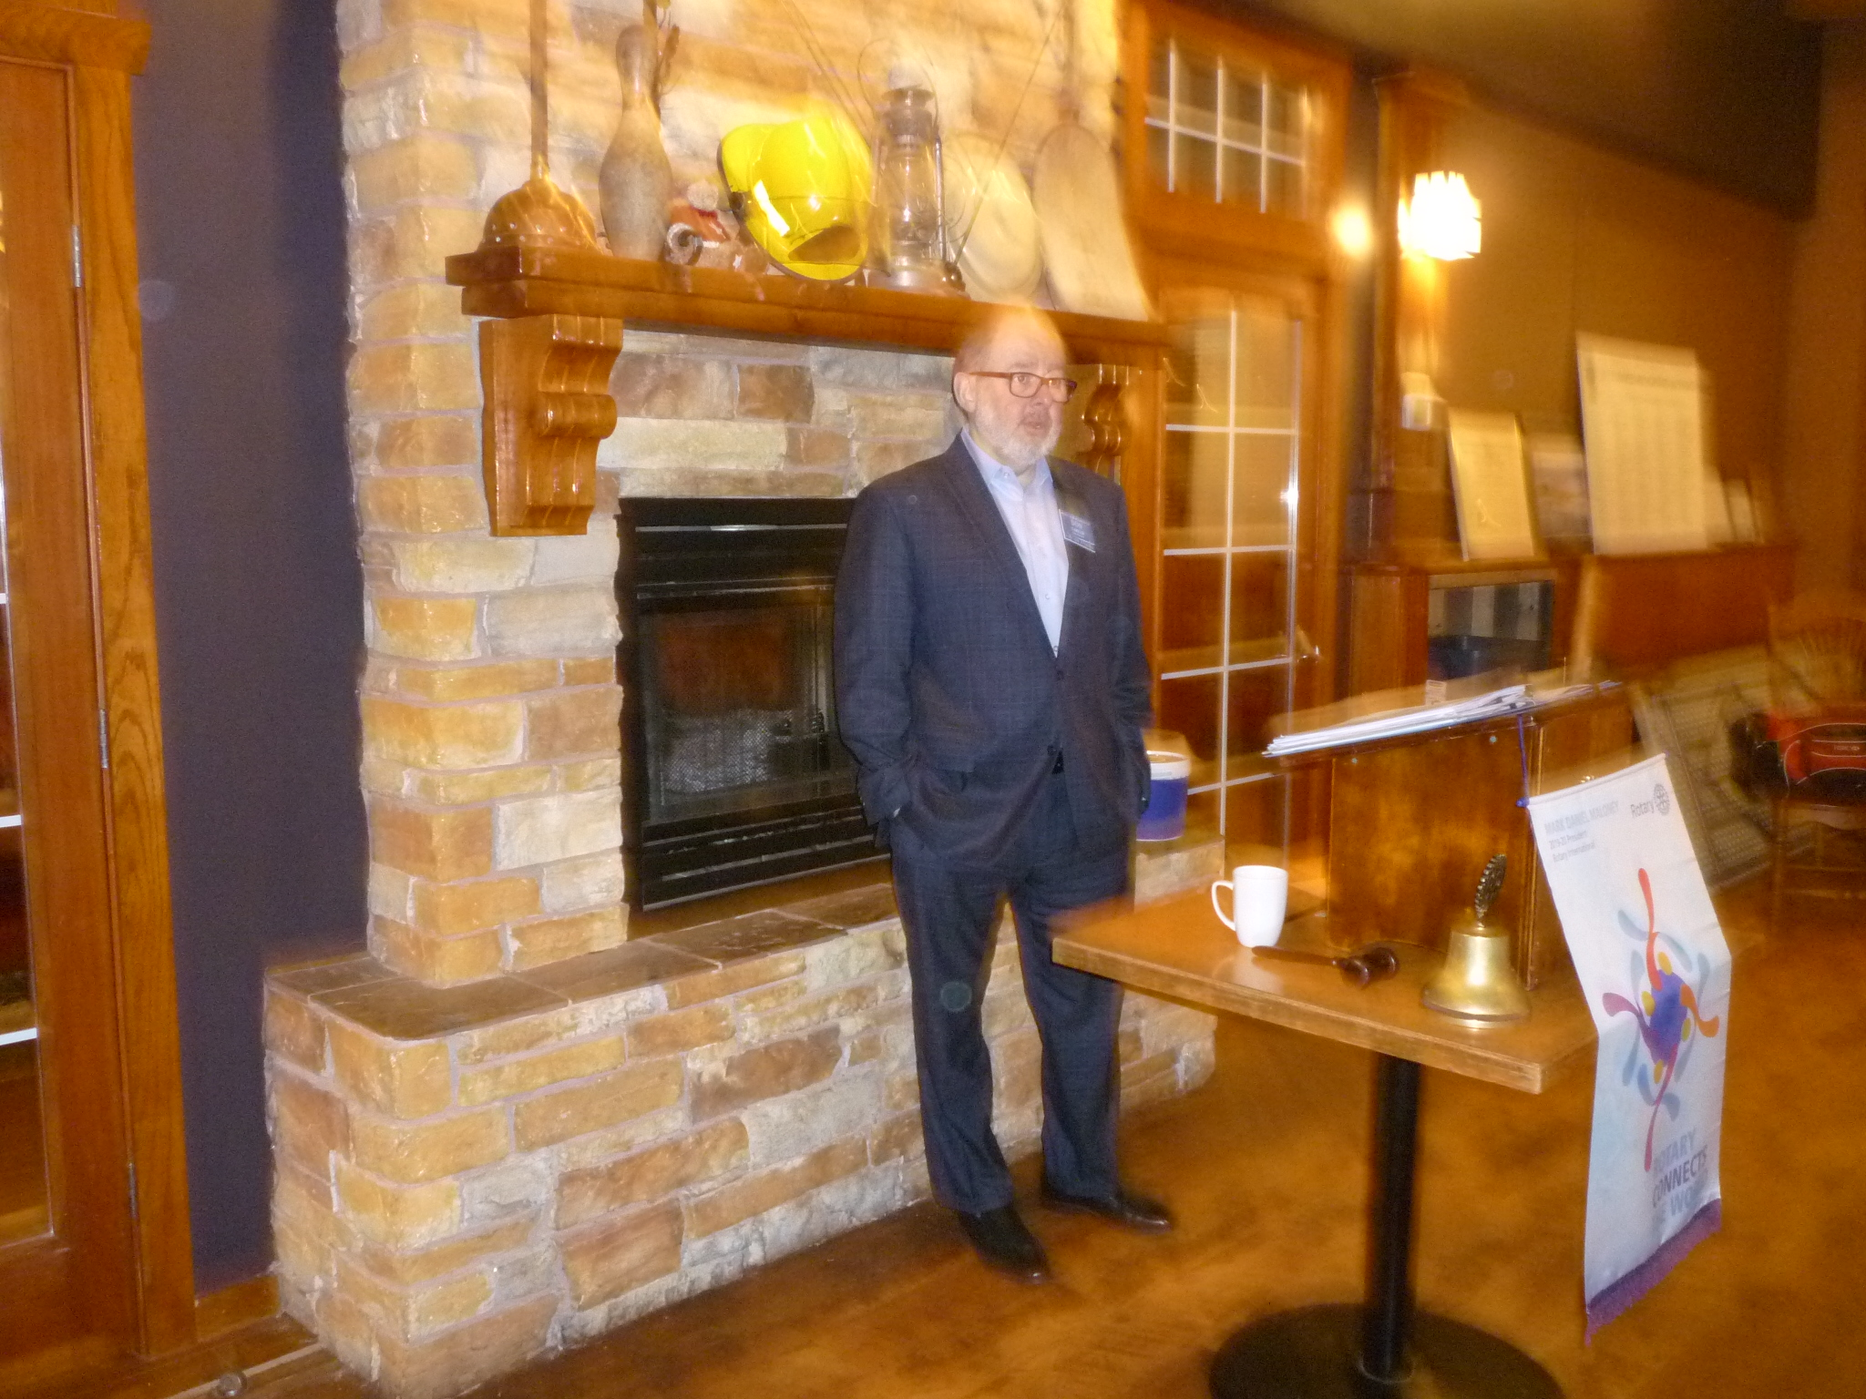

ROTARY CLUB OF LANTZVILLE
CLUB GOLF TOURNAMENT
MAY 29TH, 2020

With, as always, great enthusiasm, Don gave us an overview of what needs to be done over the next few weeks. This is our major fundraising event and as such needs input and support from everyone.

Don spoke about what makes our tournament special. It is about the extra touches we have learned work – tents on the greens, balloons in the Hall, signs everywhere, quality prizes, great sponsors, happy golfers, energetic welcoming Rotarian and community volunteers throughout the day. We have a reputation, soon to be repeated, of knowing how to organize a golf tournament and ensure that everyone goes home satisfied with their participation.

Next week, with Don’s guidance, the plan is to identify our 2020 major beneficiary. After that, it is boots on the ground and busy, busy for the next 18 weeks.

Our golf tournament results are what enable us to do what we want to and do throughout the year…
supporting the 7-10 Breakfast program, Lantzville Bus Shelter, Santa Breakfast, Easter Egg Hunt, Stock the Lockers; building fences; painting buildings; sending students to RYLA, Youth Exchange; funding Lesotho Teacher Training, Shelter Boxes, Polio Plus campaign; building homes in Mexico, cooking units in Guatemala, laterines where needed; education initiatives everywhere. This is who we are…what we do!

CLUB BUSINESS

-Motion to provide $ 1,000 from gaming to support the Nanaimo Ladysmith Public Schools breakfast programme was approved.

-Motion to provide $ 1,200 to support the Rotary Centennial committee’s proposal for City of Nanaimo banners with Rotary Logo’s for 2020 was approved.

Community Services chair Dale spoke about the magnitude of the everywhere homeless crisis. As Rotarians, we need to think about this, perhaps identify innovative, workable solutions and how we collectively can help bring them to fruition.



Rotary Club of Lantzville
President Barry Sparkes - brsparkes@telus.net

Membership Chair – Mark Taylor mark_taylor@shaw.ca

Community Services Director – Dale Werezak
dgwerezak@shaw.ca

WHAT IS VOCATIONAL SERVICE?
BY MARK E. HOPPEN

Founded as a business networking organization, Rotary emphasizes the importance of bringing together business and professional leaders for the purposes of exchanging ideas, developing relationships and improving communities.

Vocational Service is Rotarians sharing expertise, professional skill, and life experience through club projects, Rotarian Action Groups, Rotarian Fellowships and Rotarian Friendship Exchanges.

Vocational Service calls on Rotarians to encourage and foster high ethical standards in business and professions; to recognize the worthiness of all useful occupations; and to dignify each Rotarian’s occupation as an opportunity to serve society. This is the first and most fundamental Rotarian commitment.

Points to Ponder…



