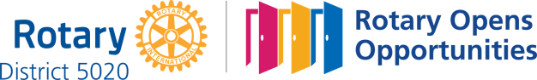

January 28th, 2021
Vocational Service Month

IN THE LANCE THIS WEEK

Club Meeting Notes
Rotary Minute
Project Amigo

FUTURE EVENTS

February 3rd Club Directors’ Meeting
4th CM – Mayor Krog
11th CM – Club Information

VISITORS AND GUESTS

Visiting Rotarians – Wayne Anderson, ADG, Sheila Anderson, Nanaimo North. Guest Heather Edwards, Project Amigo Development Officer.

CELEBRATIONS

Next Wednesday, birthday wishes to Michael R. !

“Often it isn't the mountains ahead that wear you out, it's the little pebble in your shoe.” ~ Muhammad Ali – Fix What Bugs You!

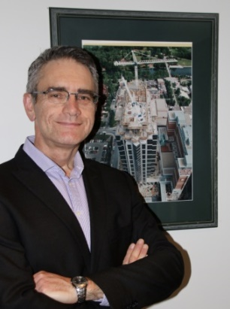
PRESIDENT MARK
Wednesday morning, Mark and other club members attended the Nanaimo Daybreak meeting. This week marked their 25th charter anniversary.

CONGRATULATIONS
To Dale and Greg, our newest Paul Harris Fellows.
To PHF members Doug S. (+8) and David L. (+2).

ROTARY MINUTE

Tess spoke about serious lesson learned as to the importance of decluttering one’s personal belongs. Her message – please do not leave this work for other people. Perhaps some of your collective stuff could/should be disappeared.

Excellence…

“Going far beyond the call of duty. Doing more than others expect. this is what excellence is all about. It comes from striving for and maintaining the highest standards, looking after the smallest detail and going the extra mile. Excellence means caring. It means making a special effort to do more.”

~Ron Southern

PROJECT AMIGO

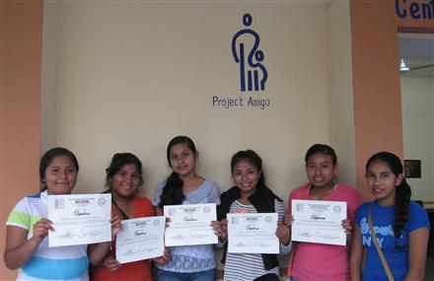
RECENT PROGRAM GRADUATES
Heather Edwards told us about the many facets of Project Amigo (PA) – a donor funded scholarship program that allows the brightest but most impoverished students in Colima Mexico to attend primary school through university and beyond.
Annual competition for scholarships is intense and for successful applicants demanding. Currently, PA supports 168 primary/secondary/high school students and 19 university students. Since inception, 88 students have earned university degrees and more than 1,000 students have graduated from high school. Other initiatives supported by PA include humanitarian service work weeks, Christmas Fiesta, micro-business projects, student day trips, vision & dental clinics and most recently student learning cyber centers & food boxes.
Sponsored by the Rotary club of Novato (CA), in 1996 PA became a registered US public charity. Today, Rotarian Sheila Anderson is a PA Canada Society director.
Thank-you Heather for an excellent presentation about this amazing organization!

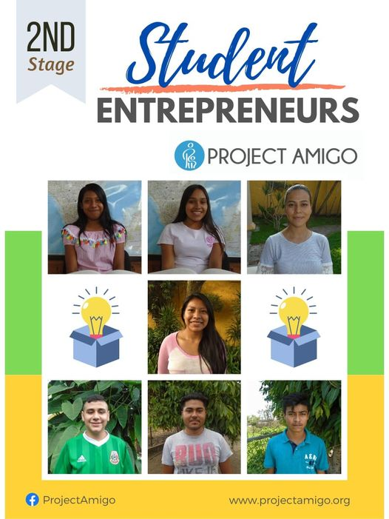

PROJECT AMIGO – CHRISTMAST FIESTA 2020

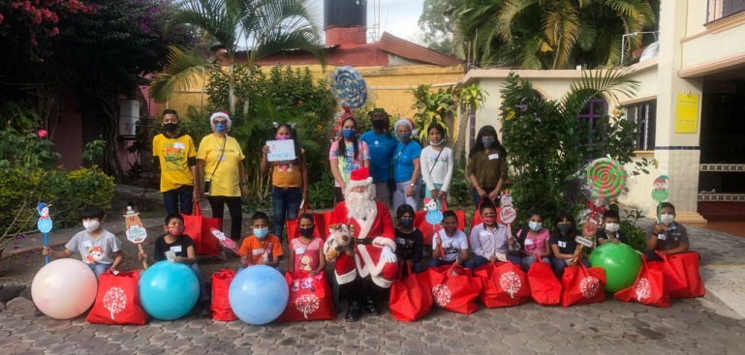

2020 PROJECT AMIGO
UNIVERSITY GRADUATE
With Honors
Giselle Hernandez - Teaching

PROJECT AMIGO

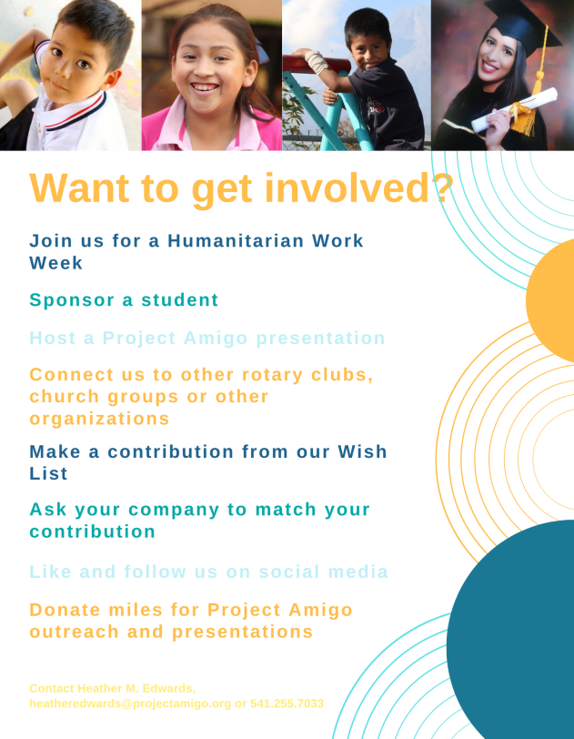

CONTACT INFORMATION
www.projectamigo.org

