January 7th, 2021
Vocational Service Month

IN THE LANCE THIS WEEK

Economic Outlook 2021
Club Meeting Notes

VISITORS & GUESTS

Visiting Rotarians – Wayne Anderson & Linda Murray; guests – Ian Douglas, Meaghan Douglas & Mark Duncan, Raymond James Ltd. financial advisors.

CELEBRATIONS

Wedding congratulations, best wishes to Dave & Cindy Elgie. Happy Birthday to Dave Elgie.

ROTARY CLUB OF LANTZVILLE
MISSION STATEMENT
Joining in fellowship to support growth and development in education and health for those less fortunate in our local and international communities.

CLUB MEETING NOTES

Welcome remarks from President Mark included acknowledgment that our meetings take place in the traditional territory of the Snaw-naw-as First Nation. Meeting attendance was good.

Thank-you’s to our speakers for a timely and interesting presentation, Neil as our sergeant at arms; Jodie for her inspiration.

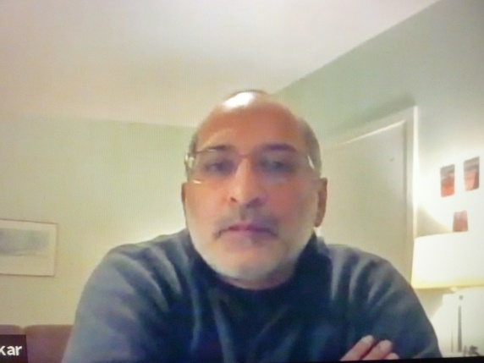
S/A Happy bucks…sad bucks…

-David L. reported on the 7-10 breakfast. Always this feel good project is greatly appreciated by our guests and it provides good club fellowship.
-From Don, how much the world has changed in 12 months. This time last year, he and friends were there for Team Canada’s win. Sad buck on this year’s loss to the US.
-Jodie and James are looking forward to their 1st ‘Hello Fresh’ dinner delivered by Tess.
-Mark is happy daughter has her L license and he is looking forward to their driving lessons.
-Jan commented on friend Kerry’s positive attitude in dealing with ongoing health issues.
-Boxing Day golf was a big success. Many thanks to Fairwinds for supporting this event.

ECONOMIC OUTLOOK 2021

Mark Duncan began the presentation with a brief overview of Raymond James (RJ) Ltd. The company is a wholly owned subsidiary of US Raymond James Financial. In Canada, there are 130 branches with 1,400 employees and agents. The Nanaimo branch advisors – Mark, Ian & Meaghan - oversee $ 300 million in investment portfolios.

Meaghan shared RJ’s perspectives and thoughts on what the financial world will look like in 2021. She gave reasons to support a strong, positive outlook. Top of list = optimism about the production of what is reportedly an effective CoVid vaccine. Ongoing we will see huge amounts of government recovery spending. For those with comfortable retirement finances and workers in secure jobs, there is huge pent-up demand that will be felt in many sectors. Barring speed bumps, RJ sees the 2021 market as being relatively stable. For investors, RJ’s preferred investments include banks (RB, TD, JP Morgan), Brookfield, Telus, WSP Global, Amazon, Google & US health care stocks.

A very robust Q&A, followed Meaghan’s ‘Outlook’. Perhaps more upside for the Canadian $. RJ does not facilitate bit coin trading & they discourage short trading. With current low interest rates, dividend paying stocks make sense for most investors. Be wary about –flavor of the day - high priced stocks.

In thanking our speakers, Neil encouraged individual follow-up with our personal investment advisors. In President Mark’s words… “the presentation was valuable to our members, as witnessed by the number of questions you handled so well.”

“We will open the book. Its pages are blank. We are going to put words on them ourselves. The book is called opportunity and its first chapter is New Year’s Day.’ ~~~Twentieth-century poet and pacifist, Edith Lovejoy Pierce

