“Rotary: Making a Difference”

July 12th, 2018
A New Rotary Year

IN THE LANCE THIS WEEK

Princess Anne lauds Rotary

FUTURE EVENTS
July 19th – The History of Daybreak
July 22nd – Annual Summer BBQ at Tuckers
July 26th – NO Meeting
July 28 – Breakfast at the 7-10 Club

“VISITING” ROTARIANS

VISITORS and GUESTS

BIRTHDAYS & ANNIVERSARIES
 |  | DUTY ROSTER
DATE | GREETERS |  | CASH | Sgt-At-Arms | Invocation | INTRO | Foundation | Rotary  Minute
Jul 12th | NO MEETING
Jul 19th | Cameron & Manikel |  | Elgie | Tamelin | Jodie W. | Lobay | Cohn | Kilner
Jul 26th | NO MEETING
If you cannot make your duty, it is your responsibility to find a replacement.
Don C – another year wiser(?) on July 17th.
Mark & Tessa – their 33rd on July 14th. Congrats!
HEALTH of the CLUB
It looks like we’re still healthy – having received no news to the contrary. ☺

ROTARY CLUB OF LANTZVILLE
MISSION STATEMENT
Joining in fellowship to support growth and development in education and health for those less fortunate in our local and international communities.

“Presidential” Observations
. 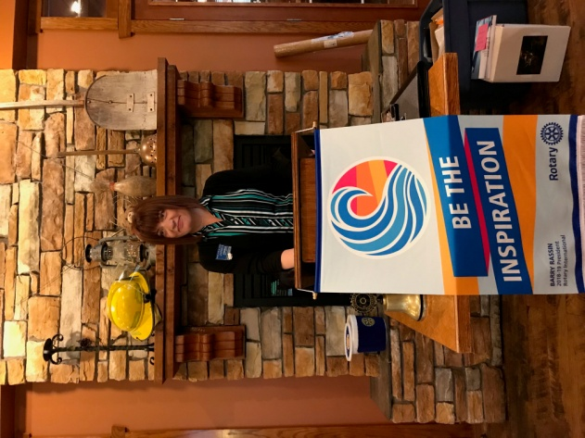
Our inspiration for the coming year. Jan deserves our support, eh?

FOUNDATION
Your contributions to The Rotary Foundation for the next few months will be going to the Annual Fund -- unless you ask Barry to direct them elsewhere!

Sergeant-at-Arms
As a reminder -- we have a new format for the weekly draw: Holder of the winning ticket will draw a card from Jan’s deck. A Joker wins the pot. Otherwise the pot will be held over – until the joker is eventually drawn. Could be a BIG pot!


Breakfast at the 7-10 Club
Thanks for your support!
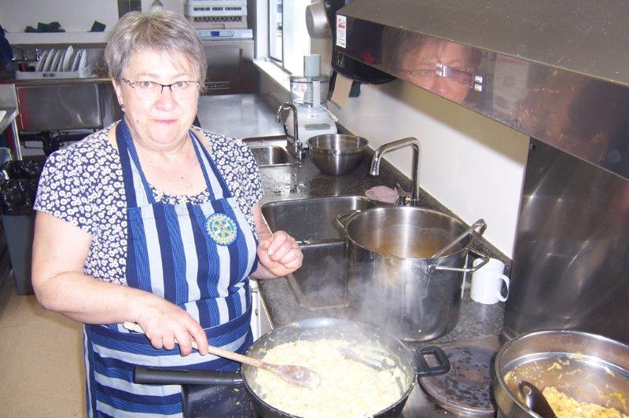
Scrambled eggs with something special…
Next breakfast – Saturday, July 28th.

News, Updates & Reminders
Summer BBQ at the Tuckers
July 22nd
Mark your calendars for this great event at Jim & Diane Tucker's fabulous property (4811 McGuffie Rd).
It will start at 4:00 pm; steak & salmon BBQ at 6:00. Cost is just $25 per person. Everything except drinks will be provided.
Good Rotary fellowship - please invite former Rotarians, prospective members or friends.
Joy needs numbers by next meeting on July 19th. And she could use help in setting up and cooking.


Rotary Minute
- Why did you join Rotary?
- Why have you stayed in Rotary?
- How have you benefited from being a Rotarian?

Princess lauds 'astonishing global reach' of Rotary members

Rotary members received a regal thank you from Her Royal Highness The Princess Royal, Princess Anne, for their work in fighting polio.
Her Royal Highness The Princess Royal, Princess Anne, lauded Rotary’s achievements and the respect it has earned at the highest levels of government around the world.
Speaking to an enthusiastic and welcoming crowd on 24 June at the Air Canada Centre in Toronto, Ontario, Canada, The Princess Royal addressed attendees of the 2018 Rotary International Convention.
Since 1970, The Princess Royal has served as president of Save the Children UK, an international nongovernmental organization that focuses on health, education, protection, and disaster relief for children.
Save the Children began pilot programs of its own to combat polio in Africa in the early 1980s. It discovered the difficulties of delivering the vaccine where it was most needed, she said.
Enter Rotary. With its “astonishing global reach,” as The Princess Royal called it, its extensive understanding of cultures and languages, and its members’ “endearing habit of leaving (their) egos at the door,” the organization ingeniously overcame obstacles that baffled others. In doing so, Rotary, along with its partners, has brought polio nearly to full global eradication.
Read the whole story at: https://www.rotary.org/en/princess-anne-thanks-rotarians-polio-fight

ROTARY INFO
You can find out where and when all the Clubs in District 5020 meet on the 5020 website:
www.clubrunner.ca/portal/Organization/Meetings.aspx?accountid=50092
Rotary International: http://www.rotary.org
Member’s access: https://www.rotary.org/myrotary/en
District 5020: www.rotary5020.org
Our website: www.clubrunner.ca/Lantzville
Our Facebook Page: www.facebook.com/RotaryClubofLantzville
Check it out – you might be surprised…

BEAUTIFUL BC - Sikanni River Bridge, Fort Nelson


Did you know that.....
If you can start the day without caffeine,

If you can get going without pep pills,

If you can always be cheerful, ignoring aches and pains,

If you can resist complaining and boring people with your troubles,

If you can eat the same food every day and be grateful for it,

If you can understand when your loved ones are too busy to give you any time,

If you can take criticism and without resentment,

If you can ignore a friend's limited education and never correct him,

If you can resist treating a rich friend better than a poor friend,

If you can conquer tension without medical help,
If you can relax without liquor,

If you can sleep without the aid of drugs,

Then…
…You Are Probably the Family Dog!



