“Rotary Opens Opportunities”

July 16th, 2020

IN THE LANCE THIS WEEK

VIRGINIA FENTON
JOHN HOWARD SOCIETY

MIKE WALKER
ROTARY (MIKE) MINUTE

VISITORS AND GUESTS

Visiting Rotarians were ADG Wayne Anderson,
San Mahara – Nanaimo Daybreak, Howard Cohen DGE D5030 and from Nepal Binaya Maharjan.
Visitors were Barry Sparkes, Cor Buys & baby Charlotte.

HEALTH OF THE CLUB

Via email, Jamal enjoys our telephone calls and personal notes. Happy to hear former Rotarian Len Olsen is on the mend. Mark tells us Mike and Gaye Harrigan are moving to Metral Drive.

ROTARY CLUB OF LANTZVILLE
MISSION STATEMENT
Joining in fellowship to support growth and development in education and health for those less fortunate in our local and international communities.
CLUB BUSINESS

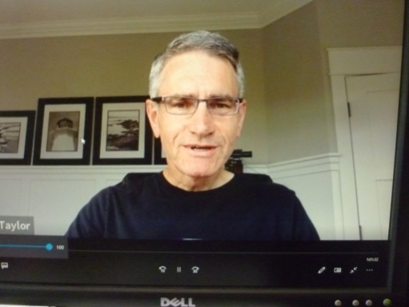

President Mark began the meeting with a warm welcome.

Invocation by Tessa; thank-you’s to our speakers and guests; happy birthday to Don Tamelin.

Big thank-you from Barry for the RCoL SD 68
2021 bursary in his name.

From Greg, last call for Roster corrections. From Dale, the Samaritan House move is scheduled for the end of July. Next week, we will discuss the logistics of returning to an in person club meeting.

NEPAL COVID-19 FOOD PROJECT

The motion: ‘that the RC of Lantzville undertakes a joint project with the Rotaract Club of Leberty College and Rotary Club of Nagarjun, Nepal to Feed the Needy during the COVID-19 lockdown’, was approved.

Project cost is $ 7,000 US. San Mahara is donating $ 4,000 from his personal fund raising event to our Club. Our Club will apply for a District Grant in the amount of $ 3,500 US. MIGs is contributing
$ 1,000. Projected completion date is September 2020.

NEXT WEEK MEETING… 7:30 a.m. Huddlestone Park. Bring a chair, your food and coffee. Brian promises nice weather!

NANAIMO REGION
JOHN HOWARD SOCIETY (JHS)

Our speaker, Virginia Fenton has been with the Society for 10 years, most recently as manager of program development, now newly promoted to co-CEO. A longtime resident of Lantzville, our Rotary has had a big influence in her life – Breakfast with Santa, Easter Egg Hunts, fund raising concerts, etc. As a youth, she went to the Ottawa Adventures in Citizenship event. Virginia touched base on several programs and services provided by JHS in their focus areas of housing, employment and education, justice and community.
Recently, our Club provided financial support for the Story Book Dads program. This program is rehabilitative, not only because it helps bridge relations between parent and child, but also because it promotes life skills. It is run by a dedicated, passionate group of volunteers who have a significant impact on the health and well-being of inmates and their families.
JHS is about creating safe, healthy and inclusive communities for all. Great information including volunteer opportunities can be found on the JHS website. Thank-you David Lobay for bringing Virginia to us. Thank-you Virginia for your enthusiasm and great work.
ROTARY MINUTE
Mike spoke about the COVID impact in his world. It takes twice as long to do anything and has brought a whole new meaning to tail gate parties. Added complexity is the many staff working from home. The real estate practice is very busy. Sadly, Mike’s referee travels in the International Badminton are on hold indefinitely.
‘We don’t rise to the level of our abilities, we fall to the level of our excuses.’ …anonymous.

